MidCentral Governance Group
Minutes of the meeting held on Thursday 11 April 2019
Attendees: | Peter Allan (Chair), Martin Sullivan, Rachel Kenny, Rasela Fuauli, Peter Ireland, Heather Browning (Deputy Chair), Angela Hobden
Apologies: | Maxine Dale, Zandra Vaccarino
In attendance: | Sandy Ryan (meeting assistant), Jo Brew, Virginia Wilton (secretariat)
Venue: | EASIE Living Centre, Conference Room, 585 Main Street, Palmerston North
Time: | 11.00 – 2.00pm

Karakia

Information: Try, Learn and Adjust – Cycle One
Fiona Scott Melton, Allen + Clarke, provided an overview of the try, learn and adjust approach to the developmental evaluation, and how it will support the development of Mana Whaikaha.

Two representatives of the MidCentral Governance Group will be members of a group who will be making sense of the data and insights gathered in the first cycle.

The analysis of the insights and data gathered will be used by the MidCentral Governance Group to make recommendations to Ministers on any improvements needed to ensure disabled people and whānau are achieving the outcomes that are important to them.

Information: Mana Whaikaha monitoring report for February 2019
The MidCentral Governance Group receives a monthly monitoring report on Mana Whaikaha. As this process is emerging, the Group provided feedback on the additional information they would like to see future reports.

Information: Operational update from Directors
Lorna Sullivan and Marshall Te Tau shared with the MidCentral Governance Group the current challenges, opportunities and successes.

Information: Baseline Study Evaluation Report
Marianne Linton (Evaluation Team, Ministry of Health) attended the meeting to present the baseline study evaluation report.
The final report, along with the technical report will be posted on the Mana Whaikaha website

Practical matters

Date of next meeting: Thursday 23 May 2019, 11.00 am, EASIE Living Conference Room, 585 Main Street, Palmerston North

I confirmed that these minutes constitute a true and correct record of the proceedings of the meeting

DATED this 3rd day of December 2019
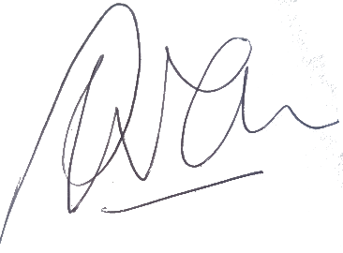

Peter Allen
Chair, MidCentral Governance Group

