MidCentral Governance Group
Minutes of the meeting held on Thursday 14 February 2019
Attendees: | Peter Allan (Chair), Martin Sullivan, Rachel Kenny, Rasela Fuauli, Peter Ireland, Heather Browning (Deputy Chair), Angela Hobden, Zandra Vaccarino
Apologies: | Maxine Dale
In attendance: | Janet Doughty (meeting assistant), Jo Brew, Virginia Wilton (secretariat)
Venue: | EASIE Living Centre, Conference Room, 585 Main Street, Palmerston North
Time: | 11.00 – 2.00pm

Karakia

Decision: Amendment to a recommendation in the Complementary Therapies paper first considered on 31 January 2019
The paper was taken as read.

The MidCentral Governance Group:

- agreed to the amended recommendation, that now reads:

that a list of the complementary therapies that Mana Whaikaha may consider funding, and those that will not be funded, are made publicly available.

Presentation: Operational update from Directors
Lorna Sullivan and Marshall Te Tau discussed the November and December 2018 Mana Whaikaha monthly reports.

Presentation: Overview of system transformation
Wendy Illingworth (Programme Lead, System Transformation, Ministry of Health) and Scott Ambridge (General Manager, Enable NZ). They discussed:

- the activities of the Workforce Working Group

- the policy work programme leading up to developing advice for Ministers on the future of the transformed disability support system

- the developmental evaluation, and the first Try, Learn and Adjust cycle.

Presentation: Mathew Parr, Acting Deputy Director General, Disability, Ministry of Health
Mathew Parr provided an overview of the new Disability Directorate within the Ministry of Health. He invited the Governance Group to share their views on how to ensure the success of Mana Whaikaha.

Practical matters

Date of next meeting: Thursday 14 March 2019, 11.00 am, EASIE Living Conference Room, 585 Main Street, Palmerston North

I confirmed that these minutes constitute a true and correct record of the proceedings of the meeting

DATED this 3rd day of December 2019

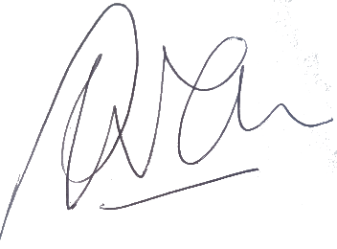

Peter Allen
Chair, MidCentral Governance Group

