MidCentral Governance Group
Minutes of the meeting held on Thursday 14 March 2019
Attendees: | Peter Allan (Chair), Martin Sullivan, Rachel Kenny, Rasela Fuauli, Peter Ireland, Heather Browning (Deputy Chair), Angela Hobden, Zandra Vaccarino, Maxine Dale
Apologies:
In attendance: | Janet Doughty (meeting assistant), Jo Brew, Virginia Wilton (secretariat)
Venue: | EASIE Living Centre, Conference Room, 585 Main Street, Palmerston North
Time: | 11.00 – 2.00pm

Karakia

Decision: Phase two provider capability plan
The paper was taken as read.

The MidCentral Governance Group did not make any decisions on the recommendations in the paper as they considered these to be operational rather than strategic.

The MidCentral Governance Group requested that the writers of the paper come back to them with a revised paper that included an assessment of each option in relation to:
- a clear problem definition
- analysis of options
- intended outcome for each option, including how it will be measured
- alignment of options with Enabling Good Lives principles.

Decision: Raising awareness of care and support workers
The paper was taken as read.

The MidCentral Governance Group supports the proposal to hold information sessions. They agreed that to participate in the sessions through sharing their knowledge of the Enabling Good Lives vision and principles.

Feedback: Service model and practice framework for connector role in Mana Whaikaha
Lorna Sullivan attended the meeting to receive feedback on the draft service model and practice framework for Connector role in Mana Whaikaha.
The MidCentral Governance Group acknowledged that the model and framework are working documents, and that they will be a very useful resource for developing the capacity of providers.
The MidCentral Governance Group requested that the Connector service model and practice framework be available to NGO connectors and providers to support the development of good practice.

Feedback: Review of the governance groups and leadership groups that support the Enabling Good Lives work programme
The paper was taken as read, and feedback provided.

Information: Update from Mana Whaikaha Directors
Lorna Sullivan and Marshall Te Tau gave an update, including some of the current challenges and successes, including improvements to internal processes and recent engagement with schools.

Key focus for the month is the transfer of funds from the Ministry of Social Development and flexible disability support contracts with providers.

Practical matters

Date of next meeting: Thursday 28 March 2019, 11.00 am, EASIE Living Conference Room, 585 Main Street, Palmerston North

I confirmed that these minutes constitute a true and correct record of the proceedings of the meeting

DATED this 3rd day of December 2019

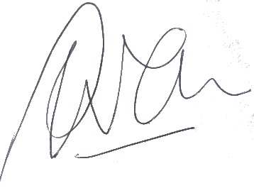

Peter Allen
Chair, MidCentral Governance Group

