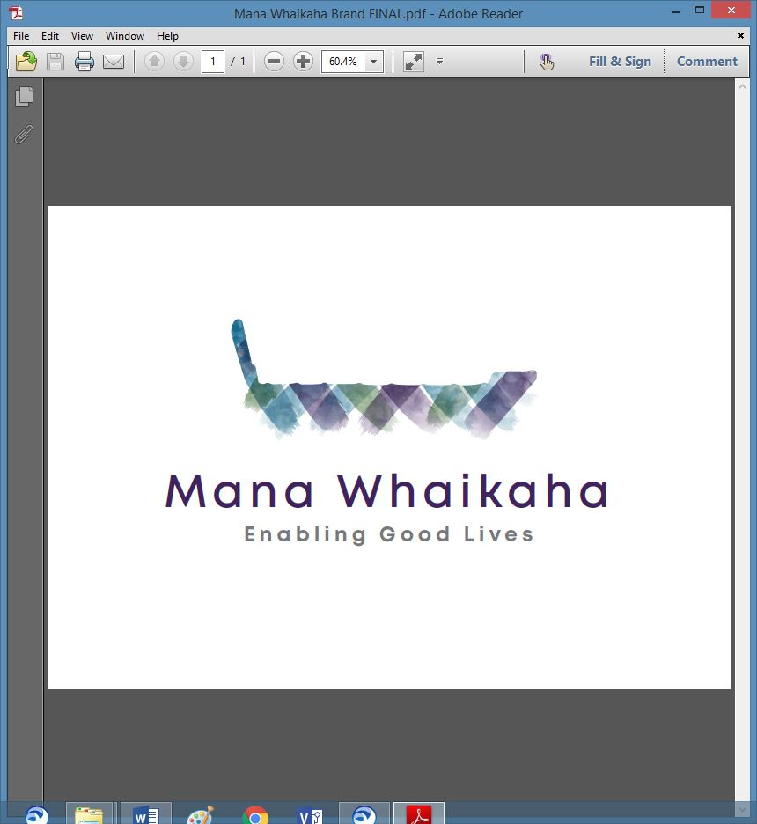

**MidCentral Governance Group**

**Minutes of the meeting held on Thursday 20 August 2020**

|  |  |
| --- | --- |
| **Attendees:** | Peter Allen (Chair), Heather Browning (Deputy Chair), Martin Sullivan, Rachel Kenny, Angela Hobden, Maxine Dale, Rasela Fuauli, Pip Brunn |
| **Apologies:** | Peter Ireland |
| **In attendance:** | Jo Brew |
| **Venue:** | Conference Room, PSA Offices, 198 Cuba Street, Palmerston North |
| **Time:** | 11.00am – 3.00pm |

# **Karakia**

**Minutes of the previous meeting**

The minutes of the previous meeting held on 23 July 2020 were accepted as a true and correct record.

**Peter Allen/Angela Hobden**

**Discussion: Julie Hook, Hannah Kerr and Rawa Karetai – System Transformation, Ministry of Health**

Julie Hook, System Transformation Lead, MoH, Hannah Kerr, Manager Disability Policy, MoH and Rawa Karetai, Communications Director, System Transformation, MoH joined the meeting by phone.

Julie and Hannah introduced themselves to the MidCentral Governance Group members and gave a brief outline of the past 4 weeks in their new roles and the work they plan to be involved in over the next few months. Rawa updated the members on his role including continuing with the Covid response team.

**Information: Process of Equity Funding Paper (Lorna Sullivan)**

The Process of Equity Funding paper was received.

Peter Allen explained a process had been requested to protect staff and people on leadership groups who have personal budgets. Matters pertaining to the process can be clarified later in the meeting when Director’s table their reports to the meeting.

**Discussion: James Poskitt**

James Poskitt, Group Manager, Strategy, Policy and Performance – Disability, Ministry of Health joined the meeting and gave an update on the change management proposal:

* The change management proposal outcome had been presented to the Mana Whaikaha Team earlier that day.
* The Tari team will be disestablished leaving one Mana Whaikaha team.
* All new roles will be for fixed term contracts with Ministry of Health to 30 June 2021.
* The roles will go through the expressions of interest process with any vacancies being externally recruited.
* The Operations Manager role will be recruited first to allow for their input into recruitment of the team.
* The Director’s role will be recruited at the end of September 2020.
* It is anticipated the new structure will be ready for implementation on 1 October 2020.

MGG members expressed their desire to be included in communications, any changes to timeframes and the recruitment process.

**Information: Director’s Reports – Marshall Te Tau and Lorna Sullivan**

Marshall tabled his report to the meeting:

* The Tari team received the change management proposal outcome from Ministry of Health earlier that day. Expressions of interest for roles are due next Wednesday.
* Enable New Zealand is working on the changes to their structure in relation to Mana Whaikaha’ s changes.
* An ‘insights’ report has been completed, once finalised will be sent to the MidCentral Governance Group members.
* Currently working on ways to improve quality of workflow-on around Explore behaviour support services; a child development project relating to later diagnosis and involved in another piece of work relating to the effective transition of children with foetal alcohol syndrome into the disability support system.

Lorna joined the meeting:

* Lorna explained how the indicative range tool is completed and assessed for quality at present. Once recruited, the new budget advisor’s role will be front facing and assist connectors and families in the quality and purpose alignment conversations after the initial indicative range and funding proposal negotiations have been done. The indicative range is used as a guide; a tool is needed for budgeting purposes and to attempt equity across similarity of needs.
* Lorna has been in contract discussions with some providers.
* ‘Crisis on call’ was clarified; Mana Whaikaha is not a 24 hour after service and that is not promoted. There is a crisis phone which is responded to at any time and at present is an unfair burden on the one crisis connector. Once the change management is implemented there will be 3 connectors to share the phone.
* Lorna will be involved in recruiting the Operations Manager role which will be done first so that person can be involved in recruiting their own team. While the new structure is expected to be up and running by 1 October it is anticipated Mana Whaikaha may operate short staffed until any external recruiting is completed.

**Correspondence**

***Inwards***

* Email from Virginia Wilton on 31/7/2020 – Proposal for Consultation on Mana Whaikaha document

***Outwards***

* Email from Peter Allen to James Poskitt on 3/8/2020– copy of Peter’s signed acceptance of extension to the term as a member of the MidCentral Governance Group
* Jo to request copies of all acceptance letters from the Ministry of Health for record keeping purpose.

**General Business**

* Terms of Reference – deferred to next meeting when we will reassess decision making parts of the terms of reference.

# **Practical matters**

# **Date of next meeting:** 24 September 2020, 11.00am at the PSA Premises, 198 Cuba Street, Palmerston North.

**The meeting closed at 3.00 pm.**

**I confirmed** that these minutes constitute a true and correct record of the proceedings of the meeting.

DATED this 24th day of September 2020



**Peter Allen**

**Chair, MidCentral Governance Group**