MidCentral Governance Group
Minutes of the meeting held on Thursday 22 August 2019
Attendees: | Peter Allan (Chair), Martin Sullivan, Rasela Fuauli, Peter Ireland, Heather Browning (Deputy Chair), Angela Hobden, Maxine Dale, Zandra Vaccarino
Apologies: | Heather Browning, Rachel Kenny
In attendance: | Jo Brew, Virginia Wilton (secretariat)
Venue: | EASIE Living Centre, Conference Room, 585 Main Street, Palmerston North
Time: | 11.00 – 3.00pm

Karakia

Discussion: National EGL Leadership Group
Jade Ferrar, Co-Chair National EGL Leadership Group attended the meeting to discuss their letter to the Deputy Director-General Disability outlining, reminding and clarifying matters relating to the system transformation’s disability support system alignment to the EGL principles or vision of intent.

Discussion: James Poskitt
James Poskitt, new Programme Lead for the System Transformation Team met the MidCentral Governance Group members. They discussed shaping strategy and narrative towards seeking government approval for national rollout, the MidCentral Governance Group’s role of leadership, and the cultural shift of transforming a system.

Information: Operational update from Directors
Lorna Sullivan and Marshall Te Tau shared with the MidCentral Governance Group the current challenges, opportunities and successes, including the role and difference between personal connectors and Mana Whaikaha connectors and the purpose of and difference between traditional residential services and transitional residential services.

Practical matters

Date of next meeting: Thursday 26 September 2019, 11.00 am, Conference Room, Level 2, 585 Main Street, Palmerston North

I confirmed that these minutes constitute a true and correct record of the proceedings of the meeting

DATED this 3rd day of December 2019

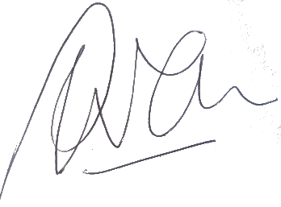

Peter Allen
Chair, MidCentral Governance Group

