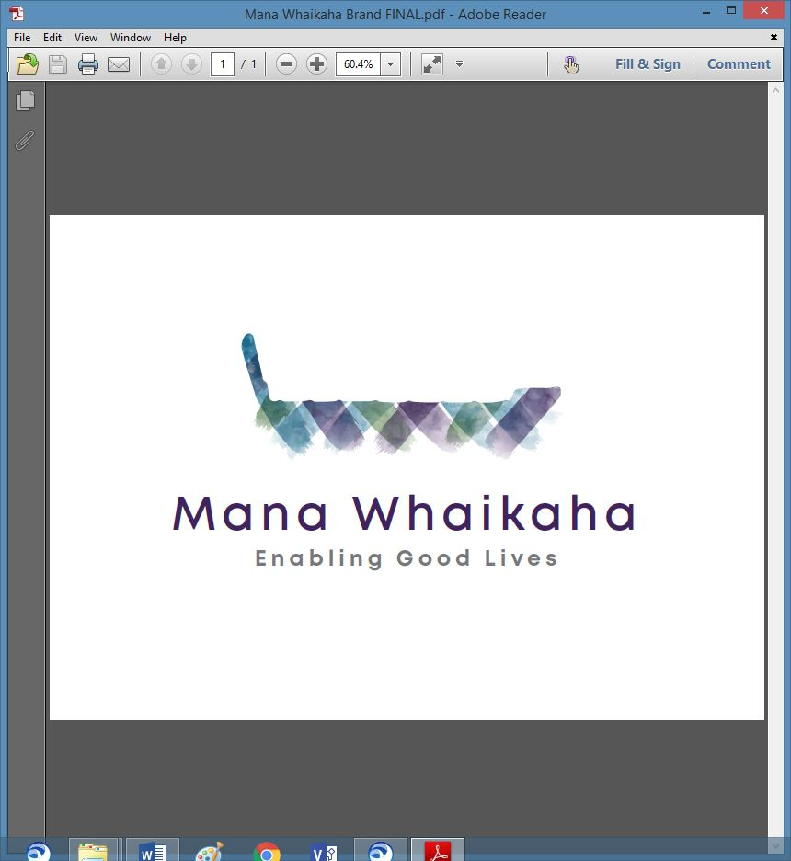

**MidCentral Governance Group**

**Minutes of the meeting held on Thursday 22 July 2021**

|  |  |
| --- | --- |
| **Attendees:** | Peter Allen (Chair), Lorna Sullivan (Co-Chair), Martin Sullivan, Rachel Kenny, Pip Brunn, Angela Hobden, Rasela Fuauli, |
| **Apologies:** | Oriana Paewai, Rachael Burt, Aroha Lowe and Peter Ireland. |
| **In attendance:** | Sandy Ryan (Meeting Assistants), Jo Brew (Secretariat) |
| **Venue:** | EASIE Living Conference Room, 585 Main Street, Palmerston North |
| **Time:** | 10.30am – 2.30pm |

**Karakia**

After the meeting opened with karakia, the Chair eloquently acknowledged Maxine Dale’s passing, paid due respects to her and the contribution she had made to the MidCentral Governance Group as representative of the Provider Group.

**Previous Minutes**

The previous minutes and notes of the meeting held on Thursday 24 June 2021 were taken as read and were a true and correct record.

**Angela Hobden/Martin Sullivan**

**Information: Transition Project – Final Report (Heather Browning – Project Lead)**

Heather informed the group the original project scope of preparing for a contestable process had changed as it had become apparent there were no service specifications. While this had suited the flexibility required by the prototype, service specifications are needed to evolve so a service definition has been drafted and submitted to Ministry of Health (MoH).

The project outcome identified Mana Whaikaha’s need to sit independently, becoming an entity of its own identity. Moving to a standalone location would enable Mana Whaikaha’s development in organisational independence and to better serve and support disabled people and whānau while continuing to lead practical system transformation.

**Correspondence**

**Inwards**

* Email received from the Chair on 27.6.21 regarding the category/breakdown of hours on attendance register.
* Email received from Minister Little’s office on 21.7.21 acknowledging receipt of letter by sent by the Chair on behalf of MidCentral Governance Group (MGG) – pertaining to PSA/Workforce Working Group matters.

**Outwards**

* Letter sent by email from the Chair (on behalf of MGG) to Minister Little re PSA/Workforce Working Group matters.

**Discussion: Board Matters (Lorna Sullivan)**

The main points of this discussion were:

* Lorna has completed a full draft of Board and Executive policies. At some stage, the group will need to develop their understanding of these policies and accountabilities.
* The next step is to develop a governance transition strategy/plan. Knowledge gained from the transition project will assist.

**Action: Lorna will prepare a draft strategy document for discussion at the meeting scheduled for 26 August 2021.**

**Action: Angela will complete the Constitution document and present to the August meeting.**

**Discussion: Expression of Appreciation to Young Leaders**

Joseph Tyers, Vinnie Vaccarino and Zandra Vaccarino joined the group for lunch.

After lunch the Chair acknowledged and thanked Joseph and Vinnie for their contributions while attending Governance meetings over the past 6 months. Their representation of the voice of young people and the development of their leadership skills were also noted. Joseph and Vinnie expressed their thanks for the new learning opportunities that arose from their experiences at Governance meetings and from being included in discussions.

**Discussion: James Poskitt (Group Manager, Strategy – Policy & Performance – Disability, MoH)**

The main points of James update included:

* Erin Black has been recruited into the role of System Transformation Lead, Disability Directorate and will begin on 2 August.
* Programme structure work for national system transformation continues.
* Machinery of Government work including decision papers are on track for September.
* The agreement to re-establish a workforce working group with scope around disabled people and their whānau, providers, unions and worker coming together in this space. It is recognised support, training and development are required to ensure everyone is protected in the employment area.
* Mana Whaikaha’s operational budget and performance measures are in development.

**Information: Director’s Report (Rachael Burt – Mana Whaikaha)**

A copy of the July report was circulated on Rachael’s behalf, in her absence.

**General**

* Nominations for representatives to the workforce working group will be discussed at the meeting on 26 August.

**The meeting closed at 2.25pm.**

**Practical matters**

**Date of next meeting:** A extra meeting will be held on Thursday 5 August 2021 at 1.00pm in Conference Room, Level 2, 585 Main Street, Palmerston North.

**I confirmed** that these minutes constitute a true and correct record of the proceedings of the meeting

DATED this 5th day of August 2021



**Peter Allen**

**Chair, MidCentral Governance Group**