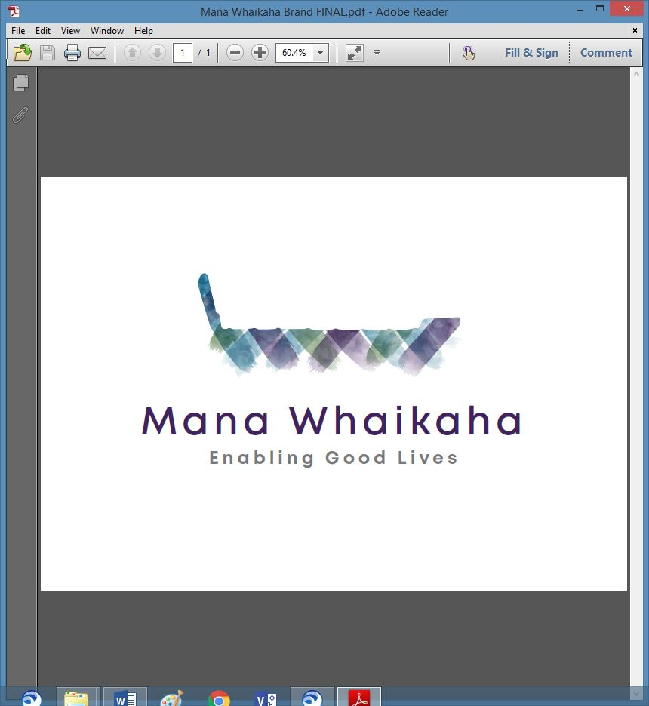

**MidCentral Governance Group**

**Minutes of the meeting held on Thursday 23 May 2019**

|  |  |
| --- | --- |
| **Attendees:** | Martin Sullivan, Rachel Kenny, Rasela Fuauli, Peter Ireland, Heather Browning (Deputy Chair), Angela Hobden |
| **Apologies:** | Peter Allan, Zandra Vaccarino, Maxine Dale |
| **In attendance:** | Sandy Ryan (meeting assistant), Jo Brew, Virginia Wilton (secretariat) |
| **Venue:** | EASIE Living Centre, Conference Room, 585 Main Street, Palmerston North |
| **Time:** | 11.00 – 2.00pm |

# **Karakia**

# **Information: Funding allocation within Mana Whaikaha**

Paul Miller, Ministry of Health, provided an overview of the funding allocation and decision processes within Mana Whaikaha, inlcujing the funding tool and how the indicative range is used.

# **Information: Operational update from Directors**

Marshall Te Tau gave his apologies.

Lorna Sullivan and discussed the additional training connectors were receiving in the tools and frameworks to develop their practice.

# **Practical matters**

MidCentral Governance Group decided to move to monthly meetings, with the ability to schedule additional meetings if needed.

# **Date of next meeting:** Thursday 27 June 2019, 11.00 am, EASIE Living Conference Room, 585 Main Street, Palmerston North

**I confirmed** that these minutes constitute a true and correct record of the proceedings of the meeting

