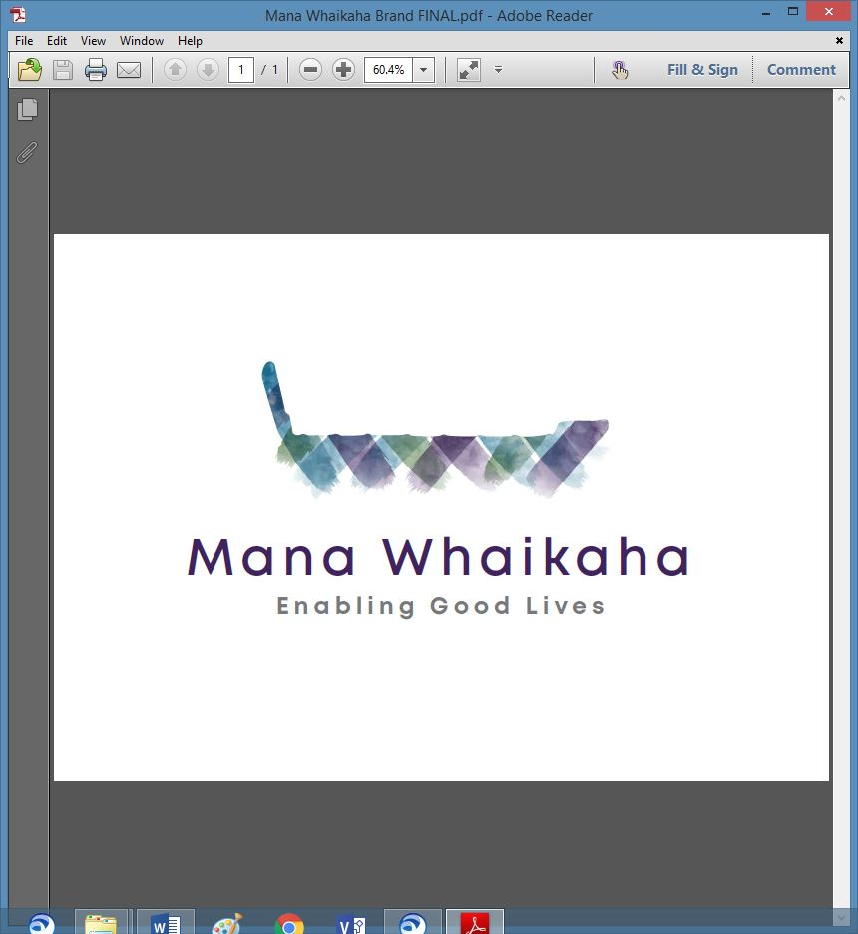

**MidCentral Governance Group**

**Minutes of the meeting held on Thursday 24 February 2022**

|  |  |
| --- | --- |
| **Attendees:** | Peter Allen (Chair), Lorna Sullivan (Co Chair), Rachel Kenny, Martin Sullivan, Rasela Fuauli, Pip Brunn, Angela Hobden, Peter Ireland, Toni Griffiths and Ally Attwell |
| **Apologies:** | Rachael Burt, Mana Whenua representation |
| **In attendance:** | Jo Brew |
| **Venue:** | Via Zoom |
| **Time:** | 10.30am – 2.30pm |

**Welcome**

Lorna as Chair for today’s meeting welcome all to the meeting.

**Previous Minutes/Notes**

The minutes of the previous meeting held on Thursday 27 January 2022 were taken as a true and correct record.

**Angela Hobden/Rachel Kenny**

The action points were updated and will be reflected in the March agenda.

**Discussion: Preliminary Leadership Insights Report (Gail Munroe)**

Gail tabled the Preliminary Leadership Insights Report.

Expected outcomes from today’s discussion were outlined:

1. Does MGG endorse the insights, are they rejected or are they endorsed with amendments?
2. Any there are gaps in the report?
3. Regarding the report’s recommendations and the intention of the future work, are there any matters that should be focused on?

The report provides a baseline for the scaling of EGL and System Transformation and was presented today to enable discussion around insights gathered and the key areas for the next stage. The scheduled date of this second and final stage is mid -April 2022.

Main points of the discussion were:

* RLG needs to remain a vehicle for leadership building, capacity and capability building and bringing together the voices of disabled people, families, and community (including providers), getting them heard and upholding EGL principles and approach through:
* Development of strategies to hear/listen to the voices, influence in implementation phase before policies are set, clear appropriate resourcing, information and transparent decision making and accountability to their wider constituency.
* Being part of a structure i.e., core to regional to a hub with the hub or central organisation managing funding.
* Ensuring equity, inclusion, and representation of invisible communities.
* A national communications strategy.
* Sector engagement.
* A term of reference with commonalities for all but with additions to retain and reflect local flavour.
* Ongoing, continued education about EGL approach and principles.
* Mitigation of risk to providers, i.e., requirements of investment for scaling, attraction and retention of workforce, and the risk posed to EGL should providers fall over.

Overall, a good report which discusses structures well. Suggestions for consideration are:

* More emphasis on capacity and capability building for families, professionals and building local communities and to include disabled people learning about EGL and what means for them. Needs to go into the regional groups before any attempt is made to roll out EGL.
* A strong paragraph added to the report emphasising the importance of regional leadership and core groups.
* There could be a whole Pasifika strand in the EGL, or specific RLG groups for Māori and Pasifika?
* Consideration on ways for the structure to better support Independent Facilitators.

There was a brief discussion about lack of accessibility of the document (EASI read) and the challenges to all involved.

***Action: MGG members will reflect on the meeting notes and compose a comment for Gail in response to the report.***

Ally arrived at the meeting and a round of introductions were done. Ally was nominated to replace Aroha Lowe as Family Core Group representative.

**Board Matters**

**Policies for review – February**

**Executive Limitations: Treatment of Staff Policy Review & Report**

* Add the following point:

“Ensure industry standards are met, as a minimum, for employees and as the standards move, employees’ terms and conditions be reviewed.”

**All agreed to the reviewed changes.**

* No compliance report received, add above point and send to Director for review by March meeting.

**Governance Policy: Governance Investment**

* Change Board to Trustees.
* Induction Manual – make using the current ‘True North’ package, remove the ‘True North’ document and include ‘Social Model’,‘ Outcome Based Model and ‘Reinventing the Board’ Government Policies documentation.
* Discussion around engaging regularly with moral owners about Governance Investment
* Include a feedback section on the Governance Group page on Mana Whaikaha website
* “The Board is keen to get feedback from……….

Need to make the role of Governance Group very clear and invite feedback on what is being done, what they’d like to see done different, and is the direction of Governance the right direction or should be re-direction so we can evaluate our role and strategic direction.

* Some Boards meet with moral owners at AGM and invite comments and questions to be raised then (and a budget would be required for this).
* Be flexible, if the feedback form isn’t right, we can remove it.
* Develop a strategy to keep people and governance informed.

***Action: Jo to organise Induction Manual and internet feedback form.***

**All agreed to the reviewed changes.**

**Governance Policy: Conflict of Interest**

* Change Board to Trustees.
* Point 7 – add “within Mana Whaikaha”.

**All agreed to the reviewed changes.**

**Info: System Transformation Update** (Erin Black – Programme Lead)

Erin’s update included:

* Developing working relationships with the Establishment Unit to assist with successful start-up of Ministry for Disabled People.
* Workforce strategy scope altered and working towards handover to incoming CEO. Tender documents likely to go out to market this Friday.
* Rescoping capacity and capability development work.
* Ongoing project work - supporting ‘My Life My Voice’, website redevelopment and next scope for aging well work
* Recruitment for new Programme Manager almost complete.
* Operating model workforce – Workforce Working Group will convene again early March.
* Operating model design – working on the approach of working in partnership with disabled people and community.
* Communications due out in the next day or two.

As the initial rollout for scaling for EGL approach is intended to start with the current DDS population, those with long term or chronic illness are unlikely to come under the approach within the next 4 months.

**Info: Establishment Unit (EU) Update** (Rommy Musch – Programme Manager)

Rommy’s update included:

* Started as Programme Lead in October 2021, reporting to Justine Cornwall.
* Most of the EU’s recruitment has been completed; over 600 applications were received for 30 roles - of the 28 recruitments to date, 15 have lived experience of disability or a family member with a disability.
* ‘Day 1 Plan’ is due to be completed next week.
* With 3 governance entities a strong governance structure in place for this piece of work.
* Future Operating Model Team is working on a 1, 3 6 and 12 month plan.
* Accessibility and wishing to be an exemplar of unconscious bias are priorities.
* Naming of the new ministry is in progress and has the intention of having an English, Te Reo and NZSL name.
* The EU has developed a working relationship with the Transition Unit.
* Assurance was given the EU will be reaching out to the Directors of the 3 EGL sites.
* Policy Framework – Rommy will bring a Policy representative to the next meeting to give an update.

***Action: Invite Rommy and Policy rep to March meeting.***

**General**

1. Peter Ireland informed the group the PSA has made submissions to MSD regarding the papers going to the Minister and Parliament about the new structure as workforce matters have been missed out.
2. Peter informed covid is within the disability community in Manawatu.

**Practical Matters**

**Date of next meeting:** Thursday 24 March 2022 at 10.30am in the PSA Lounge, 198 Cuba Street, Palmerston North (or Zoom).

**I confirmed** that these minutes constitute a true and correct record of the proceedings of the meeting

DATED this 24th day of March 2022



**Peter Allen**

**Chair, MidCentral Governance Group**