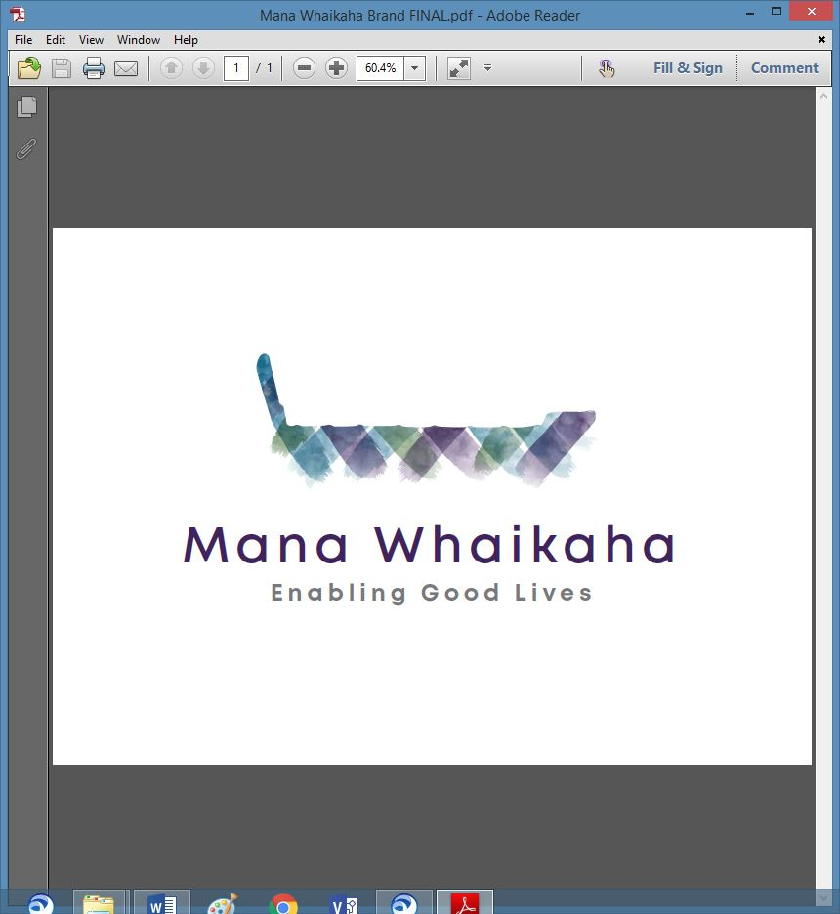

**MidCentral Governance Group**

**Minutes of the meeting held on Thursday 27 January 2022**

|  |  |
| --- | --- |
| **Attendees:** | Peter Allen (Chair), Lorna Sullivan (Co Chair), Rachel Kenny, Martin Sullivan, Rasela Fuauli, Pip Brunn, Angela Hobden, Peter Ireland, Aroha Lowe, Rachael Burt and Toni Griffiths |
| **Apologies:** | Mana Whenua representation |
| **In attendance:** | Jo Brew |
| **Venue:** | Via Zoom |
| **Time:** | 10.30am – 2.30pm |

**Karakia**

The Chair opened the meeting with karakia. Members then gave a brief update on recent EGL related matters. Points of note were:

* The first core group meetings for the year have just been held or are about to be.
* The provider sector plans to develop an employment strategy to share current and anticipated staffing shortage issues due to vaccination mandates and omicron.
* Concern about the danger of losing sight of the intention of Enabling Good Lives (EGL) and the focus of system transformation at this crucial point in the system transformation as disabled people may lose any control/voice they may have had as services go into the hands of the public service.
* Experience of the difficulties in recruiting staff for a family member.

**Previous Minutes/Notes**

The minutes of the previous meeting held on Thursday 16 December 2021 were taken as a true and correct record.

**Peter Allen/Rachel Kenny**

The action points were updated and will be reflected in the February agenda.

**Transition Plan/Strategic Planning Update**

The group appreciates the significance of strategic planning for organisational development and identified pre-requisite discussions and priorities for inclusion in a planning session. A strategic planning session will be arranged for late February 2022.

***Action: Invite Establishment Unit, Transition Unit and System Transformation Leads to attend the February MGG meeting together. (Jo)***

***Action: Engage facilitator and arrange strategic planning session. (Chair)***

**Resignation**

Aroha Lowe, Family Core Group representative resigned from the group due to personal reasons. She expressed her gratitude for the opportunity to contribute to MidCentral Governance Group and looks forward to supporting Enabling Good Lives from a different region. The Chair thanked Aroha for her service.

**Info: System Transformation Update** (Erin Black)

Erin’s key updates included:

* The Connector Handbook has been endorsed and ready for production. The handbook provides a framework resource for the Connector workforce.
* Leadership Review project – a preliminary report has been submitted. Insights from the review will inform the programme, operating model design and capacity and capability plans.
* The Establishment Unit’s key appointments are starting their new roles hence foundational relationships for working effectively across units can begin.
* Discussions around national capability and commissioning development for other communities have begun.
* A paper outlining options for an operating model is in development.

Other matters discussed included:

* Building and developing local leadership groups is on System Transformation’s priority list and are anticipated to begin within the financial year.
* Oversight or influence of disabled people on the previously mentioned initiatives and projects occurs through the endorsement process for MoH work deliverables to go via the appropriate Enabling Good Lives governance groups and Te O Mārama, the realignment in strengthening connections with leadership groups and making sure feedback loops through networks are effective.
* A member highlighted concerns regarding policy and procedural impacts on disabled people accessing their rights and responsibilities as a direct result of safeguards being established for staff relating to covid. Erin will initiate a connection for the MidCentral Governance Group (MGG) member to discuss the EGL approach to residential and covid complexities in the current environment.
* Inequities in identification of disabled person/long term illness and long term disability and one causing the other and the rules, regulations and criteria regarding their disability were discussed.

***Action: Ask MoH to consider bringing people (as above) under Supportlinks and long term illness under the EGL approach. (Erin)***

***Action: Chair & Co-Chair Mana Whaikaha, Deputy Director General Disability, System Transformation Lead, Transition Unit and the Establishment Unit meeting to be arranged to discuss future operating model of Mana Whaikaha Ltd. (Erin).***

**Board Matters**

**Governance Policies for review**

**November**

**Governance Policy: Board Code of Conduct**

* Point 6 - Remove ‘Association’ replace with ‘organisation’
* Add review date.

**December**

**Governance Policy: Chairpersons Role**

* Point 3 – Change ‘To’ to ‘They may”
* Point 8 - Remove ‘MoH’ replace with Ministry for Disabled People and remove ‘in order’
* Add review date.

**Governance Policy: Annual Planning**

* No change.

**All agreed to the reviewed decisions**

**Info: Director Report** (Rachael Burt)

Rachael tabled her report with the additional points:

* The team’s transition from the holiday period into the omicron environment.
* Recruitment process for 9 roles begins tomorrow.
* The team has been divided into 4 self-managing teams with overall positive feedback. Designed to be collaborative and support wellbeing.
* Confirmation has been given to Ministry of Health (MoH) to proceed with the extension of MGG contracts beyond end of June 2022.
* A suggestion was made to MoH for an evaluation be done within the community to check on the effectiveness of governance and leadership groups and whether both should be included in national scaling.
* The first draft for moving to independent premises will be circulated prior to the February MGG meeting for feedback and submission to MoH.
* Still seeking full clarification for actual operational budget.
* Budget comparisons were discussed.
* Upcoming meeting with MoH staff to determine their reporting requirements.

**Executive Limitations for review (November & December)**

**Executive Limitations: Global Executive Constraint Policy**

* Clarified the expectation that Rachael was to inform the group if a conflict or issue had occurred.
* No change – add review date.

**Executive Limitations: Compensation & Benefits**

* No change – add review date.

**All agreed to the review decisions**

**General**

* The Governance Group section of the Mana Whaikaha website has now been updated with current information received regarding interest register and member profiles and all meeting minutes.
* Funding for the Mana Whaikaha December team building event – Jasmine to be contact with Peter Allen next week.
* The merits of an evaluation of effectiveness of the Governance Group were discussed further.

The meeting ended with karakia and closed at 2.43pm.

**Practical matters**

**Date of next meeting:** Thursday 24 February 2022 at 10.30am in the PSA Lounge, 198 Cuba Street, Palmerston North (or Zoom).

**I confirmed** that these minutes constitute a true and correct record of the proceedings of the meeting

DATED this 24th day of February 2022



**Peter Allen**

**Chair, MidCentral Governance Group**