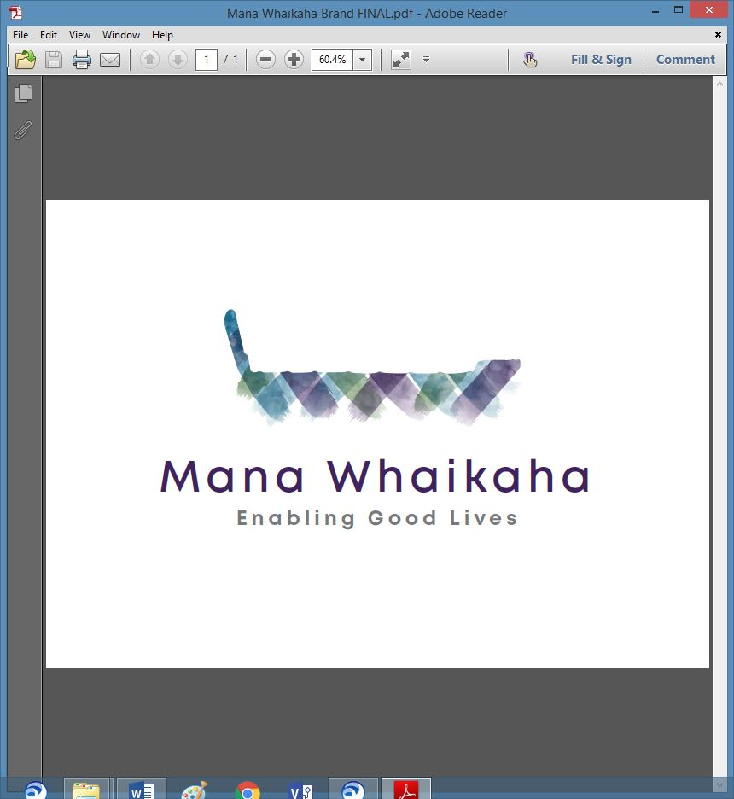

**MidCentral Governance Group**

**Minutes of the meeting held on Thursday 24 June 2021**

|  |  |
| --- | --- |
| **Attendees:** | Peter Allen (Chair), Martin Sullivan, Maxine Dale, Rachel Kenny, Pip Brunn, Angela Hobden, Peter Ireland, Rasela Fuauli, Vinnie Vaccarino, Rachael Burt and Aroha Lowe and Oriana Paewai |
| **Apologies:** | Lorna Sullivan, Joseph Tyers |
| **In attendance:** | Zandra Vaccarino and Donna DeCleene (Meeting Assistants), Jo Brew (Secretariat) |
| **Venue:** | PSA Building, 198 Cuba Street, Palmerston North |
| **Time:** | 11.00 – 3.00pm |

**Karakia**

Peter opened the meeting with a karakia.

**Information: Evaluation Outcome Project (Dr Pauline Boyle – Principal Advisor, System Transformation Disability – MOH)**

Pauline attended the meeting by phone. Pauline has been leading the evaluation monitoring analysis in this workstream and summarised the baseline evaluation work carried out by Standards and Monitoring Service (SAMS) in the past month.

The recent baseline study is a repeat of the one done completed 3 years ago prior to the start of Mana Whaikaha. Over 160 people were originally interviewed and most of those have participated again. People have been keen to engage with interviewers and have shared their ideas and struggles, and where needed have been encouraged to engage again with Mana Whaikaha. There is a particular interest in the outcome of how things are going for people using flexible disability support contracts which will help inform the use of flexible funding in the future and indicate Providers readiness in moving towards a person directed approach within a transformed system. The results and summary are expected to be published and delivered to the Minister of Health by the end of September.

**Previous Minutes**

The previous minutes and notes of the meeting held on Thursday 27 May 2021 were taken as read and were a true and correct record.

**Angela Hobden/Peter Ireland**

**Correspondence**

**Inwards**

* Email received on 1.6.21 from Lorna Sullivan to MGG members with reference to the meeting Peter Allen and Lorna had with Adri Isbister and James Poskitt on Monday 31 May 2021.

**Discussion: Julie Hook (System Transformation Lead, Disability Directorate - MoH)**

Julie attended the meeting by phone, her update included:

* Work continues around the scaling of DSS nationally and machinery of government with papers being prepared for presentation to Ministers Sepuloni, Tinetti and Little over the coming months.
* Upcoming work includes looking at the process of engaging, connecting and gathering feedback from different groups such as leadership and Te o Marama, developing a budget bid and investment plan around driving change in the long term.
* Working with Governance Group around communications and messaging as some key messages have been approved for release to various networks and groups in the next week.
* A multiyear approach for capacity and capability is in development with information being compiled to send out to leaderships groups around supporting leaderships networks.

Julie acknowledged the support she has received from leadership and Governance Groups over the past 11 months in her role and looks forward to taking the EGL approach forward into her new role. On behalf of Governance Group, Rachael Burt thanked Julie for her work and the values and expertise she brought to disability support services over the past 11 months and wished her well in her new role.

**Discussion: Essential Workers Rights/PSA Letter Matter (Melissa Woolley and Andrea Fromm – PSA)**

Melissa (Assistant Secretary) and Andrea (Policy Advisor) attended the meeting via zoom.

The group was given a brief summary of the history of the workforce working group and the matters requiring clarification today around the ongoing issues in disability services resulting from lack of funding in the sector. These issues are:

1. Lack of commitment and realisation of secure and decent work for workers in disability support services.
2. Lack of training opportunities to retain and attract new workers to this sector (also important to meet increased need for future services).
3. Lack of a piece of quantifiable information in order to evaluate and assess the ongoing process and impacts on workers during the disability transformation implementation.

The disestablishment of the workforce working party in early 2020 was another concern as 3 programmes of work that had been agreed to by the group had ceased to exist, these were:

1. Incentives related to service providers to not be constrained in their ability to providing new models of services and incentives to create opportunities for workers to attend training and ensure disabled people are not constrained in their ability to access supports that best meet with need.
2. Sharing of information to make informed decisions.
3. Practice of all stakeholders involved is focused on raising quality and continuous improvement across the system.

There are plans to meet with the Minister early in July to raise these concerns and seek commitment from the Ministers, officials and other stakeholders to secure and decent work and conditions for support workers, possibly procurement processes and suggest investment in training opportunities to attract and retain workers in this sector, monitor the workforce and see the workforce working group be re-established.

An assurance was given that the PSA are supportive of EGL principles and recognise their need for implementation across the sector regardless of roles. Gaps due to the lack of an employment hub for accessing training or support for workers and employers where they are employment relationship breakdowns was also discussed.

The PSA intend on making their position very clear to Ministers and will not support national rollout until the above matters are rectified.

The Governance Group gave their support to the PSA for the implementation of the principles, objectives, outcomes and activities of the working group, the reestablishment of the working group and the start up of an employment hub in this region. Funding was briefly discussed.

The group also agreed that the Director and Governance Group members use their roles to advise MoH in these matters and that Governance Group would support the Director by putting in a separate submission.

**Action: Rachael and Peter Ireland will meet to discuss and develop their understanding, the gap and a resolution with MoH.**

**Information: Director Report (Rachael Burt – Mana Whaikaha)**

Rachael tabled a written report, additional comments were:

* Estimated personal budget costs are based on 2017 figures therefore unlikely to be accurate so has asked MoH to compare tracking against other regions.
* The Mana Whaikaha team have given and signed their permanent contracts.
* Peter Ireland was scheduled to visit and talk with the team in early July.
* Rachael was advised the Governance Group had agreed to purchasing community database software.

**Information: Website Review (Leigh Rowe – Project Lead – Mana Whaikaha)**

Leigh joined the meeting and gave an update on the Website Review project:

* An illustration of the mock-up for the home page, explanations and site map was circulated and explained.
* The review had developed into a bigger project than anticipated.
* There is the possibility to create a space for people to be linked to providers websites.
* A member suggested reflecting diversity by including Maori, Pasifika, sign language and Easy Read within the site.
* Rachael sought approval to get the foundation of the website up and running and then build on this. MGG agreed to this proposal.

**Action: Jo will send the background to the weave and logo to Leigh.**

**Te Tihi Recommendations (Leigh Rowe – Project Lead – Mana Whaikaha)**

Leigh asked about MGG’s thoughts on the Te Tihi recommendations and if there was a strategic plan. It was confirmed the strategic plan was in development and Te Tihi’s recommendations would help Governance Group move forward and inform the intention of the planned changes. Rachael and Leigh identified some of the recommendations already in progress and will complete a stocktake of those and include in July reporting.

There was a brief discussion about the implementation phase and Te Tiriti partnership; what this looks like moving forward and the understanding this requires thinking about, discussing and demonstrating different understandings, asking questions and having conversations to learn and develop an understanding of relationships and partnerships. This will also form part of the strategic plan.

**General**

* Pip shared above the extra $20 for disability supports **will** be offset against their temporary additional supports and this might be a good question to put to the Minister.
* Apologies in advance from Oriana for the July meeting.
* The was a request that future meetings be held between 10.30am – 2.30pm. The group agreed to change the times if the venues allow flexibility.

**The meeting closed at 2.50pm.**

**Practical matters**

**Date of next meeting:** Thursday 22 July 2021 at 10.30 am in the EASIE Living Conference Room, 585 Main Street, Palmerston North.

**I confirmed** that these minutes constitute a true and correct record of the proceedings of the meeting

DATED this 22nd day of July 2021



**Peter Allen**

**Chair, MidCentral Governance Group**