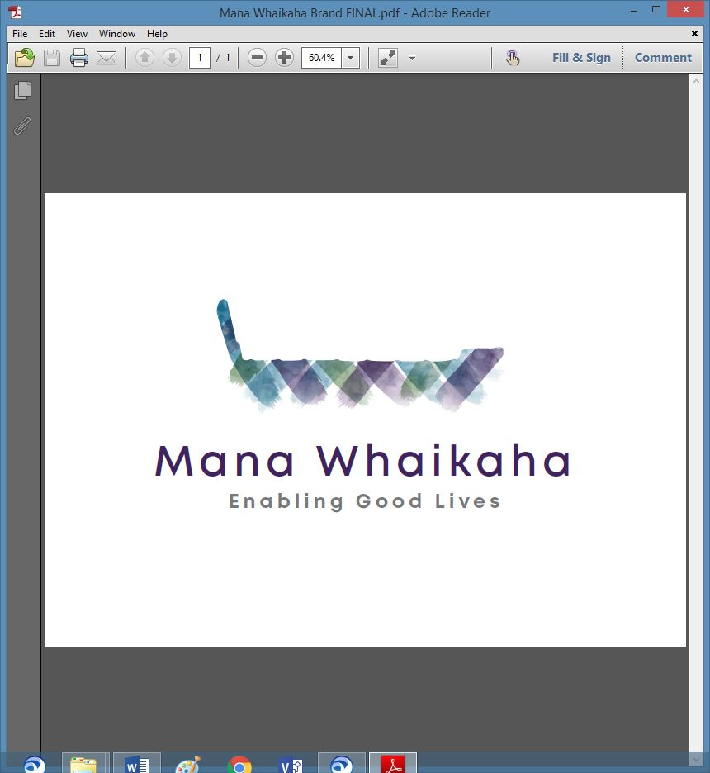

**MidCentral Governance Group**

**Minutes of the meeting held on Thursday 24 September 2020**

|  |  |
| --- | --- |
| **Attendees:** | Peter Allen (Chair), Heather Browning (Deputy Chair), Martin Sullivan, Rachel Kenny, Angela Hobden, Maxine Dale, Rasela Fuauli, Pip Brunn and Peter Ireland |
| **Apologies:** |  |
| **In attendance:** | Sandy Ryan, Jo Brew |
| **Venue:** | Conference Room, PSA Offices, 198 Cuba Street, Palmerston North |
| **Time:** | 11.00am – 3.00pm |

# **Karakia**

**Minutes and notes of the previous meeting**

The member meeting notes, and minutes of the previous meeting held on 20 August 2020 were accepted as a true and correct record.

**Peter Allen/Heather Browning**

**Discussion: Julie Hook and Hannah Kerr – Ministry of Health**

Julie Hook, Programme Lead, System Transformation and Hannah Kerr, Disability Policy Manager from Ministry of Health (MoH) attended the meeting.

Julie updated the group in developing her new role; she has been focusing on relationships and making connections with networks, learning about the work that has been done to date around co-design and the prototype and looking to the future and the evidence supporting the future direction.

Hannah explained the focus of her role and explained the engagement model for system transformation advice and presented a revised high-level timeline for advice to Ministers so the Governance Group could better understand the processes that shape the briefing papers.

**Information: Director’s Report – Lorna Sullivan**

Lorna’s verbal report included an update about the change management process. While progress is slow, MoH staff have been reassigned into roles and the appropriate paperwork is underway. Finalisation of the MoH/Enable New Zealand contract and Enable’s change management and have also contributed to the slow recruitment process. Advertisements for a number of unfilled roles will go live within the next week. A staff retreat for those already recruited to the new Mana Whaikaha team has been arranged for 1 and 2 October and will include a statement of affirmation and a code of professional practice.

Others matters included in the Lorna’s report were:

* delegations are being negotiated and will be trialled incrementally
* a capability funding investment paper has been sent to the Leadership Group – a response is yet to be received
* concern that the Connectors role will be under resourced and
* Lorna request the Governance Group consider developing a reporting framework for Mana Whaikaha to use.

**Information: MidCentral Governance Group Budget**

The budget for Mana Whaikaha Limited is nearly complete. The Governance Group are keen to learn what the MoH’s key performance indicators are for auditing purposes.

**Discussion: Decision Document Mana Whaikaha**

The decision document was received by the Governance Group. This document was presented to the Mana Whaikaha team on 20 August. We briefly discussed the difficulties of the change management process, the outcome and the recruitment process. Enable New Zealand’s change management proposal dovetailed on top of Mana Whaikaha’ s.

The Governance Group stressed their desire to be involved in the recruitment process of the Director’s role and will formalise this request to Ministry of Health.

**Inwards Correspondence**

* Email with the decision document Mana Whaikaha attached received on 21 August 2020 from Virginia Wilton, Change Manager, System Transformation - MoH

**Discussion: Terms of Reference**

The group discussed the possibility of changing the composition of the Governance Group to include 2 new seats, one for Mana Whenua and one for Pasifika.

Maxine Dale put forward the motion that

* The MGG co-opts 2 more members to the MGG group

This motion was unanimously accepted.

Peter Allen put forward the motion that

* The 2 new member representation would be 1 Mana Whenua disabled person and 1 family whanau member.

This motion was unanimously accepted.

Peter Allen put forward a motion that:

* He writes to the Minister seeking to change the composition as stated in the terms of reference to include 3 disabled persons, 2 whanau, 1 service provider, 1 Mana Whenua and 1 Pasifika.

This motion was unanimously accepted.

A discussion about how future meetings will be run will be deferred until the November meeting.

**Information: Director’s Report – Marshall TeTau**

Marshall gave his last verbal report to the meeting.

* As the Tari team will be disestablished on 30 September 2020 transition is underway so supports would remain in place.
* Marshall is leading the service specifications change for Enable New Zealand.
* Whilst staff have been stressed during the past month, they have continued to give good service ensuring the disabled person is not disadvantaged during the change.
* The Tari team is working on quality handover reports and the operational draft is being reviewed by the MoH’s legal team at present.

On behalf of the group, Peter Allen expressed thanks and appreciation to Marshall for the hard work he has undertaken in leading the Tari team over the past 2 years.

# **Practical matters**

# **Date of next meeting:** Thursday 22 October 2020 at the EASIE Living Conference Room, 585 Main Street, Palmerston North.

**The meeting closed at 3.00pm**

**I confirmed** that these minutes constitute a true and correct record of the proceedings of the meeting

DATED this 22nd day of October 2020



**Peter Allen**

**Chair, MidCentral Governance Group**

**Footnote:**

After the meeting, it was decided by email voting on 9 October that the 3 motions above be put on hold until further discussions take place.