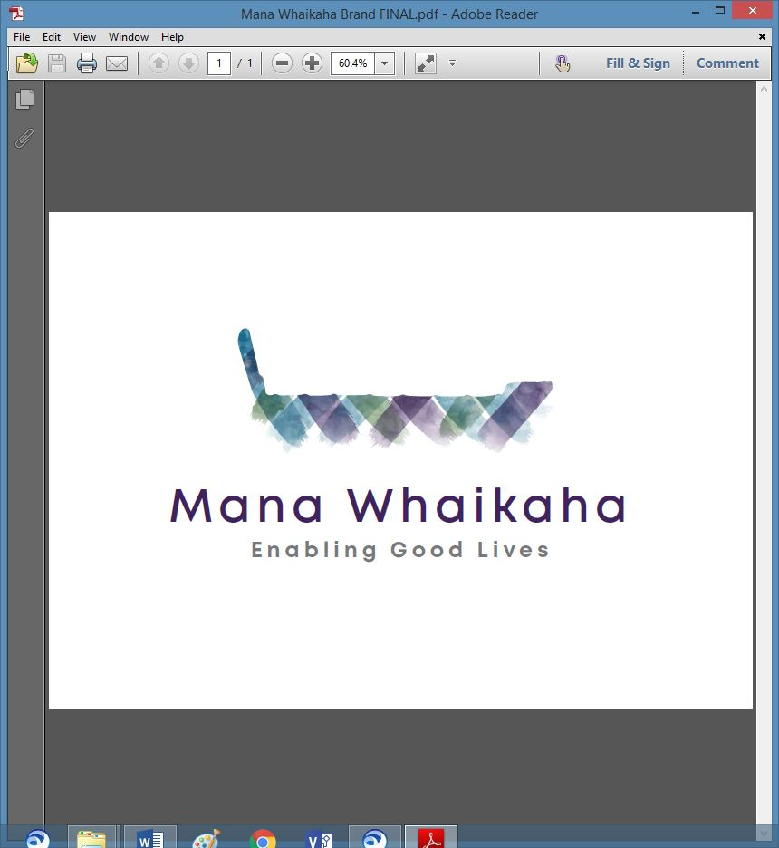

**MidCentral Governance Group**

**Minutes of the meeting held on Thursday 25 February 2021**

|  |  |
| --- | --- |
| **Attendees:** | Peter Allen (Chair), Martin Sullivan, Maxine Dale, Rachel Kenny, Pip Brunn, Angela Hobden, Peter Ireland, Rasela Fuauli, Joseph Tyers, Vinnie Vaccarino and Lorna Sullivan |
| **Apologies**  **Absent:** | Peter Ireland (late)  Robyn Richardson |
| **In attendance:** | Sandy Ryan, (meeting assistant), Zandra Vaccarino (meeting assistant), Jo Brew (secretariat). |
| **Venue:** | The Lounge, PSA Building, 198 Cuba Street, Palmerston North |
| **Time:** | 11.00 – 3.00pm |

# **Karakia**

**Minutes of the previous meeting**

Martin requested an alteration to his comment under ‘General’ ensuring accuracy.

The minutes were accepted as a true and correct record, as amended.

**Peter Allen/Angela Hobden**

**Action Points**

1. Peter and Rachael met and discussed forming a Sensitive Expenditure Committee to support the Director with sensitive expenditure matters. An up to date register will be compiled and presented to the MidCentral Governance Group (MGG) for their information. The Committee will comprise of Director, Senior Connector and Chair of MGG. **Completed**
2. Julie Hook to send copies of reports, background papers and draft implementation plan to the group. **Completed**.
3. Jo to invite Pauline Boyes to the March meeting to speak about the Outcomes Evaluation. **Carried over**
4. Jo to invite Specialist Connector to February meeting. **Completed**
5. Jo to invite Pikihuia Hillman to February meeting. **Completed**
6. Angela to write to the Minister re financial statements – **carried over to March meeting.**

**Correspondence**

* **Outwards**
* Email 8.2.21 from Peter Allen to Oriana Paewai and Di Rump seeking Mana Whenua representation on the MidCentral Governance Group.
* Email 12.2.21 from Peter Allen to Lorna Sullivan seeking indication of interest to become Co-Chair on the MidCentral Governance Group.
* **Inwards**
* 10.2.21 from Di Rump to Peter Allen confirming support for Robyn Richardson to become Mana Whenua rep in the interim.
* 11.2.21 from Julie Hook to MGG – health report and background papers to Minister for the group.

**General Discussion**

Peter Allen called for an extra MGG meeting to be arranged within the next 4 – 6 weeks to discuss:

* MGG reporting requirements from Mana Whaikaha including financials
* Strategic transition planning.

Lorna recommended ‘Reinventing your Board’ by John Carver as a resource to assist with reshaping the governance role for the future.

***Action: Peter will engage a facilitator to lead a workshop to help the group develop strategy, reporting and governance.***

Heather Browning joined the meeting.

**Information: Mana Whenua Engagement (Pikihuia Hillman, Project Manager and Materoa Mar – Te Tihi)**

After introductions Pikihuia and Materoa presented an update of the Mana Whenua Engagement project which included information about the project background, planning, workshops and outcomes to date. A draft copy of the Discovery Findings document ‘Me he pitau whakarei’ (‘Forging the path’) was tabled. This document brings together information from both whanau and kaimahi with service measures to better understand the service, disability sector landscape and wider cross-sectorial environment, its challenges, and opportunities in the development of a Maori-centred approach for Mana Whaikaha.

Discussion points:

* Martin asked about the recommendations, discovery and the low number of people who engaged. Te Tihi do plan to re-engage through one to one contact to whanau who participated in the first series of workshops.
* Peter asked about kaimahi involvement - findings for workshop 1 were optimistic, for workshop 2 they were less optimistic. Findings also indicated a lack of consistency of practice.
* Pikihuia will forward the ‘Forging the path ‘draft document to the group for their information only.
* The importance of building support and embracing change for disability in this area.
* Lorna expressed thanks on behalf of the group for the action orientated work Te Tihi has done in getting many people together, shaping the findings so MGG can think about the next stage of re-engagement in Enabling Good Lives (EGL)/co-design.

***Action: Jo to invite Pikihuia and Materoa to the next meeting.***

Peter Ireland joined the meeting.

**Information: Transition Planning Project (Heather Browning - Project Lead)**

Heather gave a brief update about her new role:

* The project scope has been agreed to by Ministry of Health (MoH)
* The purpose of the Mana Whaikaha transition project is to undertake the initial work needed in preparation for an RFP / procurement process to transition the current Mana Whaikaha prototype to a fully operational service entity, that is disabled people and tangata whaikaha led.
* a project steering group will be set up, meetings scheduled, and regular reporting delivered to MGG
* will meet with Mana Whaikaha leadership tomorrow around engagement with people
* Heather wishes to withdraw as shareholder of Mana Whaikaha Ltd as believes remaining so would be a conflict of interest in her new role.
* Maxine Dale has replaced Heather as a director of Mana Whaikaha Ltd
* transfer can be made by completing a share transfer form
* we agreed Peter A ask the Leadership group to suggest a replacement shareholder.
* As there are 3 sets of shares available Peter A will let Disabled Persons Assembly and the Leadership group know. We discussed having clear director and shareholder role guidelines – Angela will do.

Martin and Heather left the meeting.

**Discussion: Julie Hook (System Transformation Lead - Ministry of Health)**

Julie joined the meeting, points of note from the update were:

* a reminder about the health report submitted to Minister Little late December, Ministry of Social Development’s report to Minister Sepuloni and the Transition Unit’s initial paper and that System Transformation had signalled working towards a more detailed paper for March around a detailed implementation plan.
* A significant, high level meeting was held this week to develop the decisions for the cabinet paper due in March. The outcome is the cabinet paper is not necessary, the preference is now to look at further design work for what the new entity could look like with a wider scope beyond disability support services.
* A paper is due in March from the Transition Unit regarding future changes.
* Budget bids have been submitted:

1. To move the 3 EGL sites out of pilot into business as usual including additional funding to support a national plan around disabled people’s authority, capability, capacity and building networks, and workforce and provider capability
2. funding for full transformation

* Development of an implementation plan for scaling EGL at a national level within input from the community will begin.
* Change management, engagement and comms approach is critical for people and families.
* Planning a 4-month work programme is underway. This will provide an opportunity to undertake a review of current governance and leadership across the sites for key learnings.
* Lorna asked about the implementation plan; how the bigger piece of work and Mana Whaikaha would align. Julie talked about working with EGL sites, Directors, and the Mana Whaikaha transition project assisting with alignment.
* Comms due out next week to signal to people where things are at.

There was a discussion about EGL not being a ‘thing’ but rather an approach and a change of system relying on strong leadership.

Rachael Burt joined the meeting.

**Information: Specialist Connector Role (Luisa Moce)**

Luisa gave an overview of her role and how it fits into the new structure.

* As Specialist Connector, Luisa manages and is a part of ‘on call’ roster, she works in situations requiring a higher level of support around safeguarding, and where there is a need for deeper, long term planning for disabled people and their whanau.
* There are 6 Specialist Connectors sharing the load for ‘on call’. The Specialist Connectors meet each Monday for a handover meeting regarding on call matters.
* The ‘on call’ phone use varies from week to week (e.g. this week 12 calls were received) and receives all varieties of calls, i.e. late notice discharge from hospital, change of circumstances of support. Been a lot quieter over the past 2 months.
* Workload – at present is ok; some ‘on call’ needs require a lot of support so juggling the current workload is needed at times. The bigger team is working well sharing the workload of the on-call phone generated work.
* Luisa is currently working alongside 158 people, this includes those who are self-connecting, some who touch base from time to time and those who she is actively working with at present.
* Luisa was asked “how responsive is the sector to the on call?” It is not responsive, especially regarding quickly deteriorating conditions which require a lot of time or connector engagement, i.e. motor neurone.
* Maxine asked about people needing accommodation, as Ryder-Cheshire has had a room in a flat available for 3 months and has not received any enquiries. Is there someone keeping an eye on the people under 65 who are in elder care.
* Going forward there will be connector allocated to working with people in residential.
* New connectors are seeing things with hope, are excited to explore, and have big ideas - has made a difference to Luisa.

**Information: Director Report (Rachael Burt - Mana Whaikaha)**

Rachael tabled a written report to the Governance Group. Points discussed were:

* Budget advisors are supporting Enable New Zealand staff with payments until the Enable staff are properly trained in the processes and software.
* The service improvement team started on Monday, this has already created and identified a significant amount of work around systems or lack of and cultural aspects of the team.
* Rachel Kenny asked for an update around the comms strategy.
* The website is still down but Enable New Zealand will upload and host. Mana Whaikaha has updated this, and it’s now gone to Comms at MoH sign off before uploading.
* (**Note**: After the meeting Rachael Burt notified that the website update hadn’t yet been completed and was not at sign off stage. This had been confused with another piece of work.).
* Training is being provided for staff around how to gather the information for good stories.
* Rachael was asked how much of the overspend is due to extra numbers of people rather than extra budgeting for those already being supported. Rachael informed the group it was due to a huge rise due to the increase to DSS funding (and people moving into the area) and the impact of COVID for additional or new supports during that time.
* Rachael has delegated financial authority but is unsure of the amount.
* Rachael requested feedback and/or direction for future reporting.

The meeting closed at 3.00pm

# **Practical matters**

# **Date of next meeting:** Thursday 25 March 2021 11.00 am in The Lounge, PSA Building, 198 Cuba Street, Palmerston North

**I confirmed** that these minutes constitute a true and correct record of the proceedings of the meeting

DATED this 25th day of March 2021



**Peter Allen**

**Chair, MidCentral Governance Group**