MidCentral Governance Group
Minutes of the meeting held on Thursday 25 July 2019
Attendees: | Peter Allan (Chair), Martin Sullivan, Rachel Kenny, Rasela Fuauli, Heather Browning (Deputy Chair), Angela Hobden, Maxine Dale, Zandra Vaccarino
Apologies: | Peter Ireland
In attendance: | Sandy Ryan (meeting assistant), Jo Brew, Amy Evanson (secretariat)
Venue: | EASIE Living Centre, Conference Room, 585 Main Street, Palmerston North
Time: | 11.00 – 3.00pm

Karakia

Evaluation: Try, Learn and Adjust Cycle 1
The MidCentral Governance Group participated in a focus group lead by evaluators from Allen + Clark that will be part of the gathering of insights for the Try, Learn and Adjust Cycle 1.

Feedback: Review of the Enabling Good Lives governance and leadership groups
The paper was taken as read.

The MidCentral Governance Group supported increasing the diversity of perspectives and want the EGL Governance Group to have the majority of members disabled people.

Information: Operational update from Mana Whaikaha Directors
Lorna Sullivan provided an overview of the key success to date. These include:
- lots of really good stories such as families feeling like they have much greater control and getting better outcomes
- Mana Whaikaha engaging with around 2,050 people
- Processes are being refined so the response to disabled people is quicker.

Feedback: Machinery of Government voices paper
The paper was taken as read.
Feedback on the paper was provided to the Ministry of Social Development.

Practical matters

Date of next meeting: Thursday 22 August 2019, 11.00 am, EASIE Living Conference Room, 585 Main Street, Palmerston North

I confirmed that these minutes constitute a true and correct record of the proceedings of the meeting

DATED this 3rd day of December 2019
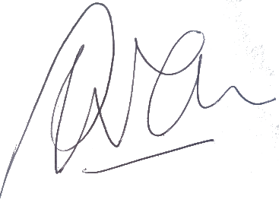

Peter Allen
Chair, MidCentral Governance Group

