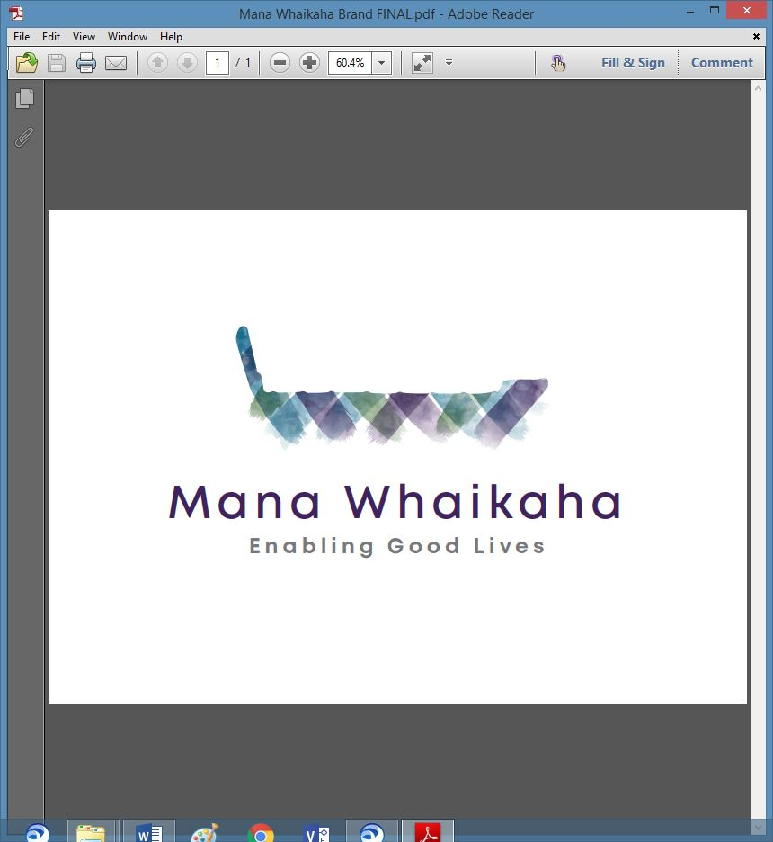

**MidCentral Governance Group**

**Minutes of the meeting held on Thursday 25 June 2020**

|  |  |
| --- | --- |
| **Attendees:** | Peter Allan (Chair), Heather Browning (Deputy Chair), Martin Sullivan, Rachel Kenny, Peter Ireland, Angela Hobden, Maxine Dale, Rasela Fuauli, Pip Brunn |
| **Apologies:** |  |
| **In attendance:** | Sandy Ryan, Jo Brew |
| **Venue:** | Conference Room, EASIE Living Centre, 585 Main Street, Palmerston North |
| **Time:** | 11.00am – 3.00pm |

# **Karakia**

**Minutes of the previous meeting**

The minutes of the previous meeting held on 28 May 2020 were accepted as a true and correct record.

**Peter Allen/Maxine Dale**

**Discussion: Ministry of Health Recommendations Update**

Paul Miller, Principal Adviser – System Transformation, Ministry of Health (MoH) and Rawa Karetai, Communications Director – COVID 19 Disability Response, MoH attended the meeting.

Paul confirmed:

* the MidCentral Governance Group (MGG) recommendations were received, considered and read
* there is an intention that James Poskitt, General Manager Strategy, Policy and Performance, Disability – Ministry of Health, Michelle Riwai, General Manager – Enable New Zealand and Peter Allen, Chair – MGG continue to meet to discuss and shape the response and work together to implement some of the recommendations
* a formal response from the MoH is pending
* Mana Whaikaha staff have been offered a 3-month contract extension to 30 September 2020,
* it was understood that the MGG has recommended structural change and this would require a consultation period and a contract extension for the Director to support the change process.

The process for submitting recommendations to the Minister were clarified for the group. The short to medium term goal of the MGG supporting Mana Whaikaha moving toward autotomy and operational independence was discussed.

**Discussion: Health & Disability System Review**

Paul Miller and Rawa Karetai remained present for this discussion.

Martin Sullivan, MGG member gave an overview of the feedback he had received from the community. The review had been met with some dismay and a belief that there had been no input from disabled people and there was no disabled person representation on the review committee. It had appeared to some that there will be a revamped NASC system with some Enabling Good Life (EGL) principles tacked on/promoted within the health sector. Martin advocates disability does not belong under health. The review discusses the social model of disability then changes to the medical model (impairment and effects of according to health issues). It is recognised the review is intended as advice to the Minister and changes would be unlikely to happen before the election and any changes afterwards would need to be legislative.

We are concerned the outcomes that disabled people deserve are not being delivered as the report appears to consolidate the status quo. We need to think about our message, our position and the best way to reflect this as we have an opportunity to advise. We agreed Martin and Heather would compose a response to appropriate Ministers.

**Programme Lead Recruitment Update**

Paul advised recruitment for the vacant Programme Lead role was still underway.

**Discussion: Michelle Riwai – General Manager, Enable New Zealand**

Michelle was welcomed to the meeting and a round of introductions were made.

We discussed the current state of Mana Whaikaha, this included the current contract extension and new contract between MoH and Enable New Zealand, embedding EGL principles across Enable New Zealand, the consultation and change management process that is required as part of moving towards the new model and the partnering and delivery of information for reporting. We agreed on the need for clarity of contract requirements such as services, deliverables and outcomes.

We also discussed Mana Whaikaha’ s mid to long term goal that the prototype moves toward Mana Whaikaha Limited, an autonomous and operationally independent entity.

**Discussion: Early Investment Paper – Lorna Sullivan**

Lorna updated the group on the progression of early investment initiatives:

* The agreements with Te Tihi to provide the framework for a culturally competent service delivery model and a training programme for a minimum of 2 connectors have been prepared.
* APM Workcare Limited has begun development of a framework for working with micro enterprises.
* Other initiatives in the pipeline include working in return for alternatives to monetary rewards and encouraging thinking about the power of 10.

**Information: Director’s Report – Lorna Sullivan**

Lorna’s report included the challenges of the current state of Mana Whaikaha:

* The limited timeframe (1 July - 30 September) to prepare for structural changes.
* Without contract completion and succinct budget information is it difficult to develop the communications and consultation plan, change process or recruit. Current resourcing is challenged, and current staff are beginning to look elsewhere for roles.
* Lorna and Marshall will staff informed of progress by sending out communications on a weekly basis.

Peter Ireland offered to speak with staff who are PSA members to gather feedback about their concerns.

Lorna talked about the positive changes and good stories that are occurring for disabled people despite the internal challenges.

**Information: Director’s Report – Marshall Te Tau**

Marshall’s report included:

* Half of the team have been focusing on end of financial year business.
* Mana Whaikaha chose not to submit a claim to MoH for additional expenses due to COVID as the incurred costs were nominal.
* Obtaining a very clear understanding of the guidelines around the changes to FFC.
* Resourcing matters.
* Ongoing support for D365 users.

**Information: Financials – Angela Hobden**

Angela circulated the forecasted budget report before reporting:

* Maxine, Martin, Peter Allen and Pip had met recently to discuss finances in anticipation of managing the MidCentral Governance Group and Leadership Group budgets. The Deaf Consumers, Family, Mana Whenua and Pasifika groups were also incorporated into the forecasted budget.
* Angela gave an overview of the budget spreadsheet explaining estimated current costs and new costs and reasonings such as a financial and administration support roles and travel.

In response to the report, the group agreed:

* Angela would open a bank account for Mana Whaikaha Limited in anticipation of receiving managed funds.

**Information: Budget Accountability – Pip Brunn**

Pip tabled the budget accountability paper which details outcomes supporting EGL principles. This will accompany the budget submission to MoH.

**Outwards Correspondence**

* Letter dated 28 May 2020 sent to Chair, MidCentral District Health Board re disabled person representation on decision making boards.

**General Business**

* As Rachel’s 2-year term as People Fire NZ representative ends on 30 June 2020, she asked the MGG to support her application for an extension of her role. The group agreed unanimously.
* Rachel asked the group what her personal liability as a Mana Whaikaha Director would be. This information is needed for her report to the National committee. Rachel was reminded she was a shareholder, not a Director and in that role, there is nil personal liability. The two Directors are Peter and Heather.

# **Practical matters**

# **Date of next meeting:** Thursday 23 July 2020, 11.00am at the PSA Premises, 198 Cuba Street, Palmerston North.

**The meeting closed at 3.00pm.**

**I confirmed** that these minutes constitute a true and correct record of the proceedings of the meeting.

DATED this 23rd day of July 2020



**Peter Allen**

**Chair, MidCentral Governance Group**