MidCentral Governance Group
Minutes of the meeting held on Thursday 27 June 2019
Attendees: | Peter Allan (Chair), Martin Sullivan, Rachel Kenny, Rasela Fuauli, Peter Ireland, Heather Browning (Deputy Chair), Angela Hobden, Maxine Dale
Apologies: | Zandra Vaccarino,
In attendance: | Sandy Ryan (meeting assistant), Jo Brew, Amy Evanson, Virginia Wilton (secretariat)
Venue: | EASIE Living Centre, Conference Room, 585 Main Street, Palmerston North
Time: | 11.00 – 3.00pm

Karakia

Discussion: MidCentral Governance Group work programme
The MidCentral Governance Group discussed how to develop their focus and work programme, particularly in relation to having financial oversight of the prototype. The key themes emerging from the discussion were:

- How to manage the workload of connectors

- How to make sure providers are taking up the opportunities of a transformed disability support system

- Early investment in children and young people

- Focus on people who have not engaged with the disability support system before.

Information: Operational update from Directors
Lorna Sullivan and Marshall Te Tau joined the meeting for a discussion about current issues. The focus of the discussion was on how to support people in residential care, and how to support providers do things differently.

Decision: Early investment priorities for 2019/2020
The paper was taken as read.
The MidCentral Governance Group agreed to recommend to the Minister for Disability Issues and Associate Minister of Health that the early investment priorities that guide funding decisions for the 2019/2020 financial year could be:
- achieving a safe, sustainable and appropriate accommodation situation, independent of residential care

- investing early in responses to challenging behaviour (including broader responses)

- building a broader informal support network

- building and achieving the potential of disabled children and young people

- improving employability, or employment status of disabled people.

The MidCentral Governance Group will send a report to the Ministers seeking their endorsement of these recommendations.

Practical matters

Date of next meeting: Thursday 25 July 2019, 11.00 am, EASIE Living Conference Room, 585 Main Street, Palmerston North

I confirmed that these minutes constitute a true and correct record of the proceedings of the meeting

DATED this 3rd day of December 2019

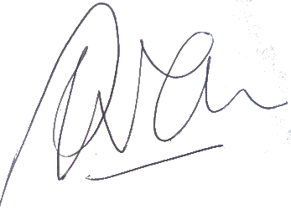

Peter Allen
Chair, MidCentral Governance Group

