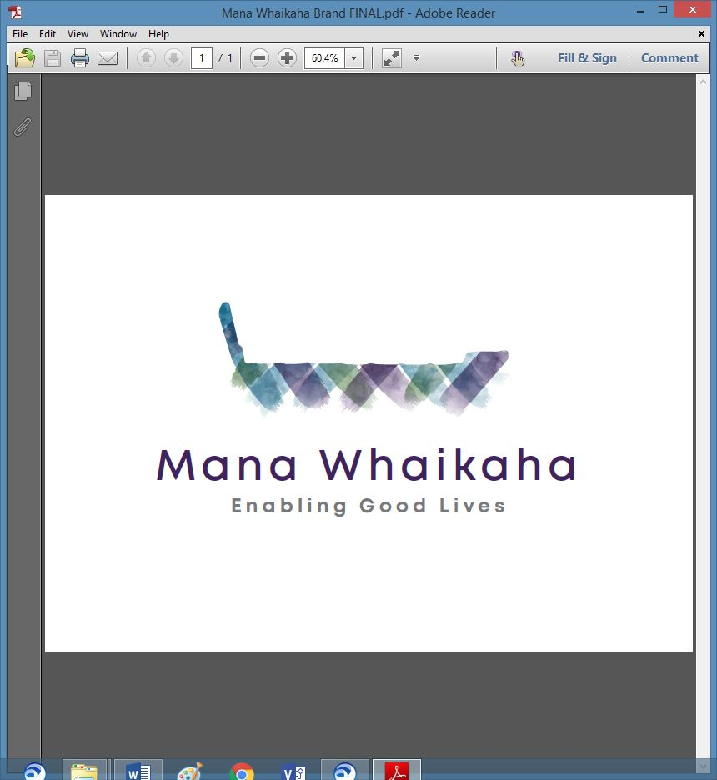

**MidCentral Governance Group**

**Minutes of the meeting held on Thursday 27 May 2021**

|  |  |
| --- | --- |
| **Attendees:** | Peter Allen (Chair), Martin Sullivan, Maxine Dale, Rachel Kenny, Pip Brunn, Angela Hobden, Peter Ireland, Rasela Fuauli, Vinnie Vaccarino, Lorna Sullivan, Rachael Burt and Aroha Lowe and Oriana Paewai |
| **Absent:** | Joseph Tyers |
| **In attendance:** | Zandra Vaccarino and Sandy Ryan (Meeting Assistants), Jo Brew (Secretariat) |
| **Venue:** | PSA Building, 198 Cuba Street, Palmerston North |
| **Time:** | 11.00 – 3.00pm |

**Karakia**

Peter opened the meeting with a karakia. The group then welcomed Oriana Paewai who will be attending future meetings as Mana Whenua representative. A round of introductions were done.

**Previous Minutes**

The previous minutes and notes of the meeting held on Thursday 22 April 2021 were taken as read and were a true and correct record.

**Peter Allen/Angela Hobden**

**Correspondence**

**Inwards** – None received.

**Outwards**

* Letter sent 5.5.21 to Adri Isbister and James Poskitt requesting a meeting with Peter Allen and Lorna Sullivan to discuss Governance Group matters.

**Information: Transition Project Update (Heather Browning)**

Heather gave a verbal report on the project work to date:

* Due to changes between December and now including the changes within the Health and Disability Sector the project scope has been agile.
* Heather has been collaborating with Mark Brown, Consultant for MoH (Ministry of Health) who is also working on an Enabling Good Lives (EGL) project.
* Is developing a service description for Mana Whaikaha which will define ethos/spirit/intent of entity supporting an EGL approach and support the development and strength of governance.

The group discussed the recently released budget figures and what this might mean for Mana Whaikaha in the future, budgets, and the development of Te ao Māori.

Peter Ireland took this opportunity to circulate the following documents:

* Disability System Transformation (NZDSN update April 21)
* NZDSN/DSS Joint Work Programme and
* Disability and Accessibility – Wellbeing Budget 2021

**It was noted the first 2 documents are in draft and not for circulation outside of this meeting.**

**Action: Invite Heather to present an update at the July meeting.**

**Discussion: Essential Workers Rights/PSA Letter (Peter Ireland – PSA Organiser)**

Peter proposed 2 of his colleagues from Wellington be invited to attend the June meeting to talk to the paper submitted at the May meeting. This opportunity would provide further information, clarification and education before the group gave their final feedback on this matter.

The group unanimously agreed to the above proposal.

**Action: Peter to arrange invitation of colleagues to attend June meeting.**

**Discussion: Board Matters**

Lorna led this discussion to develop the statements/strategic goals of the Mana Whaikaha Board.

The group revised Statement 1 and 2 from the tasks outlined in the May meeting:

**Statement/goal 1**

*Mana Whaikaha exists so that disabled people can exercise choice and control in the pursuit of what a good life looks like to them.*

**Statement/goal 2**:

*Our moral owners, the people we serve, are disabled people and their whānau, in the Mana Whaikaha rohe.*

*In this regard we give priority to the personal authority and agency of disabled people. We define whānau as those who stand in solidarity with disabled people and we undertake our mission by maximising all available funding and utilizing the skills benefits and opportunities within the community.*

*We do not do this at the cost of disabled people.*

*We do not do this at the cost of workers.*

After some discussion around the meaning and inclusion of ‘whānau’, the group agreed to include a second statement in task 2:

*“Mana Whaikaha also has a responsibility to whānau to support*

*their capacity to sustain good life for their whānau and disabled family member”*

The group also agreed task 3 be altered to remove the word *‘funding’* and replace with *‘resources’*.

**Action: Lorna will recraft the statements and circulate to the group.**

**Information: Directors Report (Rachael Burt)**

Rachael presented a written report to the meeting:

* 34 new engagements in the past month; 28 were under 20.
* Mana Whaikaha D365 tenant was successfully migrated to the Enable New Zealand tenant – this provided an opportunity to data cleanse and should provide greater accuracy for future reporting.
* The Connector team’s workload remains high; an experienced practitioner has recently started as an independent connector.
* The team will be attending personal professional development meetings with Rachael over the 2 – 3 weeks.
* A business case for resourcing post 30 June is being prepared for presentation to MoH.
* Engagement and relationship building have increased with invitations to the leadership group being extended to attend practice/training opportunities with the team.
* The Sensitive Expenditure Team has met twice.
* A high cost pathway panel for packages over A$180k has been developed.
* The overspend on personal budget remains a concern but do expect the balance at the end of the year to reflect a different, lower figure.

**Information: Website Review (Leigh Rowe)**

Deferred until June meeting (due to illness).

**Discussion: Te Tihi Recommendations**

The group discussed the first step they wish to take regarding the Te Tihi project recommendations:

* The Maori centered approach gives specific key points to consider and use as guides to honour people when making decisions, implementing, and operationalizing things. Could also be used when reporting back to Tangata Whenua.
* The group agreed a broader perspective giving a wider representation of Te ao Māori voice would be pursued.
* The group agreed to call a hui engaging Maori currently connected with Mana Whaikaha and those who are not connected. This will provide an opportunity for the group to listen to the wider Maori voices that are not being heard and/or who’s needs are not being met.

**Discussion: Policy Framework and Perpetual Agenda (Lorna Sullivan)**

Lorna led this discussion:

* She has developed a set of executive and government policies and a perpetual agenda and will take the draft documents to next Monday’s meeting when she and Peter meet with Adri and James.
* If these are accepted at the meeting, Lorna will send the documents to the group.

**General**

There was no general business to discuss.

The meeting closed at 3.01pm.

# **Practical matters**

# **Date of next meeting:** Thursday 24 June 2021 at 11.00 am in PSA Building, 198 Cuba Street, Palmerston North

**I confirmed** that these minutes constitute a true and correct record of the proceedings of the meeting

DATED this 24th day of June 2021



**Peter Allen**

**Chair, MidCentral Governance Group**