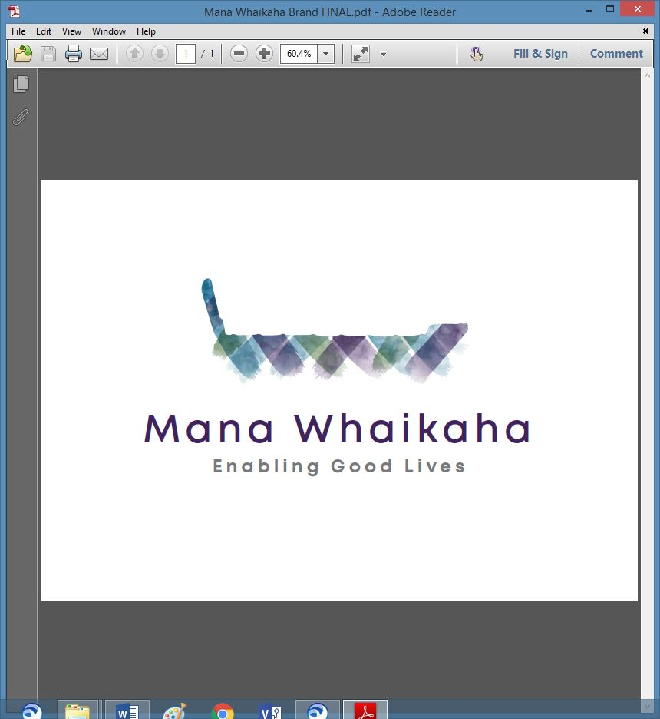

**MidCentral Governance Group**

**Minutes of the meeting held on Thursday 28 January 2021**

|  |  |
| --- | --- |
| **Attendees:** | Peter Allen (Chair), Martin Sullivan, Maxine Dale, Rachel Kenny, Pip Brunn, Angela Hobden, Peter Ireland, Rasela Fuauli and Joseph Tyers. |
| **Apologies:** | Vinnie Vaccarino |
| **In attendance:** | Sandy Ryan, (meeting assistant), Jo Brew (secretariat). |
| **Venue:** | EASIE Living Conference Room, 585 Main Street, Palmerston North |
| **Time:** | 11.00 – 3.00pm |

# **Karakia**

**Minutes of the previous meeting**

Alter minutes to reflect that Angela was not present for the December meeting otherwise a true and correct record.

**Peter Allen/Maxine Dale**

**Action Points**

Outstanding action points from 2020 were reviewed and updated:

* Sensitive Expenditure
* We agreed a subcommittee be formed with Director, Senior Connector and MGG representation by either the Chair or the Co-Chair to share consideration/approval and decisions recorded.
* Peter Allen to write to James Poskitt recommending additional membership to MidCentral Governance Group for 1 Pasifika and 1 Mana Whenua representative and to appoint a Co-Chair to replace Heather Browning.

**Try, Learn Adjust Recommendations**

The group reviewed the progress of the Try, Learn Adjust recommendations:

*Recommendation 1: Realign the structure of Mana Whaikaha to give effect to one line of authority to review and restructure the functions and roles so that Mana Whaikaha more effectively serves the interests of disabled people as well as aligning with the intent of the prototype.*

* Achieved - through restructure process reducing to one reporting line from Director, Mana Whaikaha to System Transformation Lead to Group Manager, Strategy, Policy & Performance, Disability.

*Recommendation 2: Identify whether the EGL vision, principles and approach are contributing to changing the practices and behaviours of government officials, providers, the workforce, and wider community within the MidCentral region.*

* In progress - large area to evaluate. To discuss with Julie Hook. Check on where responsibility to evaluate lies; this may require funding for sector engagement. Discuss further with the Regional Leadership Group.

*Recommendation 3: Work with mana whenua to expand their use of the capacity building fund, including expanding connections with whânau Ora.*

* In progress – mana whenua hauora representation anticipated early 2021; capacity funds are being used to establish a new charitable trust to provide a kaupapa maori provider service - the trust will be supported and assisted by Te Tihi.

*Recommendation 4: Substantively invest in support workforce development and training to align with the Enabling Good Lives vision, principles, and approach.*

* On hold – the disestablishment of the national workforce group has meant this is currently in limbo.

*Recommendation 5: Embed the EGL vision, principles, and approach in Ministry of Health contracts as well as evaluation and monitoring processes*

* Actioned – this has come through via Standards and Monitoring Services (SAMS) and been embedded into contracts.

*Recommendation 6: Substantially expand investment in capacity building for disabled people, their families and whānau***.**

* In progress – more capacity funding has been allocated (though not increased) – we need to look at how this is being done and how effectively this is being done.

**Discussion: Julie Hook (System Transformation Lead - Ministry of Health)**

Julie presented a verbal update to the meeting, this included information about:

* recommendations and planning for the ongoing development of the transformation of disability support services, moving the 3 Enabling Good Lives sites from pilot to a longer-term baseline and planning for implementation at a national level
* the Transition Unit’s role in progressing with improving outcomes for the health of disabled people in connection with the Health & Disability System Review
* planning for capacity and capability including workforce development, working with families, communications, branding, and change approach
* an update of the Outcomes Evaluation; a lead has been appointed and the scoping of the baseline evaluation has begun.

**Information: Director Report (Rachael Burt - Mana Whaikaha)**

Rachael presented a verbal update to the meeting which included:

* the Business Analyst role begins 25 February – this should assist with more detailed and informed reporting to the governance group
* approval received to recruit a Business Improvement person to develop and document process, procedures, and accountabilities from entrance to exit, for structure and to minimise gaps – hopeful for a February start date
* no other recruitment is planned.
* Enable New Zealand and Mana Whaikaha are building positive relationships; 2 staff have been employed to process payments and recruitment is underway for the remaining roles to provide support to Mana Whaikaha.
* Enable New Zealand is supporting Mana Whaikaha with maintenance of the website. The material needs to be reviewed and updated by Mana Whaikaha before the site is refreshed.
* Work has begun on what an EGL approach is from a system – connector – facilitation point of view and this is expected to be developed further into guidelines to share in a national rollout.
* Practice Manager is planning practice meetings, once completed invitations will be extended to the governance group.

**Information: Senior Connector Role (Lisa Willey)**

Lisa gave an overview of her role and how it fits into the new structure:

* The Senior Connectors are leading the 2 Connector teams, the 2 Connector Supports and the Budget Advisors.
* New staff have contributed a fresh dynamic to the team and relationships have improved across the team with the new, one reporting line.
* The last Specialist Connector is due to start on 1 February.
* As Lisa’s role has changed, she is reducing the amount of people she connects with as the Connectors need support and mentoring. Lisa will continue to connect with some people with high and complex needs.
* Overall, with the new team formation, there are less delays in processing, reduced doubling handling between the 2 teams and sitting together in a dedicated workspace is beneficial to working relationships within Mana Whaikaha.

**Correspondence**

* **Outwards**
* Email sent from Peter Allen to Julie Hook on 21.12.20 re website resourcing, support, and ownership.

**General**

* Mark Benjamin’s connection with SAMS was discussed.
* Martin suggested Angela, as Ministerial Appointment write directly to the Minister re the difficulty in tracking the financials due to lack of financial information.
* Maxine commented that written reports would be appreciated.
* Jo to invite a Specialist Connector to the February meeting.
* Jo to invite Piki from Te Tihi to attend the February meeting (overview of the Mana Whenua Engagement project).

The meeting closed at 3.00pm

# **Practical matters**

# **Date of next meeting:** Thursday 25 February 2021 11.00 am in The Lounge, PSA Building, 198 Cuba Street, Palmerston North

**I confirmed** that these minutes constitute a true and correct record of the proceedings of the meeting

DATED this 25th day of February 2021



**Peter Allen**

**Chair, MidCentral Governance Group**