MidCentral Governance Group
Minutes of the meeting held on Thursday 28 March 2019
Attendees: | Peter Allan (Chair), Martin Sullivan, Rachel Kenny, Rasela Fuauli, Peter Ireland, Heather Browning (Deputy Chair), Angela Hobden, Maxine Dale
Apologies: | Zandra Vaccarino,
In attendance: | Janet Doughty (meeting assistant), Jo Brew, Virginia Wilton (secretariat)
Venue: | EASIE Living Centre, Conference Room, 585 Main Street, Palmerston North
Time: | 11.00 – 2.00pm

Karakia

Governance Training
John Page, a member of Boardworks, joined the meeting as part of the ongoing governance training.

Decision: Phase two provider capability plan

The paper was taken as read.

MidCentral Governance Group deferred some decisions from previous meeting from this paper.

MidCentral Governance Group agreed that the decisions in this paper were not at the strategic level, and asked that the paper be resubmitted for their consideration. The new paper needs to reframed and focused at governance level and address the following:
- a clear problem definition supported by evidence
- the options to address the issue
- the assumptions behind the options
- clear indication of what will be different if an option is implemented
- how will we know what is different and when.

Information: Mana Whaikaha Directors
Lorna Sullivan and Marshall Te Tau gave an update on the success and challenges.

Practical matters

Date of next meeting: Thursday 14 March 2019, 11.00 am, EASIE Living Conference Room, 585 Main Street, Palmerston North

I confirmed that these minutes constitute a true and correct record of the proceedings of the meeting

DATED this 3rd day of December 2019
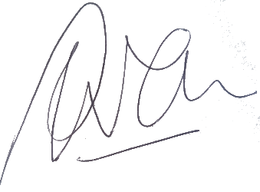

Peter Allen
Chair, MidCentral Governance Group

