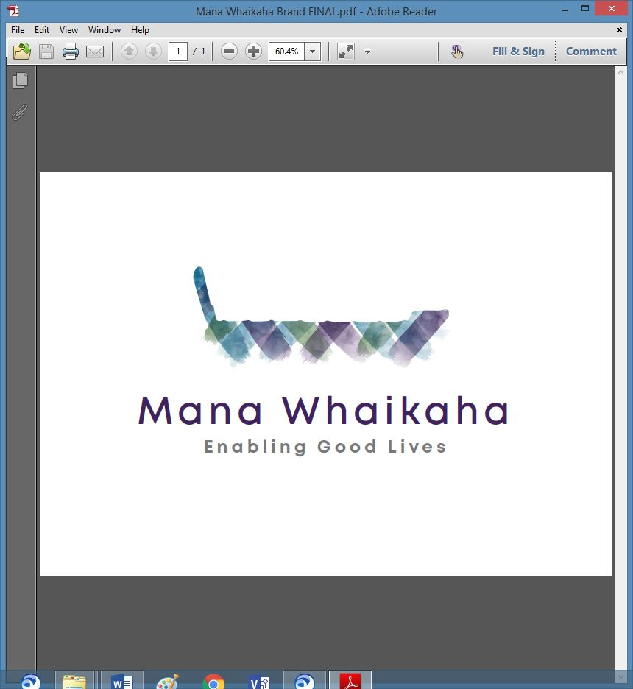

**MidCentral Governance Group**

**Minutes of the meeting held on Thursday 28 October 2021**

|  |  |
| --- | --- |
| **Attendees:** | Peter Allen (Chair), Lorna Sullivan (Co Chair), Martin Sullivan, Rachel Kenny, Pip Brunn, Angela Hobden, Peter Ireland, Rasela Fuauli, Rachael Burt, Aroha Lowe and Toni Griffiths |
| **Absent:** | Oriana Paewai from 11.45am |
| **In attendance:** | Jo Brew |
| **Venue:** | Focal Point Events Room, 233 Cuba Street, Palmerston North |
| **Time:** | 11.00am – 3.00pm |

**Karakia**

Peter opened with a karakia followed by members giving a brief update on the past month. Matters to note:

* Due to the covid mandate and vaccination related workers matters there is a possibility of a shortage of support workers in the near future.
* A new Mana Whenua representative is likely to attend future meetings supporting Oriana as she focuses on other commitments.

**Discussion: MoH Leadership/Core Group Review Project** (Gail Munro, Project Lead)

Gail introduced herself and the Core Group Review project to the group.

The intent of the project is to build a shared understanding of the journey of the Enabling Good Lives and Mana Whaikaha voice, leadership and governance arrangements and processes.

The questions asked were about the the whakapapa of Mana Whaikaha Governance Group and the members thoughts about scaling in Aotearoa:

* How was Mana Whaikaha Governance Group established?
* What were the challenges you experienced, and what worked well?
* How were the voice and leadership of the Regional Leadership and Core Groups heard by Mana Whaikaha Governance Group?
* What resources and support have been beneficial for you?
* How do you know your voices are heard at a national level by NEGL and Whanau Ora Interface Group?
* What challenges and opportunities do you see for EGL Governance Groups in the future? How do you think the leadership and voice of Mana Whenua, Leadership and Core Groups can influence the ways EGL governance could be scaled across Aotearoa?

The session was an open discussion with members contributing their knowledge and individual experiences of the journey of their representation of their groups to the MidCentral Governance Group today.

Gail plans to return early next year to share the insights gathered from interviewing across the 3 EGL sites.

**Board Matters**

**Trust Deed**

* It was proposed removing the sentence referring to Trustees being local members only so that assistance may come from outside the area where development and skill matrix requirements are needed.

**Agreed to by those present**

* Regarding the number of Trustees, it was proposed changing the wording to “no less than 7 and no more than 12”.

**Agreed to by those present**

* The cost of Governance, inclusion of groups to be represented and groups missing were briefly discussed.

**Info: Director Report** (Rachael Burt)

Rachael tabled a written report. Matters discussed included:

* Working on a practice model within covid environment and including the ‘traffic light framework’.
* Mandatory vaccinations and the implications on staffing, disabled people and whānau, support workers, monitoring and safeguarding.
* Resourcing
* Sector Liaison and Operations Manager recruited
* Business case for 9 new positions awaiting signoff.
* Procurement for new premises.
* Enable New Zealand contract matters.
* D365 updates.

**Discussion: Te Tihi Recommendations – MW Stocktake** (Pikihuia Hillman, Project Lead, Te Tihi)

Pikihuia joined the meeting with the understanding today’s discussion would include the recommendation document to understand how Te Tihi are to progress if an implementation plan required or if the project at a close.

Discussion points:

* The Mana Whaikaha stocktake has been completed and will be reviewed by Governance in alignment with the annual plan.
* The ‘clinical training’ recommendation would align better with the EGL approach if framed using the word ‘health’ and would be best addressed as a practice matter, i.e. building relationships with disabled people and whānau to understand the challenges (of diagnosis).
* It was proposed to amend the ‘clinical training’ recommendation as a practice matter, reshaping to a social model context for induction and training for Connectors.

**Agreed to by those present**

* Martin Sullivan would be an appropriate facilitator to deliver social model training to staff.
* The stocktake has assisted with the development of the Board’s 5 year strategic plan and recommendations can be scheduled for review as regular agenda items at future meetings.

The Chair expressed the groups appreciation to Pikihuia and Te Tihi for undertaking the project.

**Info: System Transformation Update** (Erin Black/James Poskitt)

Erin talked of the chains of communications leading up to ‘tomorrows announcement’ and a comms pack will be distributed post announcement to support the Group.

James updated included:

* Invitations to the ‘announcements’ have been sent out
* leaving his current role and to begin a new job on Monday 2 November.

The Chair expressed the groups thanks and appreciation for the work James did in his current role supporting the transformation of disability support services.

**Inwards Correspondence**

* Response received from Minister Little re Workforce Working Group (via email 27.9.21).

**Previous Minutes/Notes**

The minutes and notes of the meeting held on 23 September 2021 were taken as read and are a true and correct record.

**Angela Hobden/Rachel Kenny**

**The meeting closed at 3.00pm**

**Practical matters**

**Date of next meeting:** Thursday 25 November 2021 at 10.30am in a venue yet to be confirmed.

**I confirmed** that these minutes constitute a true and correct record of the proceedings of the meeting

DATED this 25th day of November 2021



**Peter Allen**

**Chair, MidCentral Governance Group**