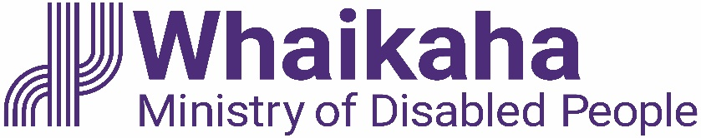
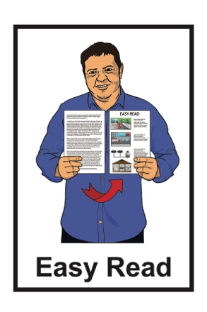

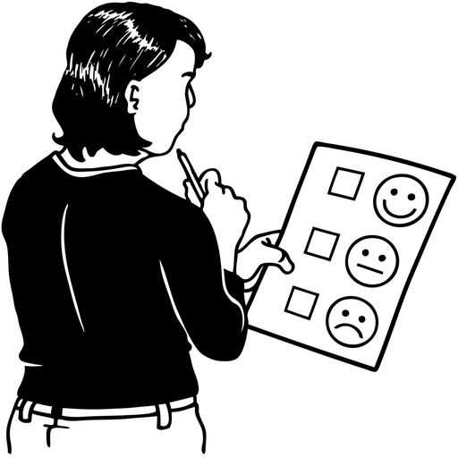
Key messages from the

Mid Central repeat survey

Easy Read published: March 2023

What you will find in here

Page number:
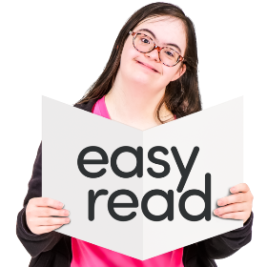

What this document is about? 3

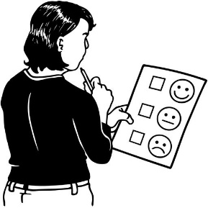
About the survey 6

Survey findings 8
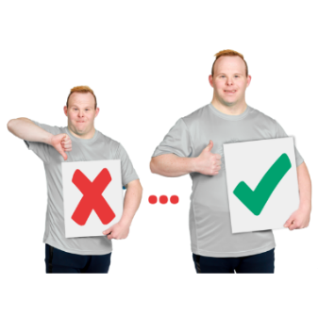

What things need to be done
better? 11

Where to find more information 13

What is this document about?

This Easy Read document is about a survey that the Standards and Monitoring Service did in 2021.

A survey is a way of finding out information by asking people questions.

The Standards and Monitoring Service / SAMS is an organisation that:
- does education about disability

- does research about disability

- is run by disabled people.

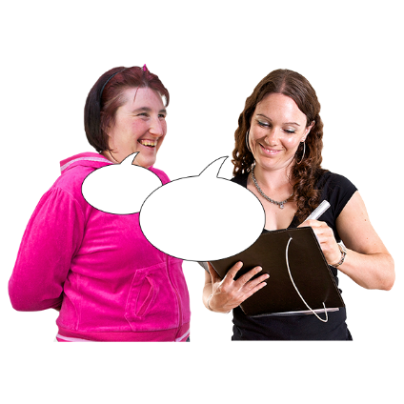
Research is:

- looking at what things have happened

- trying to find out how to do things better.

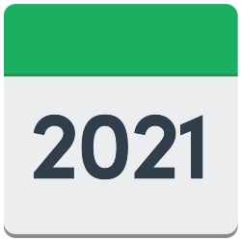
In 2021 SAMS did a survey with some people who use Mana Whaikaha services in the Mid Central region.

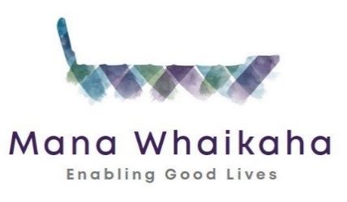
Mana Whaikaha is a disability support service who have been working in an Enabling Good Lives way since 2018.

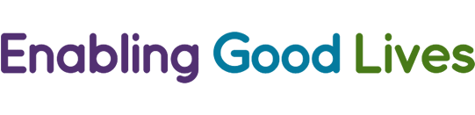
Enabling Good Lives is a different way of thinking about disability support.
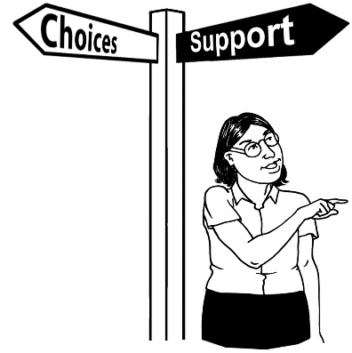

Enabling Good Lives is about having:
- choice and control in your life
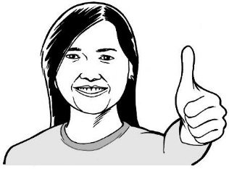
- the support you need and want
- a good life.

Enabling Good Lives is called EGL for short.

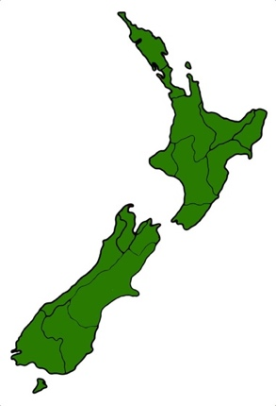
The Mid Central region includes:
- Palmerston North

- Horowhenua

- Manawatu

- Ōtaki

- Tararua.

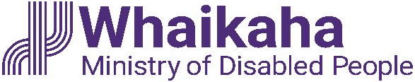
Whaikaha – Ministry of Disabled People will use the survey findings to make disability support services better for everyone.

About the survey

The 2021 survey was a repeat of a survey that was done by SAMS in 2018.

Repeat means to do something again.

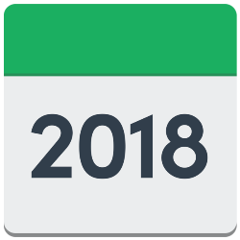
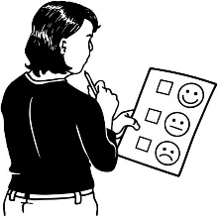
The 2018 survey looked at the experiences of disabled people before EGL.

The 2021 survey looked at what has changed after the start of EGL.

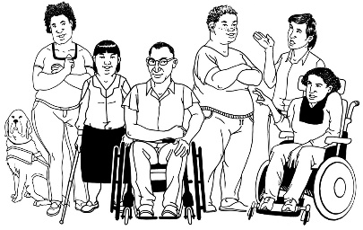
Many people who were part of the 2018 survey were also part of the 2021 survey.
The 2 groups that were part of the 2021 survey were:

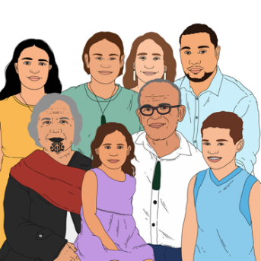
- 1 hundred and fifty four disabled people

- 1 hundred and thirty four whānau / family members of disabled people.

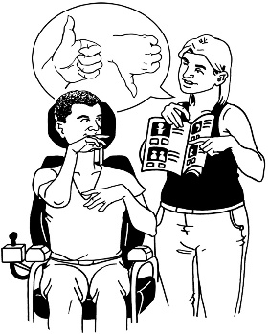
The 2021 survey looked at what changes there have been for disabled people and their whānau / family who get disability supports.

Survey findings

The 2021 survey findings showed that people felt things have gotten better since the 2018 survey.

The things that got better are that disabled people felt:

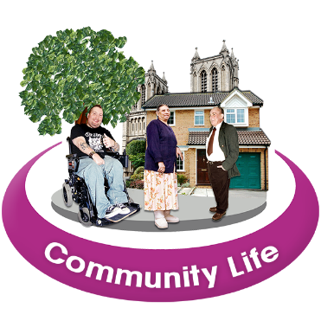
- they had more choice of the kind of support they got

- more connected / part of their community.

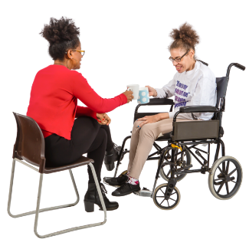
People with Kaitūhono / Connectors felt they were able to make more choices about where their support money was used.

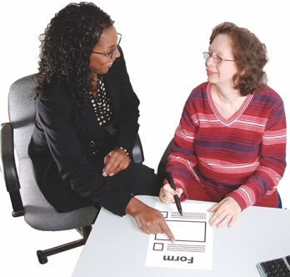
A Kaitūhono / Connector is someone who supports you to:

- think about your plans

- use your EGL money

- find organisations that may be useful for you.

Some people who used support services still had some problems.

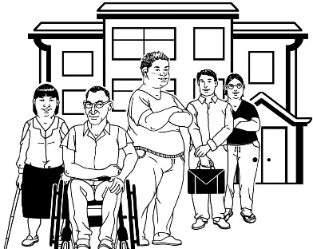
Over half of the people who used residential support services were not happy with the support they got.

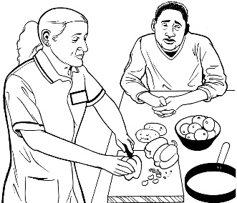
Many people in home and community services were also unhappy with some their support staff.

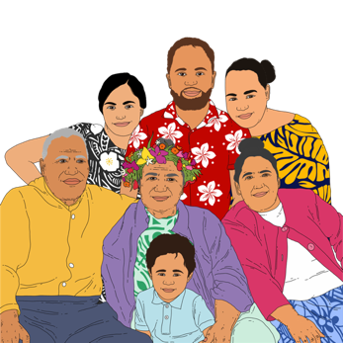
The 2021 survey findings also showed many whānau / family felt they:

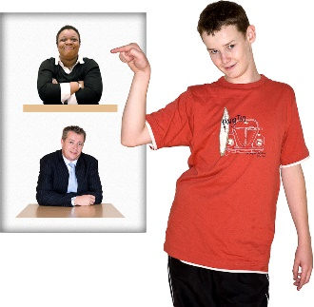
- had more choice over how their support money was spent

- had more choice over the supports they got
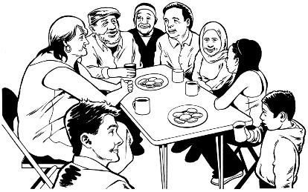
- could connect better / be a part of with their community

What things needs to be done better?

The 2021 survey found there are some things that need to change so that support services better for everyone.
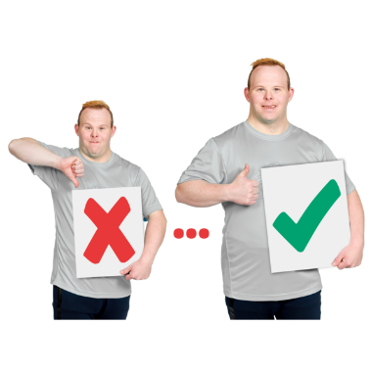

These changes need to fit in with the way that Enabling Good Lives works.

These changes include making sure:

- Kaitūhono / Connectors have the support they need to do their job well
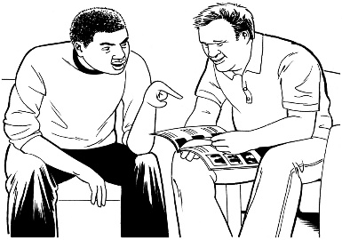
- disabled people / whānau have clear information about supports and services.

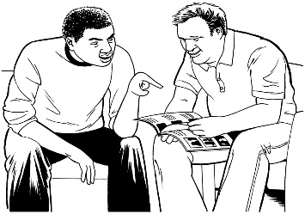
The information needs to:

- meet the needs of each person
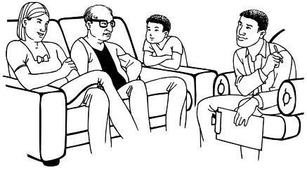
- support disabled people / whānau with planning their supports and services
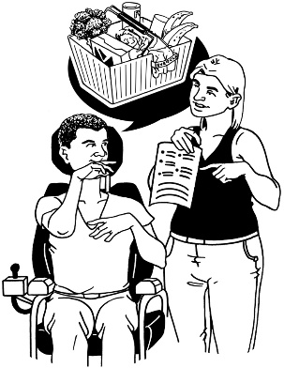
- allow disabled people / whānau to have more control over their supports and services.

There also needs to be:
- more information about how EGL works
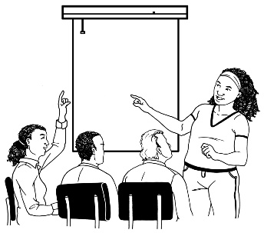
- more training for people who work in disability support services so that they work in a way that supports EGL.

Where to find more information

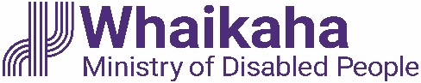
You can find more information about disability support services on the Whaikaha – Ministry of Disabled People website:

www.whaikaha.govt.nz

You can find more information about EGL on this website:

www.enablinggoodlives.co.nz

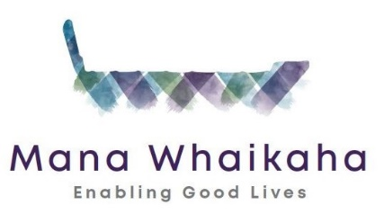
The Mana Whaikaha website also has Easy Read information about EGL principles:
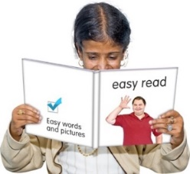
www.manawhaikaha.co.nz/assets/easy-read/EGL-vision-and-principles-Easy-Read.pdf
This information has been written by SAMS and Whaikaha – Ministry for Disabled People.

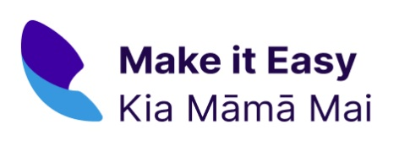
It has been translated into Easy Read by the Make it Easy Kia Māmā Mai service of People First New Zealand Ngā Tāngata Tuatahi.

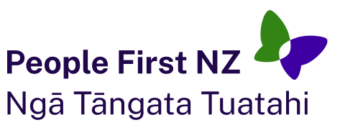
The ideas in this document are not the ideas of People First New Zealand Ngā Tāngata Tuatahi.
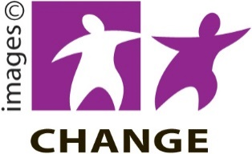
Make it Easy uses images from:

- Changepeople.org

- Photosymbols.com

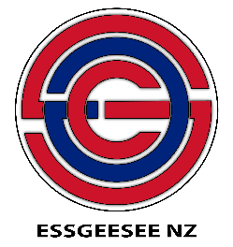
- SGC Image Works

- Huriana Kopeke-Te Aho.

All images used in this Easy Read document are subject to copyright rules and cannot be used without permission.

