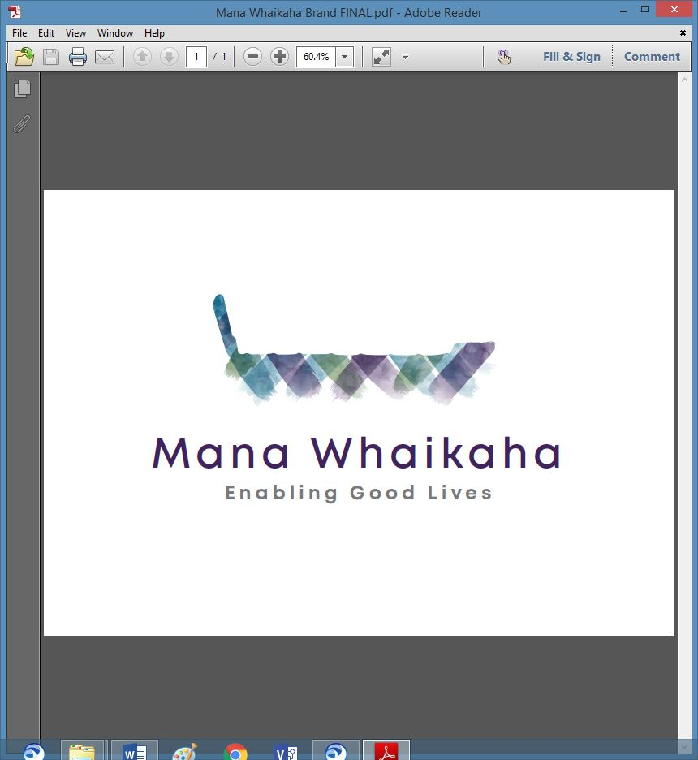

**MidCentral Governance Group**

**Minutes of the meeting held on Thursday 16 December 2021**

|  |  |
| --- | --- |
| **Attendees:** | Peter Allen (Chair), Lorna Sullivan (Co Chair), Rachel Kenny, Martin Sullivan, Rasela Fuauli, Pip Brunn, Angela Hobden, Peter Ireland, Aroha Lowe, Rachael Burt |
| **Apologies:** | Oriana Paewai, Toni Griffiths |
| **In attendance:** | Donna de Cleene, Jo Brew |
| **Venue:** | Function Room, Focal Point, 223 Cuba Street, Palmerston North |
| **Time:** | 10.30 – 2.30pm |

**Karakia**

The Chair opened the meeting with karakia and a brief round of ‘what’s on top’ for members followed. Matters of note were:

* The voice of disability being heard in the development of government legislation.
* The high proportion of suitable applications received for the lead role at the Establishment Unit.
* Member’s experience and insights from their involvement in disability focused groups and networks outside of MGG
* The effects of changes to the District Health Boards, anti-vaccinations, lack of workforce and support to disabled people.
* The imbalance of Mana Whaikaha team capacity and community demand.
* Mana Whaikaha team resourcing.

A member proposed his unclaimed meeting allowance be donated to cover the cost of the Mana Whaikaha team building Christmas activity.

**Peter Ireland/Peter Allen**

**Approved and accepted by those present.**

**Mana Whaikaha Resourcing Matters**

The group brainstormed Mana Whaikaha resourcing matters which included:

* How do we grow the ethical/moral maturity of the staff and true EGL courage and strength in leaders and community?
* Capacity for training new staff members expected to start early 2022.
* How to manage staff who have had training but still lack professionalism and practice.

**Team Development Ideas**

* In 2022, the team will be restructured into 5 teams each led by a senior leader. The teams will be selected balancing practice and process strengths and developed into self-managed teams.
* Training options include:
* A new induction programme being developed for new staff
* Developing an EGL 101 training
* A quality management lead role for staff training
* Open Futures Learning Platform modules
* Humanly Group Ltd
* John Armstrong – Human Service Training & Consultancy

Providing quality management and utilizing training platforms are 2 ways to assist training opportunities. Re-structuring into small teams has the potential to develop effective self-managed teams and development via mentoring.

**Information: System Transformation Update** (Erin Black – Programme Lead System Transformation, MoH and Marshall Te Tau –System Transformation, MoH)

Erin’s update included:

* Recent resourcing changes and consequential change of authorisation pathways have resulted on some of the System Transformation Programme projects and initiatives being delayed.
* The leadership analysis project report is due next week and is expected to assist with insights and positioning future regional leadership development throughout the national scaling of EGL.
* The EGL website redevelopment is near completion. This project will incorporate the redevelopment of accessibility of the website, an overall review of content and an opportunity for regional leaderships groups to create and publish content.
* The Workforce Working Group is developing their terms of reference and have identified focus areas for the immediate term.
* Work on the operating model, a connector handbook and formal complaints mechanism continue.

Marshall’s updated included work relating to NASC’s:

* Facilitating conversations with NZDSN and a steering group about how current qualifications can be delivered meaningfully whilst undergoing a review.
* Behaviour support pathways.
* Supporting Humanly’s work with providers.
* The EGL101 workshops and the advantages to the growth of the NASC’s who have participated in them.

The group discussed building EGL knowledge, practice and approach while shifting away from NASC systems, the need for good leadership, expediting the development of national regional leadership and the where and who of potential new locations for scaling up.

**Operating Model**

The Chair summarised the changes the MGG plan to make by transitioning into a charitable trust to uphold EGL principles and approach and support disability support services in the MidCentral region.

***Action: Chair & Co-Chair Mana Whaikaha, Deputy Director General Disability, System Transformation Lead, Transformation Unit and the Establishment Unit to meet in the new year to discuss future operating model.***

Other matters discussed included poverty, learned helplessness, personal budgets, natural supports, fundamental human needs, workforce matters, social change and devaluation and residential homes. Lorna offered to share her paper about the structural changes of organisations needed to create residential homes.

**Previous Minutes/Notes**

The minutes of the previous meeting held on Thursday 25 November 2021 were taken as read and are a true and correct record.

**Angela Hobden/Rasela Fuauli**

The action points from September’s meeting to the November meeting were updated and will be reflected in the January agenda.

**The meeting ended with karakia and closed at 2.43pm.**

**Practical matters**

**Date of next meeting:** Thursday 27 January 2022 at 10.30am in the Functions Room at Focal Point, 223 Cuba Street, Palmerston North.

**I confirmed** that these minutes constitute a true and correct record of the proceedings of the meeting

DATED this 27th day of January 2022



**Peter Allen**

**Chair, MidCentral Governance Group**