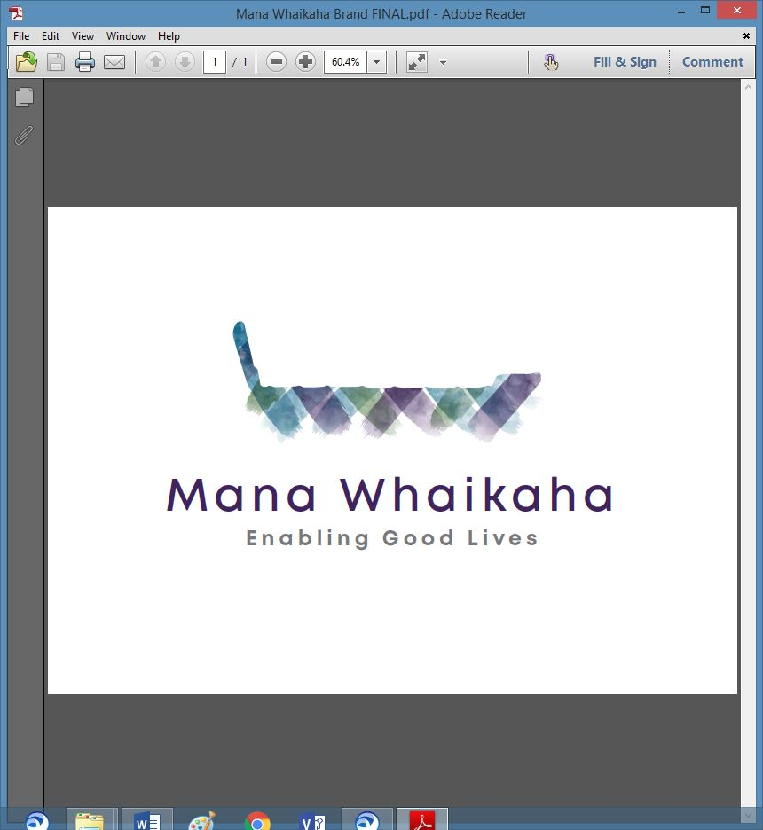

**MidCentral Governance Group**

**Minutes of the meeting held on Thursday 23 June 2022**

|  |  |
| --- | --- |
| **Attendees:** | Peter Allen (Chair), Martin Sullivan, Rachel Kenny, Pip Brunn, Angela Hobden, Peter Ireland, Rasela Fuauli, Rachael Burt, Toni Griffiths |
| **Apologies:** | Ally Atwell (late) |
| **In attendance:** | Jo Brew (Secretariat) |
| **Venue:** | PSA Lounge. 198 Cuba Street, Palmerston North |
| **Time:** | 10.30am – 2.30pm |

**Welcome**

The Chair welcomed all and opened the meeting with a karakia.

**Discussion: Insight of NGO delivery of Disability Support Services** (Barry De Geest, and Sonia Hawea, Chief Executive -Taikura Trust)

Barry and Sonia attended the meeting to share insights about working as a Non-Government Organisation (NGO) delivering disability support services. The group learnt:

* Taikura Trust was founded by representatives of Tainui and Ngāti Whātua mana whenua who were both consumers and service providers within the sector and had close relationships with the Pasifika community, disabled people and services. Services were accessed via 3 DHB’s in the area delivered paediatric NASC’s and 2 community organisations provided support to people with intellectual and physical disabilities.
* The above community leaders collaborated to bring some strong, culturally based practices to the NASC function as a coalition, forming a trust with the values of disability, mana whenua and Pasifika leaderships working in partnership to deliver to the aspirations of disabled people and families set then, in the 90’s.
* Today, the founders remain the same within the Trust, though there has been a change of aspirations but recently in response to the changing environment have reviewed the structure and wish to strengthen so have developed a subsidiary (of which Barry is Chairman).
* As an NGO, Taikura Trust has its own Board separate from any agency.
* NASC’s were split from the 5 DHB’s, Taikura Trust was formed as the umbrella service delivery.
* Reflections include lack of adequate data led to poor funding design and decisions and an unexpectedly high population of disabled people.

Other matters discussed included:

* The importance of removing the name “NASC’.
* Being mindful of the risk that contracts can inadvertently change the intent of service delivery.
* The strategies used to minimise gaps between original intent and contract.

**Discussion: Role of MGG now and in the regions in the future** (Bernadette Anne, Operations Transition Lead Establishment Unit for Ministry of Disabled People - MSD)

Bernadette addressed the Chair’s question regarding the role of the MGG now and in the regions in the future. Points of discussion included:

* The voice of disabled people and community are paramount for the new ministry.
* As part of the plan to develop, the structure for further development of EGL will involve regional leadership groups.
* The nuances involved in the definitions of some terms including ‘voice’ and ‘partnership’ and clarifying shared definitions as a task for the new CE.

***Action: MGG to collate information they consider to be important for the new CE to know, i.e., what’s happening in this region, suggestions for national rollout, the perfect site, tips, and tricks etc, and pass to Bernadette. The Regional Leadership Group to be given the same opportunity.***

**Discussion: Identifying MGG expectations to pass onto the new Chief Executive**

The group discussed a range of suggestions, expectations, and questions pertaining to the development of EGL and the new ministry of disabled people to be compiled into a letter to be sent to the Operations Transition Lead, Establishment Unit, and the new CE.

***Action: Martin Sullivan to compose the letter on behalf of the group.***

**Info: System Transformation Update** (Erin Black, Programme Lead, System Transformation - MoH)

Erin’s final update to the group included:

* Recently gained endorsement from the EGL governance group for the:
* Monitoring evaluation, analysis and learning framework and strategy.
* EGL draft partnership framework – to be handed over to new CE.
* Kaituhono Connector Framework including the main practice guides and companion guides.
* All the above were co-designed with our disabled communities.
* Still work to be done on workforce strategy, future operating model design for the national EGL scaled approach and related commissioning functions that will form package for work in progress for handover to the CE and DCE.

The group expressed their thanks and appreciation for the work Erin has done in her role while holding fast to her values and standing courageously at the forefront.

**Info: Director’s Report** (Rachael Burt, Director – Mana Whaikaha)

Rachael tabled her report. Discussion points included:

* Business as usual, busy, continuing to work around the covid environment and the impacts of this on disabled people, whanau, community and supports.
* Several situations with multi complexities regarding persons and their environment have required significant input over the last 6 weeks. This area has a large population with high and complex needs. Unsure what the triggers are for the persons involved. Transitioning people from forensic spaces into community has been challenging.
* Recently presented the business paper to the Operational Management Team (OMT); 32 people attended this presentation. The experience was a learning opportunity.
* Busy in multiple ways relating to the transition and working across MoH, Establishment Unit and MSD spaces.
* Six vacancies across the team at present plus a lot of sickness within the team.

**Previous Minutes**

The minutes from the previous meeting were taken as read and are a true and correct record.

**Angela Hobden/Peter Allen**

**Action Points**

The action points were updated and will be reflected in the July agenda.

**General Business**

1. Request for panel discussion speaker for ‘Delivering Disability Service Conference on Monday 29 August.

* Peter A and Martin volunteered to participate, Jo to send response**.**

1. Progress on feedback form for MGG section on Mana Whaikaha website.

* Form completed, email set up, just waiting for upload onto website – Jo to check progress.

1. The celebrations to launch the new ministry on Friday 1 July were briefly discussed. There will be celebrations for community, officials, and staff in Wellington and Palmerston North plus live streams available to watch.

**Farewell**

Peter A thanked Angela for her time and expertise given during her time on the governance group. The group farewelled her with a bouquet of flowers as a token of appreciation.

The meeting closed at 2.11pm

**Practical Matters**

**Date of next meeting:** Thursday 28 July 2022 at 10.30am in the PSA Lounge, 198 Cuba Street, Palmerston North.

**I confirmed** that these minutes constitute a true and correct record of the proceedings of the meeting

DATED this 28th day of July 2022



**Peter Allen**

**Chair, MidCentral Governance Group**