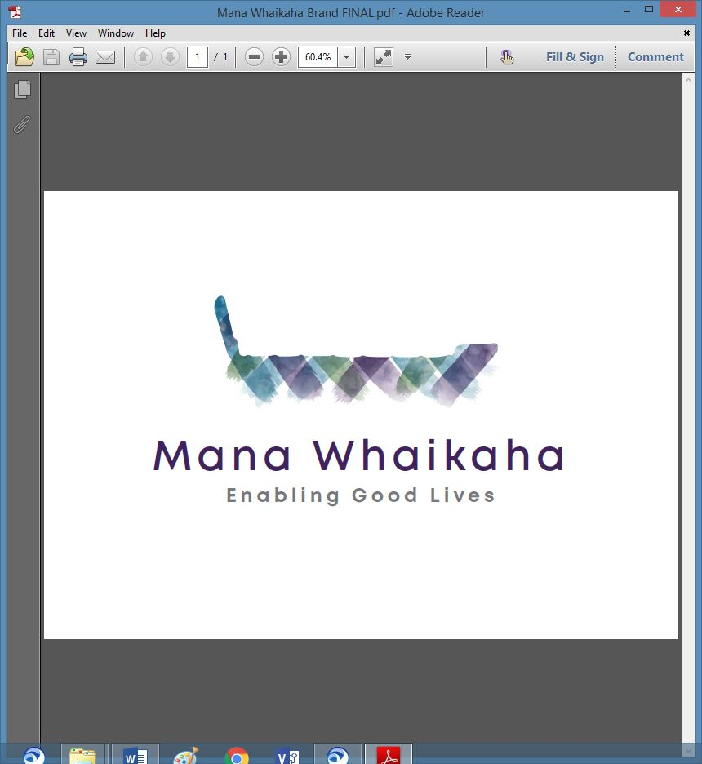

**MidCentral Governance Group**

**Minutes of the meeting held on Thursday 28 April 2022**

|  |  |
| --- | --- |
| **Attendees:** | Peter Allen (Chair), Lorna Sullivan (Co Chair), Rachel Kenny, Martin Sullivan, Rasela Fuauli, Pip Brunn, Angela Hobden, Peter Ireland, Toni Griffiths, Rachael Burt and Ally Attwell |
| **Absent:** | Peter Ireland |
| **In attendance:** | Sandy Ryan and Jo Brew |
| **Venue:** | Functions Room, Focal Point, 223 Cuba Street, Palmerston North |
| **Time:** | 10.30am – 2.30pm |

**Welcome**

The Chair welcomed all and opened the meeting with a karakia.

**Discussion: Business Memo** (Rachael Burt, Director, Mana Whaikaha)

Rachael tabled the business memo. As Mana Whaikaha has achieved a ‘NASC’ transformation, plans are being developed, focusing on continued system transformation. This document sets out a proposed pathway for the future of Mana Whaikaha and includes:

* Expanding Mana Whaikaha to encompass the full role envisioned for the Prototype through the 2017 co-design, including:
* Transforming 24/7 (residential) support.
* Integrating EMS with personal budgets.
* Creating stronger integration, and a stronger voice of family and child, in early intervention services.
* Achieving greater change in the provider sector; and
* playing a stronger role in the High and Complex Framework.
* Strengthening the investment approach Mana Whaikaha takes to achieving shifts in the life course of disabled people; and
* integrating further into Mana Whaikaha payments and other supporting functions which have historically been contracted out.

The absence of a succession plan for the Director role as identified as an additional business risk and will require attention. It would be prudent to develop a succession plan for the Operations Manager role also.

**The group agreed with and endorsed the business plan.**

**The group agreed the report be adapted for the Mana Whaikaha website and checked by OMT and MGG before uploading.**

**Info: Establishment Unit Update** (Rommy Musch, Programme Lead and Bernadette Anne, Operations Transition Lead)

Rommy and Bernadette attended the meeting to give updates on the work regarding the transition to the new ministry for disabled people.

Rommy’s update included:

* ‘AmplifyU’ is open to consultation/suggestions for the English and Māori names for the new ministry. A NZSL name will be developed once the former names are chosen.
* A Facebook live comms session was held recently for the disabled community.
* An interim domain name is awaiting approval.
* Induction packs are being distributed to MoH staff who are transitioning across to MSD.
* Design briefs for IT, HR and Corporate Services await approval and include a forward work programme for post 1 July.
* There are approximately 35 Establishment Unit (EU) staff working towards the 20 day implementation plan leading up to 1 July to ensure the new ministry will be operational on day 1.

Bernadette’s update included:

* Visited Mana Whaikaha to listen to staff needs, i.e., accommodation, technology equipment etc.
* Meeting with the EGL sites and others to gather information to use in ensuring a smooth transition.
* Compiling a briefing for the new CEO.
* An invitation to contact Bernadette with any questions.

The main priority is for the ministry to be up and running as business as usual on 1 July.

**Discussion Points**

* The differences between Regional Leadership Group and MidCentral Governance Group.
* Feedback on the EU’s live session:
* The 30 minute live session was a good mechanism for engaging people – more and longer sessions with time for a range of questions would be appreciated.
* The voice of families be acknowledged, and preparation be done for a range of questions from families at future sessions.
* Maintain a balance so the voices of disabled people and families are both heard.
* NASC’s will continue their services from 1 July, and until decision making is done by the new CEO.
* The need for caution so the voice of system service doesn’t dominate the voice of disabled people and that pragmatism doesn’t become the status quo going forward.

**Discussion: MidCentral Governance Group’s Future**

The Chair asked the group to think about and express their thoughts on the MGG, i.e., on the future of the Governance Group; have we made decisions, is there a role to play in the future.

Discussion points and thoughts included:

* The group had not acted in the realm of true governance services as they had no authority other than acting in an advisory role.
* MGG holds and supports the voice and vision of EGL within the region.
* MGG remain as a group for representation, or think tank, or a group working alongside the Director of Mana Whaikaha, maintaining relationships with the community with the possibility of working as a true governance group in the future?
* Will the Minister continue to appoint people to the group; is their decision the driver?
* Is there an evaluation of what the MGG has done and what they should be doing?

**Info: System Transformation Update** (Erin Black, Programme Lead)

Erin’s update included:

* The narrowed work focus and engagement for the new ministry.
* The operating design model project work (for national scaling approach) has begun to wind down and will be packaged for the new CEO.
* This project has been running in parallel with the EU’s operational model work (for the new ministry).

A discussion followed the update and covered:

* MGG’s transition with MSD, managing expectations of and allaying concerns of disabled people, managing expectations and readiness required by NASC’s and service providers in understanding what the EGL approach is and working in person directed ways and the lack of understanding of the EGL approach by general society.
* The importance of voice and partnership and organisational culture in transition and moving forward.

**Info: Directors Report**

Rachael tabled her report. Discussion points included:

* The planned recruitments have been completed but the team now has 4 vacancies due to internal appointments being made.
* Some staff have been diagnosed with long covid.
* The community participation budget appears underspent as most of this sits within personal budget. This is due to the difficulties in merging the data from the different platforms as transfers from different budgets aren’t shown.
* The personal budget figure continues to be based on past estimates of approximately 2017 when there were less people receiving supports.
* Transition
* 6 Connectors specialise in this space
* A Community Development Advisor is currently working on an employment perception project.

**Farewell**

As this was Lorna’s last meeting, the group farewelled her with their thanks and appreciation for her contribution to the MidCentral Governance Group. Lorna’s knowledge, experience, and leadership as advocate for disabled people, EGL approach and Director of Mana Whaikaha was acknowledged with admiration.

**Minutes from the Previous Meeting**

The minutes from the meeting held on 24 March 2022 were taken as read and are a true and correct record.

**Angela Hobden/Martin Sullivan**

The action points were updated and will be reflected in the May agenda.

**The meeting closed at 2.30pm.**

**Practical Matters**

**Date of next meeting:** Thursday 26 June 2022 at 10.30am in the PSA Lounge, 198 Cuba Street, Palmerston North.

**I confirmed** that these minutes constitute a true and correct record of the proceedings of the meeting

DATED this 26th day of May 2022



**Peter Allen**

**Chair, MidCentral Governance Group**