MidCentral Governance Group
Minutes of the meeting held on Thursday 28 November 2019
Attendees: | Peter Allan (Chair), Heather Browning (Deputy Chair),Martin Sullivan, Rachel Kenny, Rasela Fuauli, Peter Ireland, Angela Hobden, Maxine Dale, Zandra Vaccarino
Apologies:
In attendance: | Jo Brew  Sandy Ryan
Venue: | Conference Room, Level 2, 585 Main Street, Palmerston North
Time: | 11.00am – 3.00pm

Karakia
Minutes
The minutes of the previous meeting held on 24 October were accepted as a true and correct record.
Information: Monitoring Report
Bre McQuade, Business Insight Specialist gave a verbal update informing the group the July – September 2019 quarterly report had been submitted to MoH for approval and signoff. A progress update on the Customer Record Management (CRM) software development upgrade informed the group phase 1 had been completed and released into production. Phase 2 development has begun with the gathering of business and reporting requirements.

Information: Zandra Vaccarino
Due to personal reasons, Zandra tendered her resignation from the MidCentral Governance Group. The Chair thanked Zandra for her contribution to the group and accepted her resignation with regret.
Information: Operational update from Directors
Lorna Sullivan and Marshall Te Tau gave operational updates. Lorna’s update focused on workforce matters including the volume of work and high demand on connectors and the possible solutions to manage these. The Governance Group agreed to support Lorna to manage workforce challenges to maintain quality of service. Marshall’s update informed the group that reporting for August – September was almost complete, an OIA (Official Information Act) request pertaining to all documents released from Mana Whaikaha to the MidCentral Governance Group had been received and that the changes implemented from phase 1 of the CRM development were positive. Marshall requested an opportunity to table 4 papers at the next meeting and sought clarification of the Governance Group priority of early investment.
Information: Rawa Karetai, Enabling Good Lives – Waitaha
Rawa Karetai met with the Governance Group to give an overview of how Enabling Good Lives – Waitaha operated including the highlights and challenges of their operational model.
Discussion: James Poskitt, Ministry of Health
James Poskitt joined the meeting by telephone. Matters discussed included that planning for Mana Whaikaha 2020 was underway, currently in the information gathering stage. James will attend the next meeting to present the information to the group.
Correspondence
Outwards
- Early investment priorities were forwarded to the Mana Whaikaha Directors on 25 October 2019.
Inwards
- A letter was received from Raewyn Cameron, Manager System Enabling Team requesting nominations for facilitators with lived experience to co-present Disability Responsiveness Training.

Practical matters

Date of next meeting: Wednesday 18 December 2019, 11.00 am, EASIE Living Conference Room, 585 Main Street, Palmerston North

I confirmed that these minutes constitute a true and correct record of the proceedings of the meeting

DATED this 18th day of December 2019

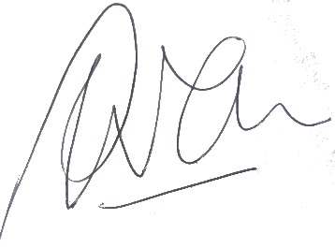

Peter Allen
Chair, MidCentral Governance Group

