Here is some Easy Read information about research done by SAMS.

The research was about the way people get disability support.
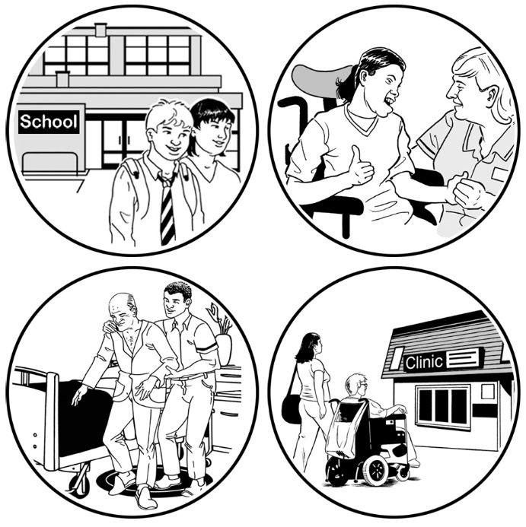

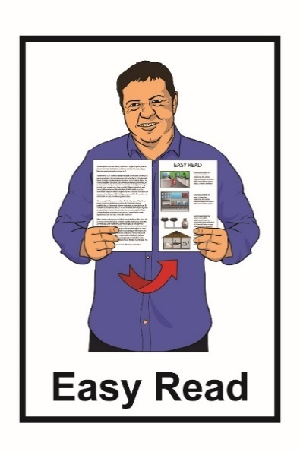
What is in this booklet?

Page Number
Before you start 3

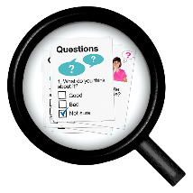
About the research 4

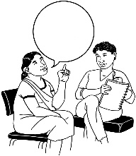
How was the research done? 9

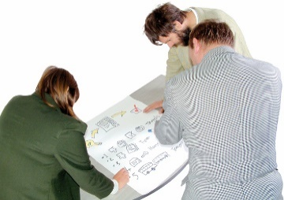
What did the map show? 14

Page Number
How is the old disability support system working? 16

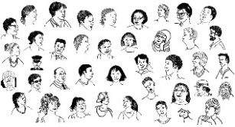
What did disabled people and representatives say? 18

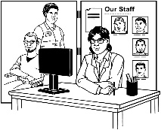
What did disability support services and support workers say? 29

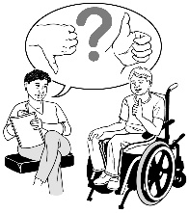
What happens next? 32

Before you start
This is a long document.

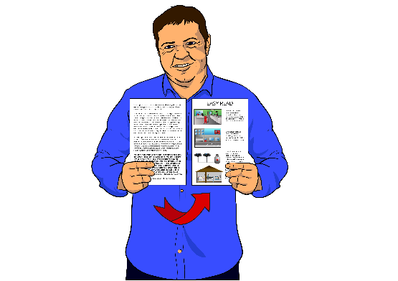
While it is written in Easy Read it can be hard for some people to read a document this long.

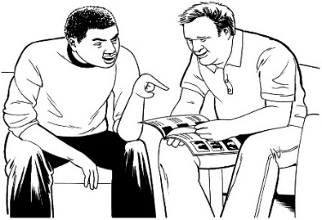
Some things you can do to make it easier are:
- read it a few pages at a time

- have someone assist you to understand it.

About the research

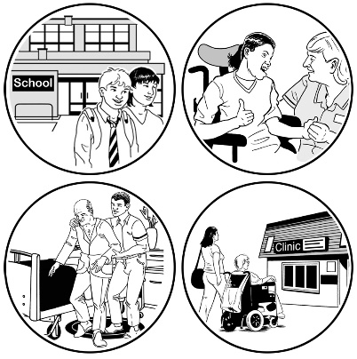
A new disability support system is being tried at the moment.
\
A disability support system is the way that disabled people in a region or country get the support they need.
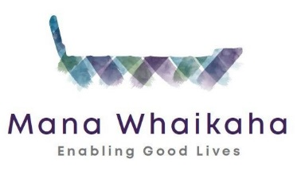
The new disability support system that is being tried is called Mana Whaikaha.
People started trying Mana Whaikaha on the 1st of October 2018.
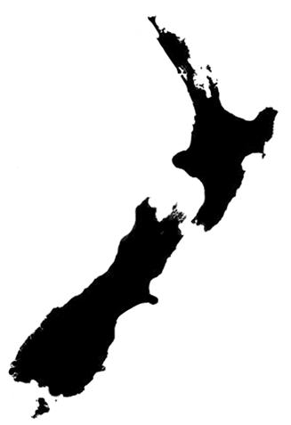
Only people who live in the MidCentral area can try Mana Whaikaha.

The MidCentral region includes:

- Palmerston North

- Horowhenua

- Manawatu

- Ōtaki

- Tararua.

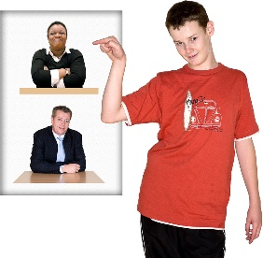
Mana Whaikaha aims to give people:
- more choice about their disability support

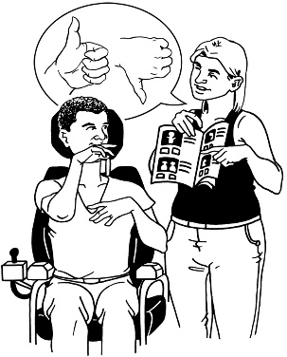
- more power to make choices about their lives.

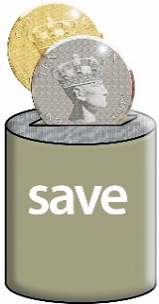
Mana Whaikaha also wants to make sure the disability support system uses money in a good way.

The Ministry of Health wanted to do some research.

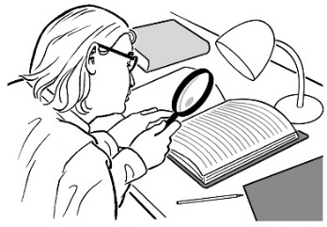
Research is:
\
- looking to find an answer to a question you have

- trying to find out how to do things better.
The Ministry of Health did some research on what the disability support system was like before Mana Whaikaha started.
This kind of research is called a baseline study.

The research was done by an organisation called Standards and Monitoring Services.
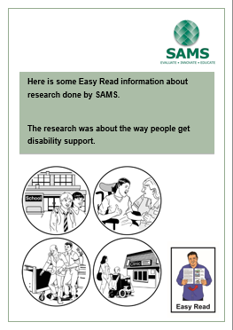
Standards and Monitoring Services are also known as SAMS.

This booklet will tell you what the baseline study found out.

How was the research done?

SAMS did the research by:
- making a map of the disability support system

- asking people living in the MidCentral area to do surveys.

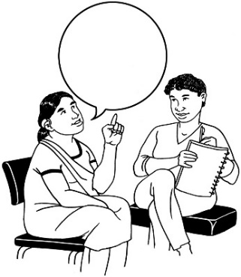
\
A survey is a way to get information from people.

A survey asks questions about something an organisation wants to know about.

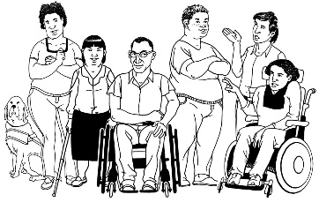
SAMS did 1 survey with disabled people.

This survey was done by 1 hundred and 72 disabled people or their proxies.
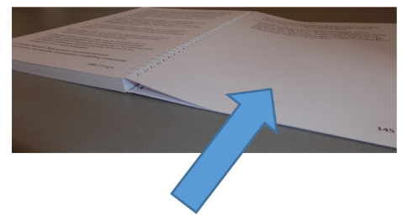
You can see what proxies are on the next page.

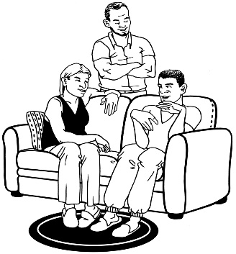
SAMS also did a survey for family members of people with disabilities.

This survey was done by 1 hundred and 52 family members or representatives for disabled people.
You can see what representatives are on the next page.

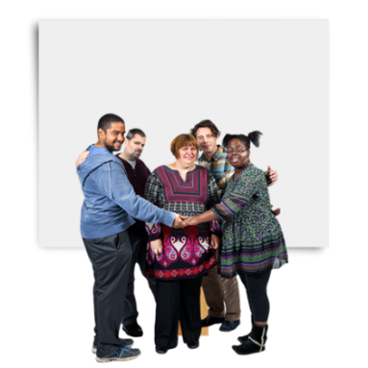
Proxies or representatives are people who advocate for disabled people.
\

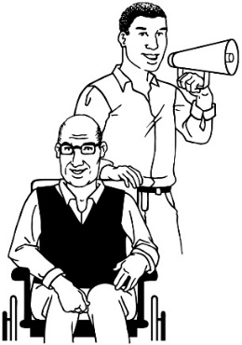
Advocate means speaking up for someone else.

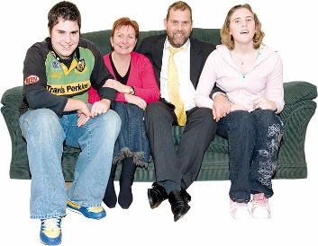
An advocate can be:
- whānau / family members

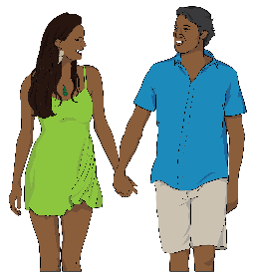
- guardians

- partners

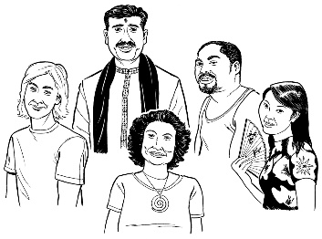
- friends

- other people.

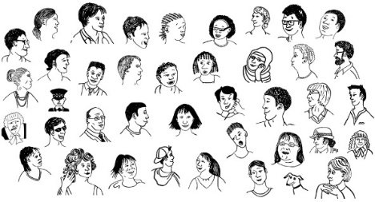
SAMS also did surveys with:
- 9 disability support services

- 1 hundred and 8 support workers.

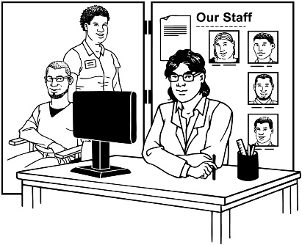
\
Disability support services are organisations that:
- give disability support to people

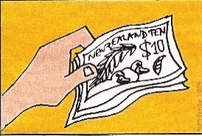
- get money from the disability support system to support disabled people.
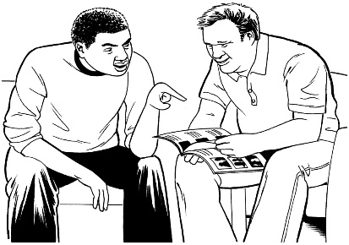
Support workers are paid to assist disabled people.

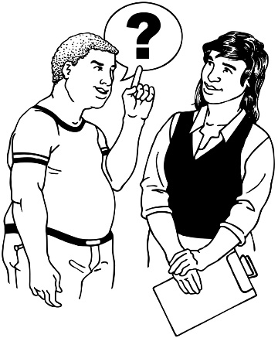
SAMS also did a survey with 21 government stakeholders and others.
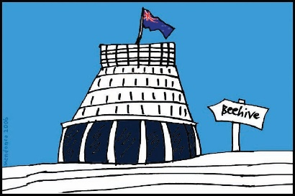
\
Government stakeholders are people who:
- work for the government
- want the disability support system to work in a good way
- helped to make the map of the disability support system.

The other groups include groups like Disabled People’s Organisations like:
- People First New Zealand

- Disabled Persons Assembly.

What did the map show?
SAMS made a map of the old disability support system.

The map of the disability support system showed:
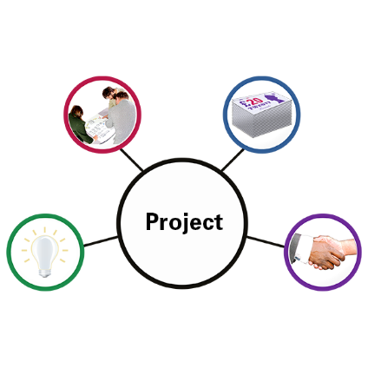
- the people and organisations who are part of the old disability support system

- how these people and organisations work together.

The map also showed that there needs to be more:
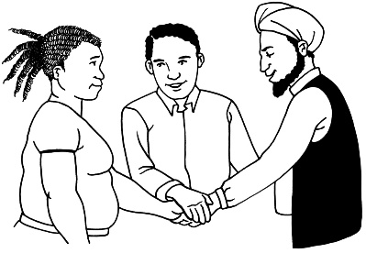
- working together between the local and national disability support systems

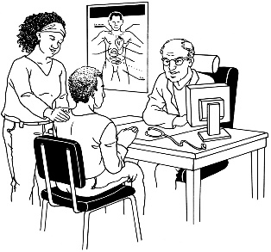
- communication between different disability services

- support for disabled people wanting health care

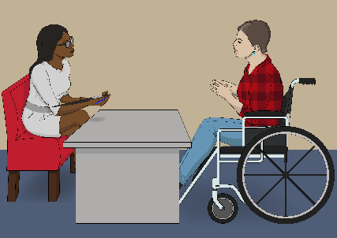
- support for disabled people wanting to find work

- support for disabled people leaving school

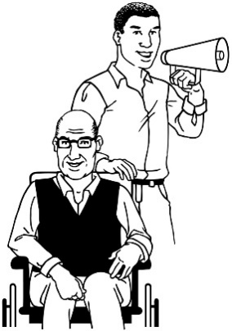
- support to teach people about being advocates in the disability support system.

How is the old disability support system working?
Our research showed that the old disability support system is very bureaucratic.

This means that:
- the old disability support system has lots of rules

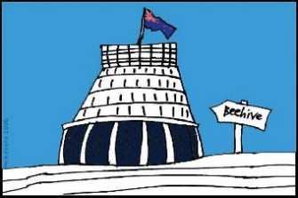
- the rules have been made by the government

- everyone has to follow the rules
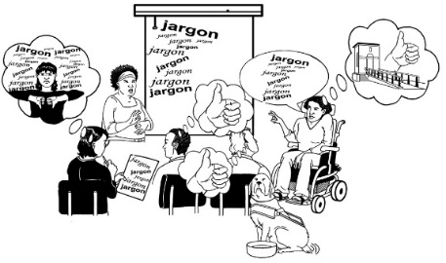
- disabled people and other people do not help to make the rules.

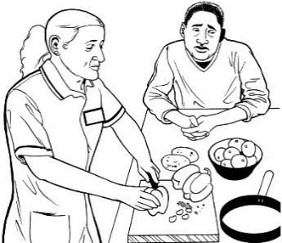
The rules in the old disability support system also mean that:
- disabled people do not always get the disability support they want or need
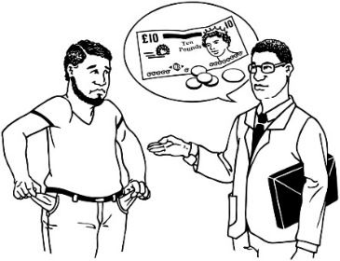
- many disabled people are not able to pay other whānau / family members to support them

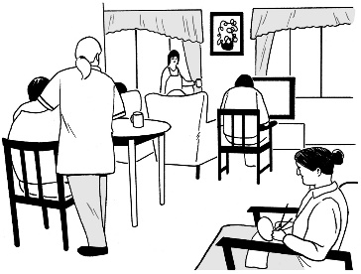
- disability support services can only give people some kinds of disability support.

What did disabled people
and representatives say?

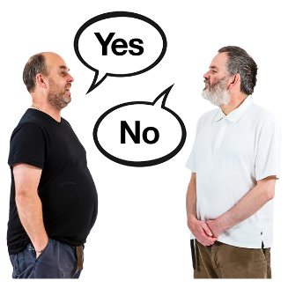
Not all people feel the same way about the old disability support system.

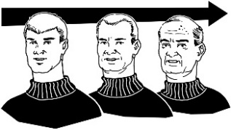
The way people feel about a disability support system can change because of:
- their age
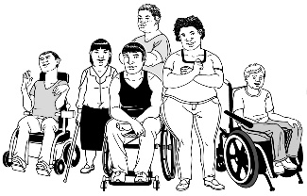
- their disability

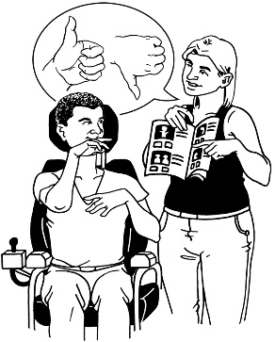
- the kind of disability support they get

- how much disability support they get

Being happy
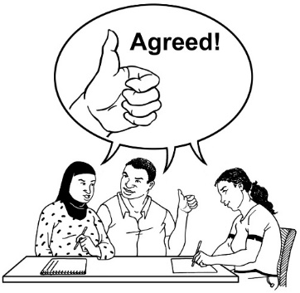
Most disabled people who did the survey were happy with the support they were getting from the old disability support system.

Some people felt both:
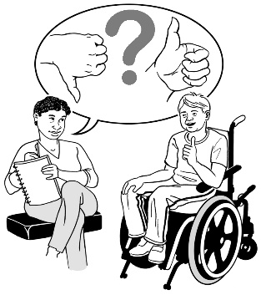
- happy with the support they were getting from the old disability support system

- unable to do everything they want to do in their lives.
Most family members of people with disabilities who did the survey were happy with the old disability support system.

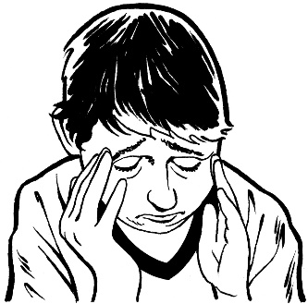
Some disabled people and family members were unhappy with the old disability support system.

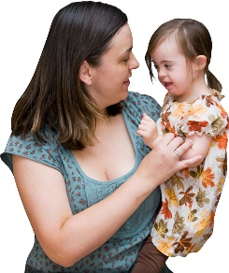
Family members of disabled people were more unhappy with disability support services than disabled people.

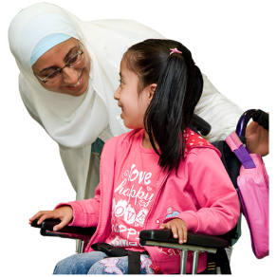
The most unhappy people were family members who:
- have young families

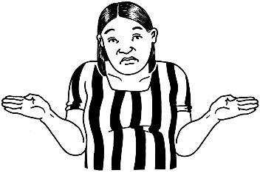
- support a disabled child or young person at home

- do not know about different disability support.

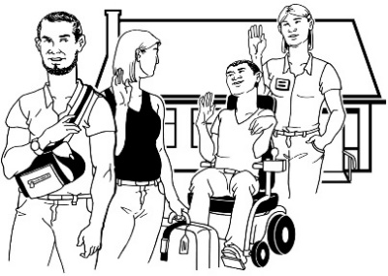
These people said they:

- cannot find anyone to support their disabled child or young person when they need a break.
- have little time to do what they want to do
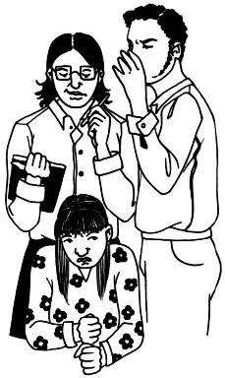
- do not feel like part of the community.

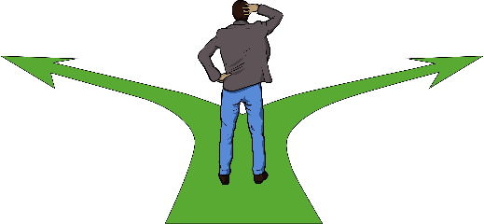
Choice and control
Many disabled people or their proxies said they were doing what they wanted in their life:
- most of the time

- all of the time.

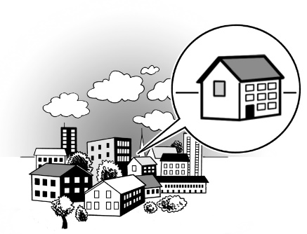
Many disabled people are living in group homes in the community.

This means that they are living:
            - in houses in the community

            - with other disabled people.

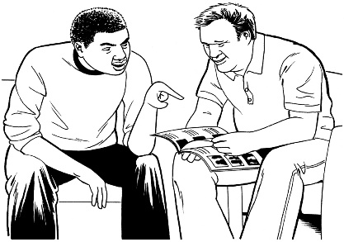
Many of these people:
- have learning disability

- need a lot of disability support.
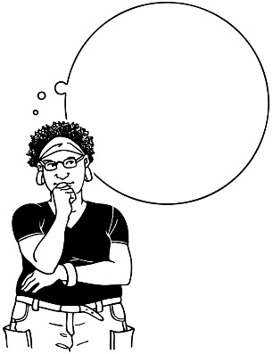
Many family members told us that disabled people in group homes are not given the support they need to think about what they want to do in their lives.
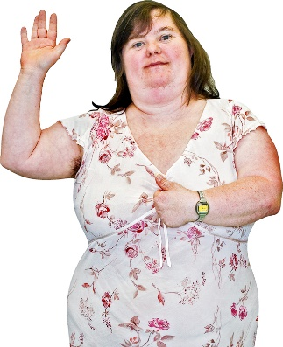
Many of the people with disabilities also told us they did not have control over some things in their lives.

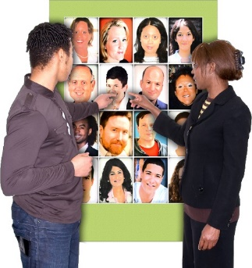
Some disabled people do not have control over:
- what disability support they get

- who supports them

- who they live with.

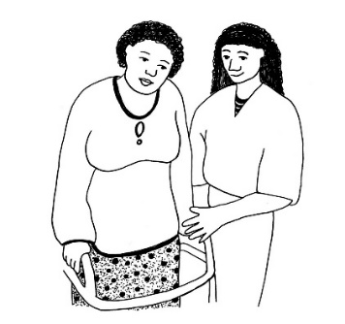
People with disabilities and family members said:
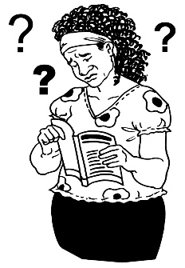
- disabled people who can do more things for themselves have more choice and control over their lives

- many adults with learning disability can do the things they want to do
- many adults with physical disability cannot do the things they want to do.

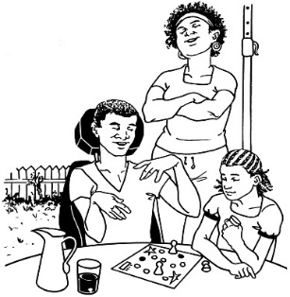
Relationships
Most disabled people felt they were important to their family.

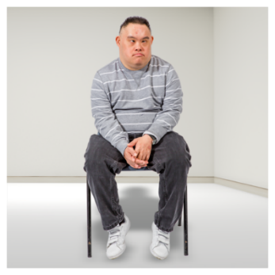
Most disabled adults said they:
- were single

- have never been in a relationship.

A few disabled people said that they lived with a:
- husband

- wife

- boyfriend

- girlfriend.

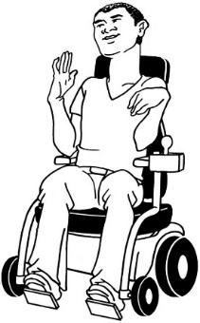
Most of these people had a physical disability.
Most disabled people said they have friends who do not live with them.

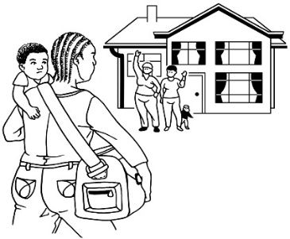
Some disabled people said they had not visited any friends in the 4 weeks before the survey.

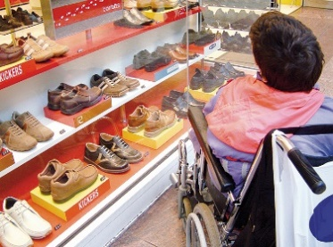
Some disabled people said that in the past 2 weeks they had:
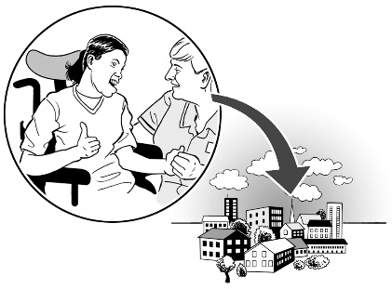
- only been to the shops

- not been anywhere in the community.
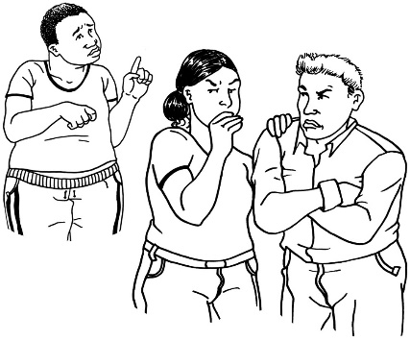

A lot of disabled people said they do not feel like they fit in with the rest of the community.
Work and money
Most disabled people said that they had not done any paid work in the week before they took the survey.
Many disabled people said they have an income of 30 thousand dollars or less.
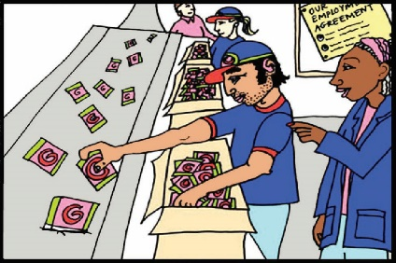
\
Income is money people get from:
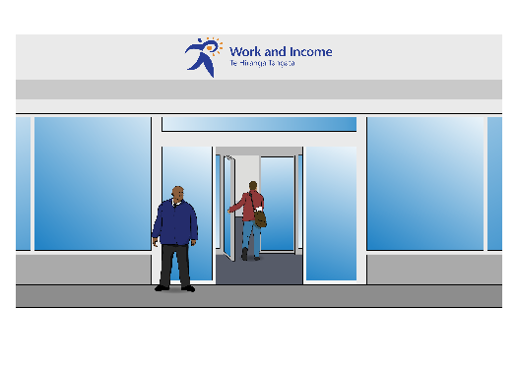
- working

- benefits.

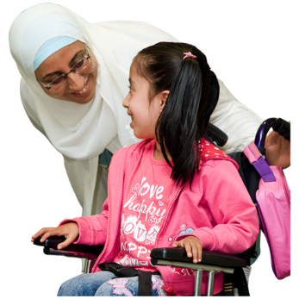
Some family members who support a disabled person in their home:
- have given up other work to do this work

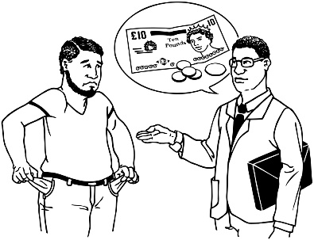
- live in a house where everyone together has an income of between 40 thousand dollars and 50 thousand dollars.

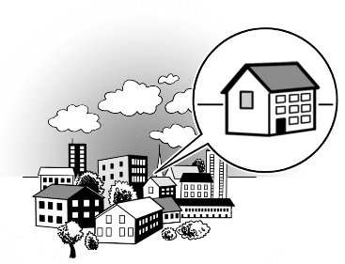
Many people with disabilities who live in group homes:
- get less than 30 thousand dollars per year to live on.

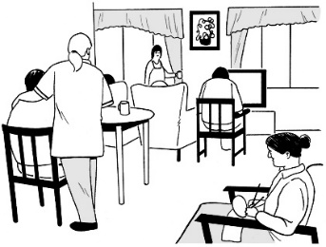
- use most of their money to pay for the disability support they get in their house.

What did the disability support services and support workers say?
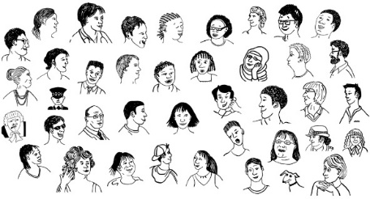
Surveys were also done by:
- disability support services

- support workers.
\
Disability support services are organisations that:
- give disability support to people

- get money from the disability support system to support people.
Support workers are paid to assist disabled people.

This is what the survey found out.
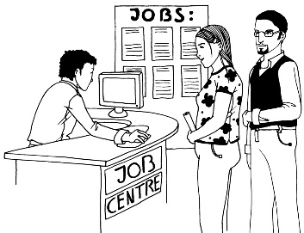
Some support workers are worried that a new disability support system will take away or change their jobs.

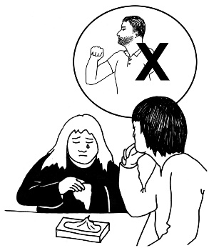
Many disability support services and support workers feel they cannot:
- talk about bad things that are happening in the disability support system
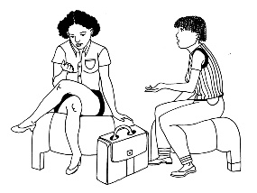
- make things better in the disability support system.

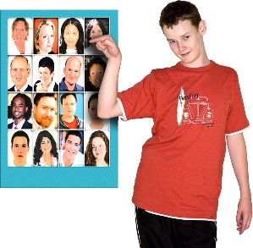
Many services and support workers feel a new disability support system will:
- give people more choice over their disability support

- mean government money will be used better.
Many services and support workers feel a new disability support system will not change things if there is not more money to pay for disability support.

What happens next?
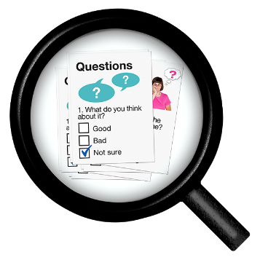
More research will be done to find out:

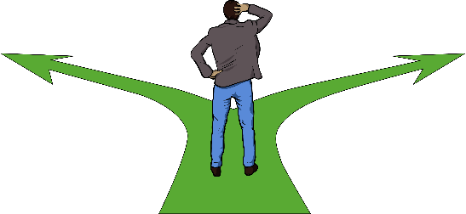
- how well Mana Whaikaha is working

- what changes could make Mana Whaikaha better
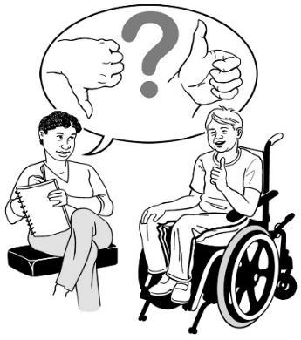
- if more people in New Zealand should have a disability support system like Mana Whaikaha.

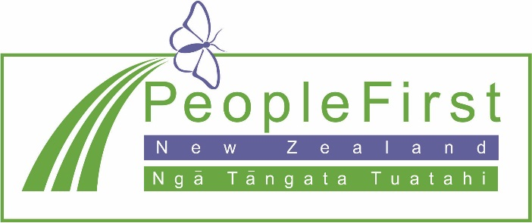

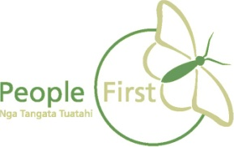
This information has been translated into Easy Read by the Make It Easy service of People First New Zealand Inc. Ngā Tāngata Tuatahi.

The ideas in this document are not the ideas of People First New Zealand Ngā Tāngata Tuatahi.
