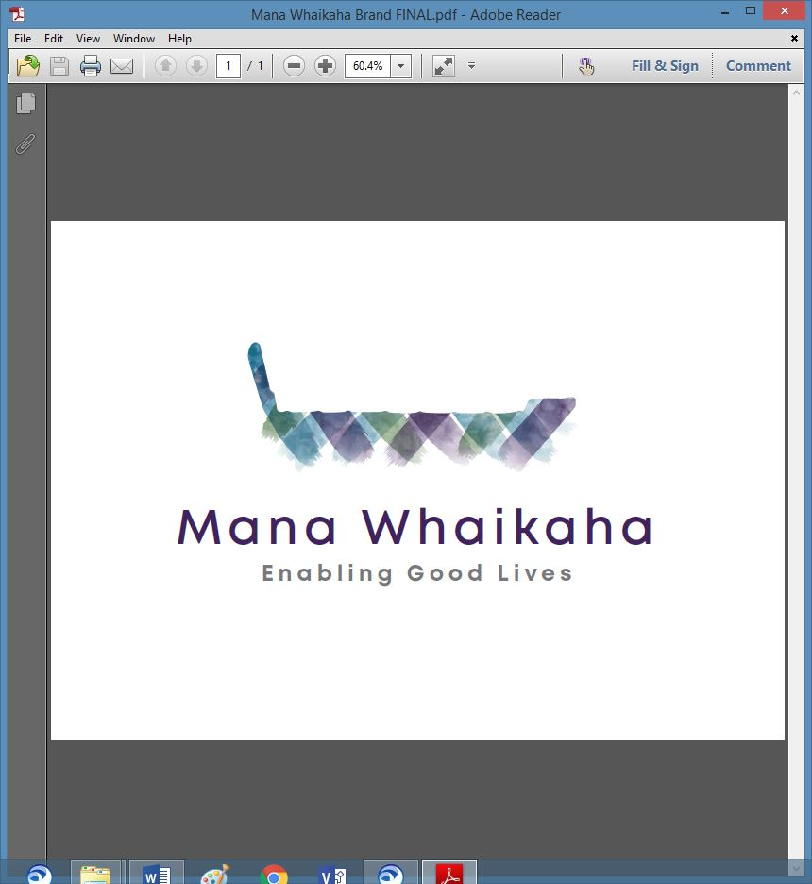

**MidCentral Governance Group**

**Minutes of the meeting held on Thursday 22 April 2021**

|  |  |
| --- | --- |
| **Attendees:** | Peter Allen (Chair), Martin Sullivan, Maxine Dale, Rachel Kenny, Pip Brunn, Angela Hobden, Peter Ireland, Rasela Fuauli, Vinnie Vaccarino, Joseph Tyers and Lorna Sullivan, Rachael Burt and Aroha Lowe (from 1pm) |
| **Absent:** | Robyn Richardson |
| **In attendance:** | Donna DeCleene, (meeting assistant), Zandra Vaccarino (meeting assistant), Jo Brew (secretariat). |
| **Venue:** | EASIE Living Conference Room, 585 Main Street, Palmerston North |
| **Time:** | 11.00 – 3.00pm |

**Karakia**

Peter opened the meeting with a karakia.

**Discussion: Essential Workers’ Rights Matters – Peter Ireland (PSA Organiser)**

Peter tabled a copy of a letter on behalf of the PSA (Public Service Association). The letter sent from the PSA to the Minister was in regard to workforce issues and outlines concerns around the contracting out of government responsibilities and the potential affects this could result in for worker’s rights which in turn affects the rights, choices and control of disabled people and vice versa. There was a discussion about how to ensure workers’ rights in this scenario.

The group agreed to bring their thoughts on the matter to the May meeting for discussion before formal feedback is taken to the PSA.

**Information: Mana Whenua Engagement – Pikihuia Hillman (Project Manager) and Materoa Mar, Te Tihi)**

The Solutions document and the Recommendations documents were circulated.

Pikihuia gave an overview of the documents.

* The contents of the earlier Findings document were themed against the Māori centred approach schema. This schema allowed solutions to be analysed for their relevancy and appropriateness in developing a Māori centred approach. Further sub-themes enabled the easy identification of duplication across sections of the schema. The high-level solutions were provided from whānau and kaimahi. The recommendations were developed by simplifying and prioritising the solutions by a working group in partnership with a small group of Mana Whaikaha kaimahi.
* The recommendations have been prioritised against key objectives, most important being at the top and least important at the bottom. These key objectives are:

1. Clearly articulating Mana Whaikaha aspirations.
2. Strengthen the Mana Whaikaha data-ecosystem as a lever to make informed decisions.
3. Developing the Self-Connector pathway to alleviate stress upon current connector service capacity.
4. Building Connector Capability to improve and standardise Tangata Whaikaha experience.
5. Building Inter-sectorial relationships to create high leverage activities.
6. Strengthening ICT infrastructure to automate data processes and provide Tangata Whaikaha and whānau access to their data.

* It was highlighted that the project scope did not include Governance. The actualisation of Te Tiriti based relationships should translate across all areas and levels of Mana Whaikaha and the sustainability of a Māori centred approach can only be achieved where operational services are support by appropriate Māori strategic partners.
* The next step is to create an implementation plan once feedback has been received from the MGG group.

Lorna acknowledged the recommendations would help the MGG group as they are in the process of redefining their executive and board policies.

**Action:** *The MGG will discuss the recommendations at the May meeting and then feedback to Te Tihi.*

**Discussion: Pasifika Core Group – Lorna Sullivan**

Lorna spoke on behalf of the Pasifika Core Group.

As the Pasifika Core Group are developing their capability and capacity around Mana Whaikaha they would like to be invited to attend leadership meetings as observers to learn and develop their knowledge.

Peter and the attending leadership members agreed to support this request.

Rasela will make a formal request, in writing, to the leadership group.

Lorna informed the Pasifika Core Group is also working towards getting a connector to work specifically with the Pasifika group.

**Discussion: Board Matters – Lorna Sullivan**

Lorne led this discussion as a lead on from the Board Training workshop held in April. The next step for this group is to build policies etc for a framework for the Board. The Constitution document is already in progress. The Ends Policy is the next document to develop. The group discussed ideas and composed a draft.

**Action**: *The group will send their feedback to Jo by Friday 30 April – to be forwarded to Lorna.*

**Action:** *Rachael will take to the Leadership Group meeting on 5 May and to the Mana Whaikaha Team for feedback and bring to MGG’s May meeting.*

***Action****: Policy framework and perpetual agenda to be agenda items for May meeting; also invite Rachael and Senior Leadership Team to participate in discussion.*

**Previous Minutes**

The previous minutes and notes of the meeting held on Thursday 25 March were taken as read and were a true and correct record.

**Angela Hobden/Martin Sullivan**

**Information: Website Review Document**

Jo tabled the Website Review Document on behalf of Leigh Rowe, Mana Whaikaha.

The document illustrated the basic changes to make the site more people orientated. Refreshing the website is very timely regarding the digital platform recommendation identified by Te Tihi. The group noted there was some content missing. To gain more clarity around the refreshment project it was agreed to invite Leigh to the next meeting to discuss.

***Action****: Invite Leigh Rowe to the May meeting to give progress update.*

***Action****: The group is invited to send feedback/questions around the document to Jo by Friday 30 April.*

***Action****: Rachael to check with Leigh for any further detailed documentation and will send the group. In turn the group is asked to feedback to Jo by Friday 30 April.*

**General**

* ***Action*** *- Invite Heather Browning and Marc Brown to the May meeting to talk about the Transition Project.*
* Be aware, we may need to call extra MGG meetings to discuss extra business as required, in the short term.
* ***Action*** *-Lorna and Peter to request a meeting opportunity with Adri Isbister and James Poskitt.*
* ***Action*** *point reminder – Angela to write to the Minister re Mana Whaikaha’ s financial information.*

The meeting closed at 3.00pm.

**I confirmed** that these minutes constitute a true and correct record of the proceedings of the meeting

DATED this 27th day of May 2021



**Peter Allen**

**Chair, MidCentral Governance Group**