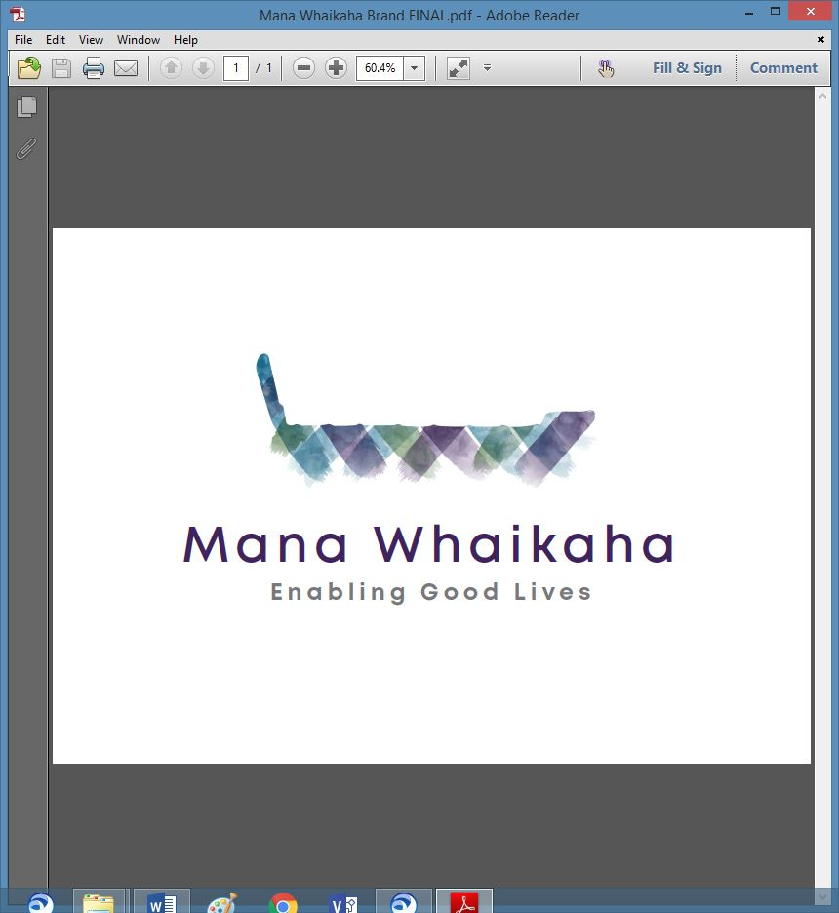

**MidCentral Governance Group**

**Minutes of the meeting held on Thursday 23 September 2021**

|  |  |
| --- | --- |
| **Attendees:** | Peter Allen (Chair), Lorna Sullivan (Co Chair), Martin Sullivan, Rachel Kenny, Pip Brunn, Angela Hobden, Peter Ireland, Rasela Fuauli, Rachael Burt, Aroha Lowe and Toni Griffiths |
| **Absent:** | Oriana Paewai |
| **In attendance:** | Jo Brew |
| **Venue:** | Via Zoom |
| **Time:** | 10.30am – 2.30pm |

**Karakia**

The Chair opened the meeting with a karakia; this was followed by a brief update from each member.

**Previous Minutes/Notes**

The minutes and notes of the meeting held on 26 August 2021 were taken as read and are a true and correct record.

**Angela Hobden/Rasela Fuauli**

**Board Matters**

**Operational**

* Rachael and Angela met to discuss financial operating costs and financial system requirements. They are confident financial tasks and budget management could be managed inhouse. Estimates for financial tasks will be sought via Governance.
* Progress for scoping alternative premises continues.
* Consideration regarding a contract of services post April continues.

***Action: Seek estimates for external financial system requirements – Angela***

***Action: Develop business case for move to alternative premises – Director, Chair and Co-Chair***

***Action: Chair to discuss contract of services with Adri Isbister***

**Board Policies**

* Co-Chair previously circulated electronic copies of the draft policies and strategies to members.
* Sensitive Expenditure Policy (already reviewed), Complimentary Therapies Policy and Early Investment Policy to be added to the collection.
* It was proposed the group accept, in principle, the draft Board policies and schedule a review of 1 or 2 each meeting to work through as per scheduled on the annual agenda.

**Lorna Sullivan/Peter Allen**

***Action: Director to draft Complimentary Therapies and Early Investment Policies and forward to Co-Chair.***

***Action: Director and Co-Chair to work through Executive policies to ensure reporting requirements are understood.***

**Constitution**

* Add a statement regarding strategies to use to ensure the right skills and/or supports required by Trustees are implemented.
* Add a quorum into document if not already mentioned.

***Action: Co-Chair and Angela to work together to update Constitution document then circulate to group.***

**Skills Matrix Discussion**

* The group was asked if they agreed with the proposed number of 7 Trustees.

**All agreed – accepted.**

* Not all skills are needed by each Trustees, but the range could be covered collectively by them.
* Use the following 3 strategies to get the right skills/supports required:
* Get the right people for the job
* Co-opt some skills onto the board
* Contract the skill level.
* The matrix can be reviewed at any time.

***Action: Jo to add ‘EGL Understanding’ to the matrix then circulate to the group.***

**Induction Manual for Trustees**

* The need for an Induction Manual was discussed. Martin will collate information and develop this documentation.
* Add Social Model of Disability to compliment the EGL approach, ‘True North’ and ‘How do some people get harmed’ papers.
* With regard to Trustees, it was noted, as a reminder that disabled people are in charge and control; they and their families should be at the core (50%) of the Trustees make up. If the Trustees makeup was to be similar to the present Governance Group, 7 Trustees may not be enough. To be discussed further at a future meeting.

***Action: Martin to collate Induction Manual; Lorna and Jo to provide ‘How do some people get harmed’ and ‘True North’ papers.***

**Transition Plan Update**

* Establishment of Mana Whaikaha entity – in progress/on track.
* Constitution – in progress.
* Consultation with RLG – planned for October.
* Board Policies – distributed and agreed in principle today (completed); annual reviews to begin under scheduled agenda item of Board Policies.
* Board Operational Policies and Annual agenda review with Director – to do.
* Annual plan – schedule as workshop during November and include some staff and RLG members when arranging.

***Action: Director to request annual budget or preferably 3 year budget from MoH***

***Action: Chair to discuss national database with NEGL.***

**General Business**

**Workforce Working Group**

Pip and Rasela attended their first Workforce Working Group (WWG) meeting and gave a brief update:

* There were no concerns about the number of members representing the MidCentral region. Representation will be sought from the areas where it appears missing.
* It has been agreed a facilitator lead the group and was requested this be a disabled person from within the community, if available.
* Provider and service top heavy at present.
* Discussed the necessity of the formation of an employment hub for disabled people and families as employers and for family members as employees to access clear guidance, support and ensure regulations were upheld.
* A copy of the original work programme to be circulated to all via Ministry of Health.
* Recognised the disabled person and their families remain at the centre of the groups outcomes.
* The local group would benefit from meeting in between WWG meetings to work together and develop understanding and cohesion for maximum effect. The group may meet to workshop the work programme.

**Discussion: Erin Black** (Programme Lead, System Transformation – MoH)

Erin gave an update about the Disability Support Services (DSS) Transformation being reset across the 3 workstreams.

* **Transition** –The Cabinet paper has been entered into Ministry systems and is expected to go to Cabinet early October.
* **Capability and Capacity Development** – Currently in phase 1 (framework and foundations) with the current focus on commissioning an investment in disabled persons led initiatives.
* **EGL Experience Operating Model –** working on**:**
* Scoping and partnering discussions around what community expectations are if walking through the door of a new agency or entity in July 2022.
* Monitoring Information Analysis and Learning strategy and outcomes framework.
* A workforce strategy.

**Information: Director Report** (Rachael Burt, Mana Whaikaha)

Rachael gave a verbal update:

* A meeting has been held to discuss the financial operating requirements of an independent entity.
* There has been a significant impact on workload with 12 staff being off recently.
* The business case relating to an increase of resource has been very slow to progress but believed to be now awaiting final sign off at MoH.
* Some staff are working extremely hard to meet the of the demands of the community which have become difficult to manage especially in lockdown.
* Interviews for the roles of Sector Liaison and Manager – Operations were conducted last week. Hoping to make offers of appointment for both roles by the end of this week.
* Continues to centre the focus of the original intent and consultation with community on the transformation in this region to MoH.

**General Business continued**

* Action Points were updated and those outstanding were carried over until the next meeting.
* Agenda item for October to include feedback on Te Tihi recommendations.
* Acknowledgements of appreciation were shared for the work and support involved in moving Mana Whaikaha forward.

**The meeting closed at 1.45pm**

**Practical matters**

**Date of next meeting:** Thursday 28 October 2021 at 10.30am in the PSA Lounge, 198 Cuba Street, Palmerston North.

**I confirmed** that these minutes constitute a true and correct record of the proceedings of the meeting

DATED this 28th day of October 2021



**Peter Allen**

**Chair, MidCentral Governance Group**