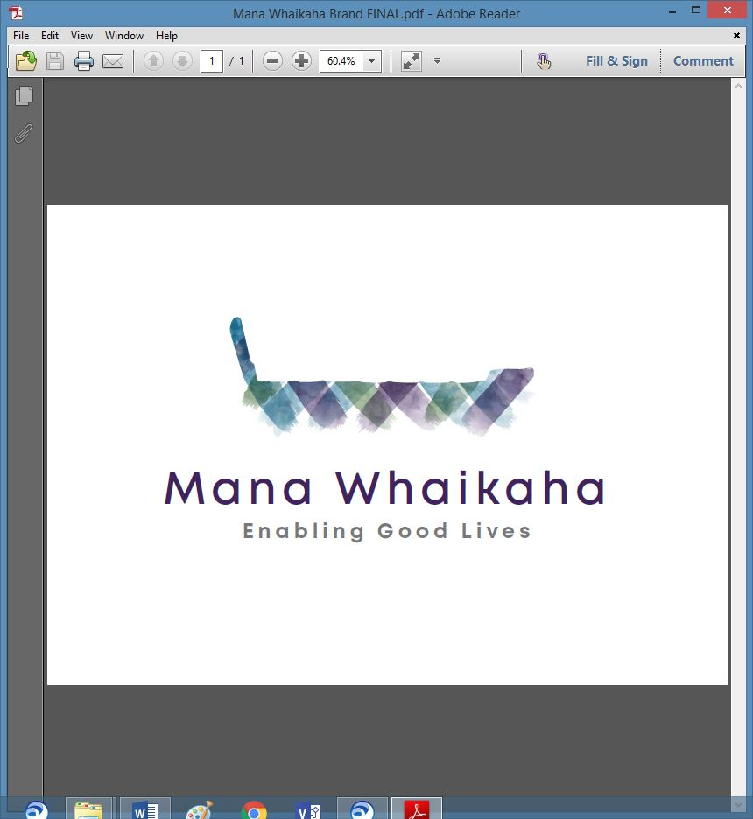

**MidCentral Governance Group**

**Minutes of the meeting held on Thursday 28 July 2022**

|  |  |
| --- | --- |
| **Attendees:** | Peter Allen (Chair), Martin Sullivan, Rachel Kenny, Pip Brunn, Peter Ireland, Regena Te Whaiti and Rachael Burt |
| **Apologies:** | Rasela Fuauli and Ally Attwell |
| **In attendance:** | Sandy Ryan (Meeting Assistant), Jo Brew (Secretariat) |
| **Venue:** | PSA Lounge, 198 Cuba Street, Palmerston North |
| **Time:** | 10.30am – 2.30pm |

**Welcome**

The Chair opened the meeting with a karakia and welcomed Regena Te Whaiti, Mana Whenua representative to the MidCentral Governance Group.

**Previous Minutes**

The minutes from the previous meeting was taken as read and are a true and correct record.

**Peter Ireland/Martin Sullivan**

**Action Points**

The action points were updated and will be reflected in the August agenda.

**Te Tihi Recommendations Review**

* Rachael Burt, Director – Mana Whaikaha gave a verbal update on the Te Tihi project recommendations.

**Action: Secretariat to update the document and circulate with the minutes.**

* Mana Whenua core group will monitor the recommendations.

**Action: Secretariat to forward the Te Tihi project documents to Regena.**

**MGG Decision Making**

The Chair will review and draft an updated terms of reference document. This will include ways the MGG can be included in the decision-making process within Whaikaha and Mana Whaikaha, as appropriate. Once the draft has been completed and accepted, the 3 parties be invited to discuss and develop a final version.

**Action: The Chair to draft an updated Terms of Reference document and circulate to MGG.**

**Director’s Report** (Rachael Burt, Director – Mana Whaikaha)

Rachael tabled her report. Discussion points included:

* The team is significantly short staffed with 6 vacant positions and approximately 8 staff on sick leave each week.
* The potential of staff burnout is a concern.
* Enable New Zealand has lost 4 staff members who were performing Mana Whaikaha related tasks; Budget Advisors are covering some of those tasks at present.
* Team members are stepping up to ensure the people we serve are well supported.
* A team event would benefit staff morale.

**General Business**

There was no general business.

The meeting closed at 1.38pm.

**Practical Matters**

**Date of next meeting:** Thursday 25 August 2022 at 10.30am in the PSA Lounge, 198 Cuba Street, Palmerston North.

**I confirmed** that these minutes constitute a true and correct record of the proceedings of the meeting

DATED this 25th day of August 2022



**Peter Allen**

**Chair, MidCentral Governance Group**