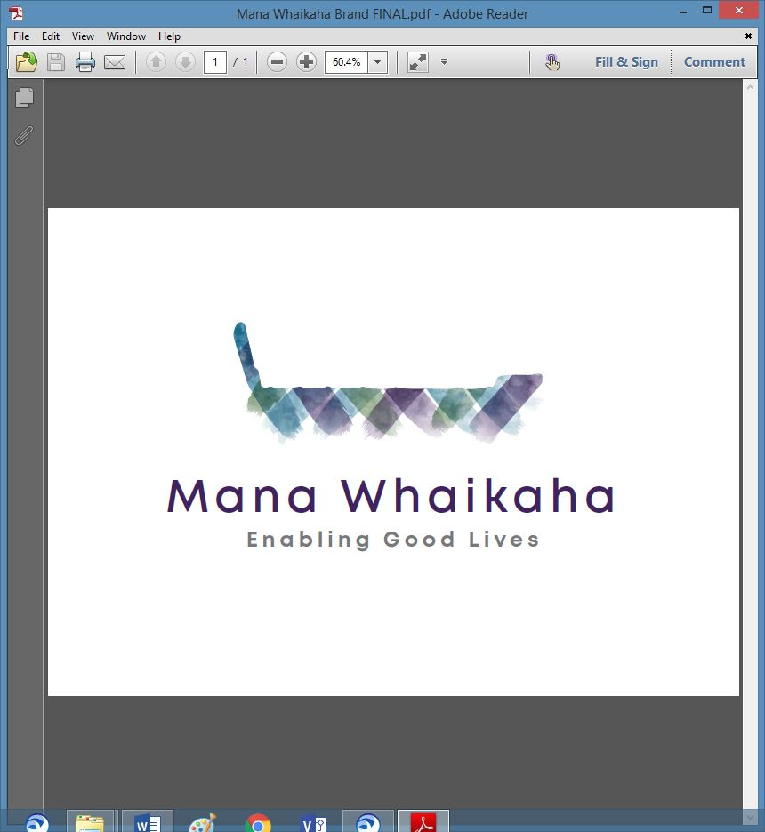

**MidCentral Governance Group**

**Minutes of the meeting held on Thursday 25 August 2022**

|  |  |
| --- | --- |
| **Attendees:** | Peter Allen (Chair), Martin Sullivan, Rachel Kenny, Pip Brunn, Peter Ireland, Rasela Fuauli, Ally Attwell and Rachael Burt |
| **Apologies:** | Regena Te Whaiti |
| **In attendance:** | Catherine Mu (Meeting Assistant), Jo Brew (Secretariat) |
| **Venue:** | PSA Lounge, 198 Cuba Street, Palmerston North |
| **Time:** | 10.30am – 2.30pm |

**Welcome**

The Chair opened the meeting with a karakia.

**Previous Minutes**

The minutes from the previous meeting was taken as read and are a true and correct record.

**Martin Sullivan/Peter Ireland**

**Action Points**

The action points were updated and will be reflected in the September agenda.

**Director’s Report (Rachael Burt, Director Mana Whaikaha)**

Rachael tabled her report. Discussion points included:

* Engaging and supporting Whaikaha regarding scaling up by providing previously prepared background, design, workstream and Cabinet documentation and prior learnings from Mana Whaikaha.
* Reflecting on the above documentation and learnings has led to a reset within Mana Whaikaha, starting with a focus on entry into Mana Whaikaha.
* The existing EGL template is being updated and redeveloped into a digital template with prompts.
* The welcome pack is being updated.
* Rachael will work from Wellington one week per month for the next several months.
* Mana Whaikaha remains short staffed; sickness has continued to affect the team and 6 current vacancies remain unadvertised/unfilled.
* The 3 EGL Directors have developed a formula to assist with future recruitment needs – based on this, Rachael plans to submit a secondary recruitment proposal. Extra staffing should allow the senior leaders focus on strategic work and Senior Connectors to actively support connectors in their day-to-day practice.
* Several complaints have recently been received and are under investigation.

**Compliance (Rachael Burt, Director – Mana Whaikaha)**

As Connectors have not previously had access to compliance, they are sometimes unaware when personal budgets are unspent. When this money accumulates and gathers interest, it is classified by IRD as income which creates a risk for the disabled person. As the money is no longer under contract if not used within the previously specified timeline there is a financial risk to Mana Whaikaha. This also creates an imbalance about the spend of disability supports. There are 3 options for safeguarding management of this:

* **Option 1** – on a percentage basis at the end of the year any underspend is returned to Mana Whaikaha to be redistributed into the pool for reallocation. This becomes problematic as Mana Whaikaha become debt collectors.
* **Option 2** – delay personal budget and put new funding agreement in place with data entry but no money attached to it so the surplus can be used and there is an auditable trail.
* **Option 3** – start a new personal budget but reduce by the amount of money remaining in the account.

Note: there are some legitimate reasons why money might accrue – these would need to be recorded to avoid becoming compliance issues. i.e., saving up for support person (and payment of extra hours) to accompany person on a holiday.

**All presented agreed option 2 was the preferred option to use to develop policy.**

**Action: Rachael will develop a paper outlining that process and present to the next MGG meeting for approval.**

**New Compliance Framework**

* A compliance platform has been developed for Mana Whaikaha. This will allow the disabled person to give Mana Whaikaha the rights to access their disability account to make compliance checks. Red flags for purchases will be automatically raised with an opportunity for the person to justify the purchase. The red flags would also be raised with the Connector. This should eliminate accrued and inappropriate debt.
* Invitations will be sent to Regional Leadership Group to forward to disabled people and whᾱnau inviting them to attend a forum to learn about the new compliance framework. Three forums are planned.

The meeting closed at 1.38pm.

**Practical Matters**

**Date of next meeting:** Thursday 22 September 2022 at 10.30am in the PSA Lounge, 198 Cuba Street, Palmerston North.

**I confirmed** that these minutes constitute a true and correct record of the proceedings of the meeting

DATED this 22nd September 2022



**Peter Allen**

**Chair, MidCentral Governance Group**