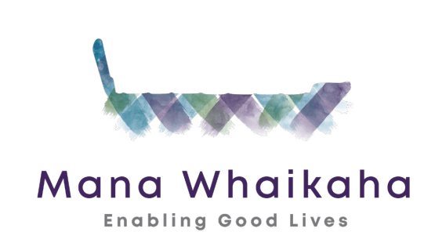
CAPABILITY BUILDING FUNDING GRANTS
Information

What is this fund for?
The fund is for groups of disabled people, families, whānau and aiga to build their skills and capacity.
The fund promotes the Enabling Good Lives approach.
In particular, the fund aims to build on the principles of:
Self-determination
Disabled people are in control of their lives.

Beginning early
Invest early in families and whānau to support them; to be aspirational for their disabled child to build community and natural supports.

Ordinary life outcomes
Disabled people are supported to live an everyday life in everyday places; and are regarded as citizens with opportunities for learning, employment, having a home and family, and social participation – like others at similar stages of life.

Mana enhancing
The abilities and contributions of disabled people and their families are recognised and respected.

Relationship building
Supports, builds, and strengthens relationships between disabled people, their whānau and community.

Who can apply?

You can apply if you are:
- a group of disabled persons or
- a group of families with disabled family members or
- under the umbrella of one of these groups or do
- endorsed by either of these groups

AND
What you plan to do will benefit a group of disabled people or families, whānau or aiga who live in the MidCentral District Health Board region.

Map of MidCentral District Health Board region

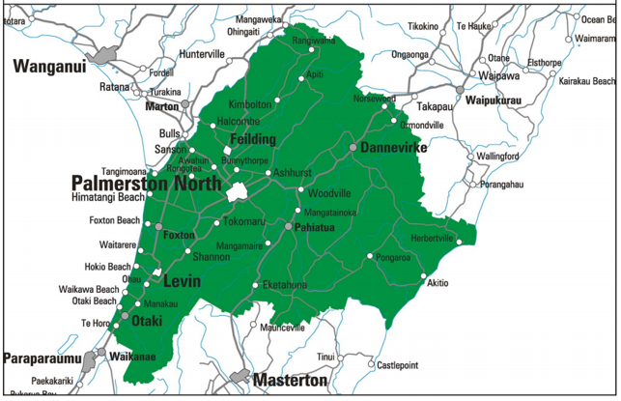

What sort of things can be funded?
Any activity that increases the skills and capabilities of a group of disabled people, families, whānau or aiga may be funded.
Here are some examples of things that may be funded.
- A group of 8 families coming together for workshops and wānanga to share ideas and plan for their disabled teenager’s future.
- Project to develop marae-based supports for disabled whānau hapu and iwi members.
- Project linking young disabled school leavers with mentors and buddies to assist them make community connections and join activities.
- Managing your individual funding and being an employer – series of workshops for disabled people and families.
- What makes a good support service – seminar on what to look for when choosing a disability support service.
- Fono for Pacific people to learn what support, entitlements and benefits are available to them.
- Disabled people coming together with a business mentor to develop an innovative social enterprise.
- Development of resources.

How do I apply?
The application process is fully accessible for people using all forms of alternate communication. A good way to start is to contact the Fund Advisor to discuss your application.
To make an application or ask a question, please contact the Funding Advisor, Jo Brew.
Funding Advisor can be contacted by emailing apply@manawhaikaha.co.nz or phoning (06) 352 6138.
You can apply by filling out the form in this pack and emailing to the Funding Advisor or by submitting what you want by video, email or by a face to face presentation.

What do I include in my application?
Your proposal needs to include:
- who is applying
- what you want the funding for
- the amount of funds requested
- the estimated completion dates
- who will benefit and what will the outcomes be
- how will you tell us you have been successful

What happens next?
You will be contacted within 2 days by the Funding Advisor to tell you your funding application has been received. The Funding Advisor will check you have included all the necessary information and may ask you more questions about your application.
Your application will then be considered by the MidCentral Regional Leadership Group Funding Panel. This panel is made up of disabled people and family members from the MidCentral Regional Leadership Group.
The Funding Panel will decide whether to fund your proposal or not.
You will be notified of the outcome by the Funding Advisor within 4 weeks from the time you submitted the application.
Great – your application was successful!
A letter of authorisation, with a fund reference number, will be issued to successful applicants.
You will be required to report back to the Funding Panel to let them know the outcome of your activity. The Funding Advisor is available to discuss the best way for you to do this based on your type of activity.

What if my application was declined?
If you are not successful in getting funding you can discuss the reasons with the Funding Advisor. You may request the Funding Panel reconsider their decision. You will probably need to give more information to support this request.
If the Funding Panel agrees to reconsider your application, you will be notified of the outcome within two weeks.

Got questions or need help?
The Funding Advisor, Jo Brew, is available to help with developing your proposal and with completing an application for funding.

Contact Details for Funding Advisor, Jo Brew
Email apply@manawhaikaha.co.nz
Phone (06) 352 6138

CAPABILITY BUILDING FUNDING GRANTS
Application Form
This application form is for capability building funding for groups of disabled people, families/whānau and aiga.
This form is a guide only. You can apply in any way you choose. You may want to do this face to face or by video.
Note that to be eligible for this funding you need to be:
You can apply if you are:
- a group of disabled persons or
- a group of families with disabled family members or
- under the umbrella of one of these groups or
- endorsed by either of these groups

Note: a ‘group’ of disabled persons’ does not mean you have to be a Disabled Person Organisation (DPO).

SECTION A - Personal Details

Name of Applicant:
Name of Disabled Persons Organisation (if applicable)
Name of Families of Disabled Persons Organisation (if applicable)
Address:
Suburb:
City: Postcode:
Phone: Mobile:
Email:

If applying under an umbrella organisation please tell us the following:
Umbrella Organisations name:
Charities Registration Number (if they are registered):

SECTION B - Your Proposal
Please answer the questions below:

- What do you want funding for? (Describe what you will do, including the duration of the project and the estimated completion date)

- Describe the group or groups of people (needs to be 3 or more people) your proposal will benefit. Note the people must live in the MidCentral District Health Board region.

- Describe the skills and capabilities people taking part in your activity will learn and develop or other ways they will benefit.

- If you are running an event or workshop tell us about the people leading this, for example the presenters/facilitators you plan to use.

- Tell us how you will make sure your activity is fully accessible to everyone who wants to participate (if using a venue is it fully accessible, is the presentation accessible to people who are blind, will you have DEAF participants and if so have you got New Zealand Sign Language interpreters?).

- Please attach or submit any additional information to support your application. If you wish to present your application in person please tell us that.

If you have questions, please contact the Funding Advisor, Jo Brew by:
Email apply@manawhaikaha.co.nz or by phoning (06) 352 6138

Section C – Funding Required
(Note – If your application is for over $20,000.00 you will also need to complete Section D).

Total Cost: $

How much can you contribute: $

Total funds required $

Detailed breakdown of costs

Item/Activity | Supplier | Cost (incl GST)
Eg:  Venue Hancock House  Photocopying Workbooks | Palmerston North City Council  Warehouse Stationery | $ 50.00  $ 24.00
 |  | $
 |  | $
 |  | $
 |  | $
 |  | $
 |  | $
 |  | $
 |  | $
(if more space is required, continue on a separate sheet and attach to application)

Have you applied to anyone else for this funding? Choose an item.

If yes, please provide the following details:

Name:
Date: Click or tap to enter a date.
Amount applied for: $

If you have any quotes to support your proposal, please attach them with your application.

NOTE: Should the costs exceed the funding approved by more than 10%, the Capability Funding Panel will not be liable for covering this cost.

SECTION D – For requests over $20,000.00

If you are applying for a grant of more than $20,000.00 you need to be an organisation rather than informal group.

You can be a disabled persons-led organisation or a family of disabled person’s organisation, come under the umbrella of one of these organisations or be endorsed by one of them.

You will need to include the following information with your application:
- Annual Accounts – these must be no older than 16 months at the time of the application. If the constitution, rules, or trust deed stipulates that the organisation must have compiled, reviewed, or audited accounts, the organisation must provide that report with their application.
- Bank statements - no older than 6 months from the submission of the application, showing all account balances.
- Two letters of support - these must be signed, dated and no more than six months old, from disabled leaders or senior people with credibility in the disability sector.
The followed are attached:
Annual Accounts Choose an item.
Bank Statements Choose an item.
Two letters of support Choose an item.

If you have questions, please contact the Funding Advisor, Jo Brew by:
Email apply@manawhaikaha.co.nz or by phoning (06) 352 6138

SECTION E - Confidentiality
By signing and submitting this application you are giving permission:
- For your contact details and information in the application to be shared with the MidCentral Regional Leadership Group Funding Panel members, the Fund Advisor and the Director, Disabled People, Family and Whānau Supporting Team.

- For the information you provide to be used by Mana Whaikaha for statistical purposes and/or policy development.

- To participate in an evaluation of the outcomes and benefits of this proposal if requested.

I (name of applicant):
Declare that:
☐ (Tick) The information included in this application form and supporting documentation is true and accurate.
☐ (Tick) Any funding received from the MidCentral Regional Leadership Group Funding Panel will be solely used for the purpose specified in this application and that any unspent funds will be returned to the funder.

Signature: Date: Click or tap to enter a date.

If you have questions, please contact the Fund Advisor, Jo Brew by phone (06) 352 6138 or email apply@manawhaikaha.co.nz

Note: Please send funding applications in by midday of the 1st Friday of each month so they can be processed for consideration at the Funding Panel’s monthly meetings.

