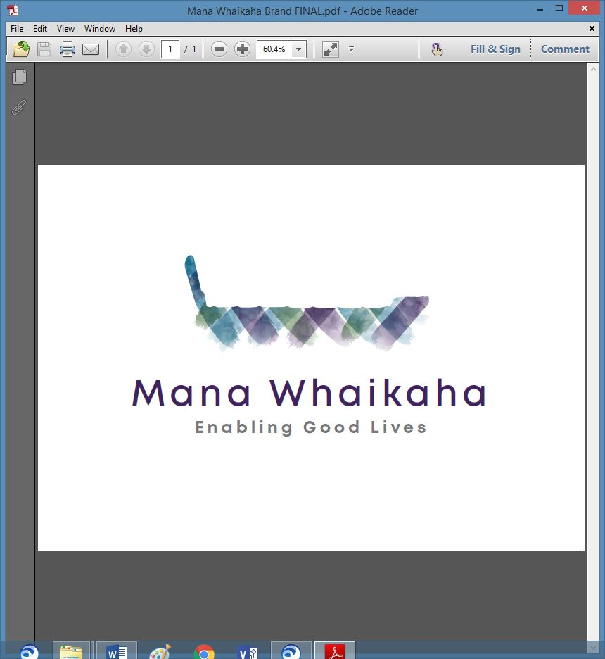

**MidCentral Governance Group**

**Minutes of the meeting held on Thursday 24 March 2022**

|  |  |
| --- | --- |
| **Attendees:** | Peter Allen (Chair), Lorna Sullivan (Co Chair), Rachel Kenny, Martin Sullivan, Rasela Fuauli, Pip Brunn, Angela Hobden, Peter Ireland, Toni Griffiths, Rachael Burt and Ally Attwell |
| **Absent:** |  |
| **In attendance:** | Jo Brew |
| **Venue:** | Via Zoom |
| **Time:** | 10.30am – 2.30pm |

**Welcome**

The Chair welcomed all and opened the meeting with a karakia.

**Previous Minutes/Notes**

The minutes of the previous meeting held on Thursday 24 February 2022 were taken as read and are a true and correct record.

**Angela Hobden/Rachel Kenny**

The action points were updated and will be reflected in the April agenda.

**Information: Repeat Study - Summary Report 2021** (Pauline Boyles)

Pauline tabled the summary report and reminded the group this was a draft version.

Key points noted were:

* There were significant shifts for disabled people but less significant for whānau.
* There were 17 critical significant shifts in terms of where we were in 2018 and where we are in 2021.
* Two major outcomes were whānau are a voice for disabled people (a major winner for children and young people) and that Mana Whaikaha responded to a longstanding gap and built something for these communities who had not been heard before.
* The barriers are in our parallel system, i.e., provider contracts. This indicates the importance in constructing a system for the future to allow people manage their services and lives if they chose to do so rather than a whole disability support contract approach.
* Connectors are critical but the ecosystem around the connectors needs improvements.

**Report Recommendation**: Future scaling and development of Mana Whaikaha considers a range of supports available in the work force, the role of regional leadership and ways to manage diverse demographics more effectively. Planning should draw on results of this survey and on the qualitative study yet to be reported on Flexible Disability Supports.

Discussion Points

* The survey conclusions align with what Mana Whaikaha have already identified, i.e., resourcing challenges.
* Despite the challenges of starting a new organisation without an infrastructure, the lack of adequate resourcing and a covid environment, all involved should be proud of the achievements of the prototype.
* System transformation is working alongside the Establishment Unit, the community steering group and will work in with the government tripartite group and the new disability approach to evaluation and learning (including research).

**Board Matters – Strategic Planning**

Discussion points included:

* The remaining reduced timeframes and lack of engagement from Ministry of Health has cast some uncertainty around the practicalities of forming a standalone entity contracting to deliver a service to disabled people however there is a significant risk in doing nothing so need to continue to plan a future direction.
* The group identified the next steps which include a meeting with the Director of the Disability Directorate and a strategic planning session for the group (dependant on availability of suitable facilitators).

**Discussion: Reflections of Preliminary Leadership Review Report**

The group discussed the Reflections document tabled on behalf of Gail Munro. This contains a summary of feedback submitted by this group, MidCentral Regional Leadership Group (RLG) and the MidCentral Pasifika Core Group in response to the Leadership Review Report by Gail Munro).

Comments included

* Terms of reference document could have a shared foundation but have a local flair reflecting their own region/community.
* Easy read is important in making documents accessible, extra funding for extra capacity to translate into Easy read would be a good investment.

***The reflections document was received and accepted by the group.***

**Info: Directors Report**

Rachael tabled her report with additional comments being:

* Nine staff have been recruited into the vacancies advertised during December 21/January 2022. The Senior Connector appointment is currently being finalised.
* The new ministry will have higher expectations relating to compliance and auditing of personal budgets and how they are used. Tools are being developed to be user friendly for disabled people and to provide better reporting for Mana Whaikaha and the ministry.
* The Mana Whaikaha team has taken a significant hit from covid.
* A business memo is being developed for ‘the next phase’. The draft document includes proposed changes to residential contracts, integrating Equipment Modification Spend into personal budgets, creating stronger intervention and a stronger voice of family and child for early intervention services, taking a stronger role in the high and complex framework, and transitioning business services into Mana Whaikaha.

**Discussion: PSA** (Andrea Fromm, Policy Team)

Andrea joined the meeting and the group discussed workforce matters:

* The reinstatement of the Workforce Working Group (WWG) was a positive outcome influenced by the MGG and PSA working together, stating their joint position in a letter to MoH during 2021.
* The WWG is currently working on a workforce strategy and the creation of an employment hub.
* Local RLG members have clarified the WWG was contributing to workforce issues on a national level, not a local level as first thought.
* To be effective, system transformation needs a workforce strategy ensuring EGL principles are effectively realised, strategized, retained and continued **and** a well trained workforce.
* It was suggested drafting a letter highlighting some joint matters both MGG and the PSA would like to take forward which haven’t yet been recognised as important e.g., the workforce strategy including the implementation of EGL principles being put on the new CEO’s work programme as encouraged by the community steering group.
* Community voices including PSA, community groups, governance etc, regionally and nationally being heard by the community steering group and channelled by them through to the Establishment Unit (EU).
* The EU is not represented on the WWG.

***Action point: Pip and Rasela to develop strategy and priorities and present to Regional Leadership Group.***

**Correspondence**

**Outwards**

* Email sent on 21.3.22 from the Chair to Pauline Boyles re MGG Terms of Reference and reallocation of seats.

**Policies for Review**

* Deferred until the April meeting.

The meeting closed at 2.30pm.

**Practical Matters**

**Date of next meeting:** Thursday 28 April 2022 at 10.30am in the Function Room, Focal Point, 223 Cuba Street, Palmerston North

**I confirmed** that these minutes constitute a true and correct record of the proceedings of the meeting

DATED this 28th day of April 2022



**Peter Allen**

**Chair, MidCentral Governance Group**