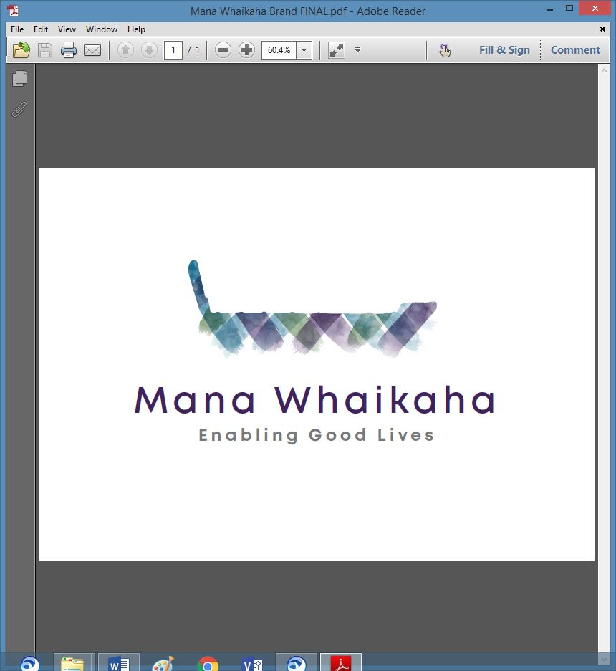

**MidCentral Governance Group**

**Minutes of the meeting held on 26 May 2022**

|  |  |
| --- | --- |
| **Attendees:** | Peter Allen (Chair), Martin Sullivan, Rachel Kenny, Pip Brunn, Angela Hobden, Peter Ireland, Rasela Fuauli, Rachael Burt, Toni Griffiths |
| **Absent:** | Ally Attwell |
| **In attendance:** | Sandy Ryan (Meeting Assistant), Jo Brew (Secretariat) |
| **Venue:** | PSA Lounge, 198 Cuba Street, Palmerston North |
| **Time:** | 10.30am – 2.30pm |

**Welcome**

The Chair welcomed all and opened the meeting with a karakia.

**Info: Flexibility Disability Support (FDS) Christchurch & MidCentral Reports and Summary** (Pauline Boyles)

Pauline tabled the FDS MidCentral and Christchurch Evaluation Report covering:

* Flexibility Disability Supports: Background
* Methodology: strengths and limitations
* Key positive findings
* Opportunities for future development
* Linkages between repeat study MidCentral and FDS
* Improvements Recommended

Other points discussed were:

* There was no fiscal analysis of FDS and the costs of administering it as these costs fit within the personal budget and indicative range.
* Although costing work and costing methodology was not the focus of this study, funding flaws are acknowledged.

Pauline left the meeting.

The following recommendations, as taken from the report were proposed:

1. **Note** the positive trends noted in the study for participants as well as the learning around implications for future contracts and future.
2. **Agree** that the evaluation reports are returned to participants via SAMS the evaluator and to be made available on the Christchurch EGL website.
3. **Agree** responsibility for full publication is handed over to the Establishment Unit.

**All present agreed to endorse the above 3 recommendations.**

**Info: Establishment Unit** (Bernadette Anne)

Bernadette’s update included:

* A work project on information gathering about the various leadership groups is being collated in readiness to handover to the incoming CEO.
* Operational practicalities are being organised to ensure smooth transition for staff and continued service delivery, i.e., equipment, connectivity, alternative accommodation.
* Supporting IT and HR staff with their work.
* Planning the formal welcoming pōwhiri for all new staff.
* Gathering information from the 3 EGL sites.
* Working with the System Transformation at MoH about gathering information on ‘where things are at’ to develop into a work programme for the new ministry.

**Info: Directors Report** (Rachael Burt)

Rachael tabled her report, further discission points included:

* 3 Directors of the EGL sites have met to collate information for the incoming CEO.
* Cabling to allow connection from the Enable premises to MSD’s system is underway. MSD’s IT Team have been visiting our office to test the system to ensure a smooth transition.
* Progress with plans for a new site continues.
* Will be presenting the business memo to OMT this afternoon.
* Has approval to recruit a Project Lead role.

**Info: Chair’s Update** (Peter Allen)

Peter’s update included:

* The EGL budget – $100 million split over 4 years and is tagged contingency with conditions (i.e., Treasury need an implementation plan for the investment with evidence of expectations of returns).
* Top priority for NEGL is to take an active role in developing leadership groups nationally, once regions are announced. Anticipated funding via capability and capacity building investment from the EGL budget over a 12 – 24 month period.
* Approximate budget splits are $743 m to service providers, $108 m to develop and build the new ministry and $100m to prepare EGL upscaling nationally.
* Trying to implement the tripartite governance (Māori, Disabled People, and officials all at the governance table) in the different places.
* The Pasifika Core Group representative was encouraged to keep conversations open to ensure the Pasifika voice is heard.
* EU is fulfilling their scope of ensuring the team transitions to the new ministry at an operational level, ready to start on 1 July.
* Looking forward to meeting the CEO and hoping all parties are aligned and wanting to achieve the same things.

A brief discussion followed regarding:

* The importance of the voice of the leadership groups and the need for them to be heard to within the tripartite approach as they represent the voice of the community.
* Talking and sharing with new leadership groups is very important so people can gain an understanding of the EGL approach which will help them determine what is important to them and begin/develop their own plans.

**Previous Minutes**

The minutes from the previous meeting was taken as read and are a true and correct record.

**Angela Hobden/Toni Griffiths**

The action points were updated and will be reflected in the June agenda.

**Correspondence**

**Inwards**

* Email received on 18.5.22 from Pauline Boyles with an attached letter informing the MGG about an OIA request relating to the Baseline Evaluation.

**General Business**

* Jo will submit an electronic attendance register directly to Nick for this meeting. Will cc Peter in for verification.
* Jo to invite Mark Jacobs and Erin Black to the next MGG meeting.
* A brief discussion around the importance of funding for service delivery remaining in New Zealand, i.e., profit and taxes benefitting New Zealander’s, and with Non-Government Organisations who are values based, not profit focused.

The meeting closed at 1.40pm

**Practical Matters**

**Date of next meeting:** Thursday 28 July 2022 at 10.30am in the PSA Lounge, 198 Cuba Street, Palmerston North.

**I confirmed** that these minutes constitute a true and correct record of the proceedings of the meeting

DATED this 26th day of June 2022



**Peter Allen**

**Chair, MidCentral Governance Group**